How to add a post to Reading Challenge Blog.
Log in to Glow via https://glow.rmunify.com/
Click on the Reading Challenge Blog tile on the launch pad.
To insert a post click on +new, then post
Give your post a title then type your comment in the box.
Give your post a category and a tag to help people find it more easily. For example, fiction, non-fiction, book review or author’s name.
Photographs can be added by clicking on the Add Media button.
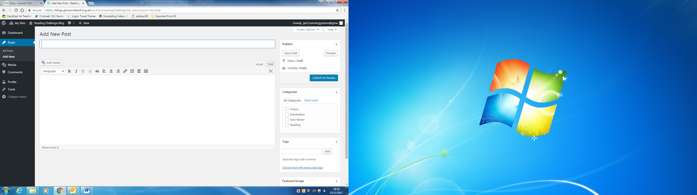
When you are happy with your post, submit it for review.

