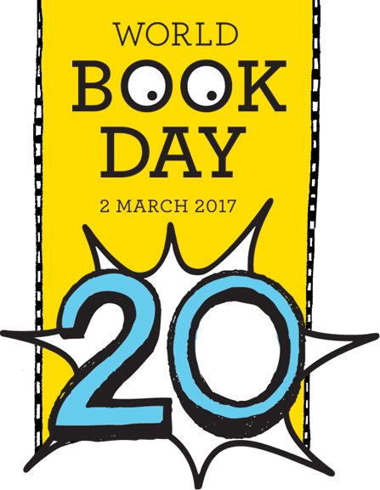

My World Book Day P6 & 7 Activity Book

OLM

2017

Name:

Class:

How many stars would you give this book out of 10?
Opinions Would you change anything about the book to make it better?

___________________________________________________________________________________________________________________________________________________________________________________________________
Recommendation Would you recommend this book to a friend? Why?

______________________________________________________________________________________________________________________________________________________________________________

Characters Who was your favourite character? Who are the main characters?
______________________________________________________________________________________________________________________________________________________________________________________________
Plot What happens? Are they any plot twists? Did you find the plot interesting?

______________________________________________________________________________________________________________________________________________________________________________

A Book Review- Book Title: Author- ___________________

Choose a line

Choose from one of the story lines below and use your imagination to write a story which includes this line:

- When I opened my eyes there was nothing. All I could see was darkness.
- She screamed and screamed, so loudly that it felt as if my eardrums were going to burst.
- He burst out laughing and kept going until tears were streaming down his face.
- Ahead I saw the most amazing spectacle I had ever seen. This was so grand and spectacular I did not know where to look.

________________________________________________________________________________________________________________________________________________________________________________________________________________________________________________________________________
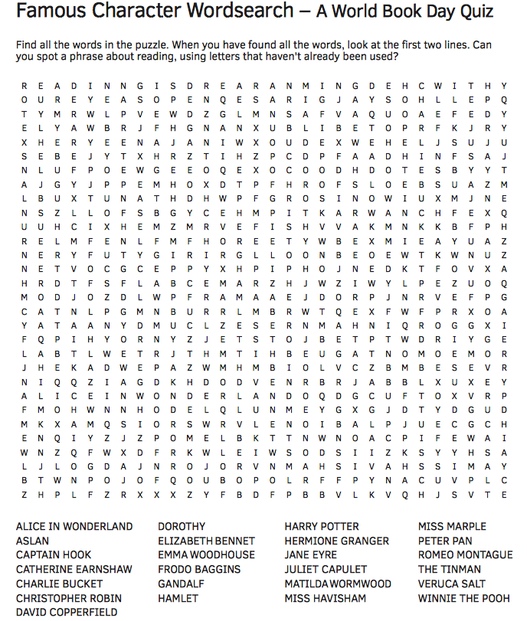
Imagine that you have the opportunity to interview the author of your favourite book! What would you ask him/her?
Interview the author!

Design a front cover for a book! Use your imagination and think of a great title, a good image for the front and a blurb which makes your reader want to pick up your book! Look at good examples of book covers which are eye catching to help you.
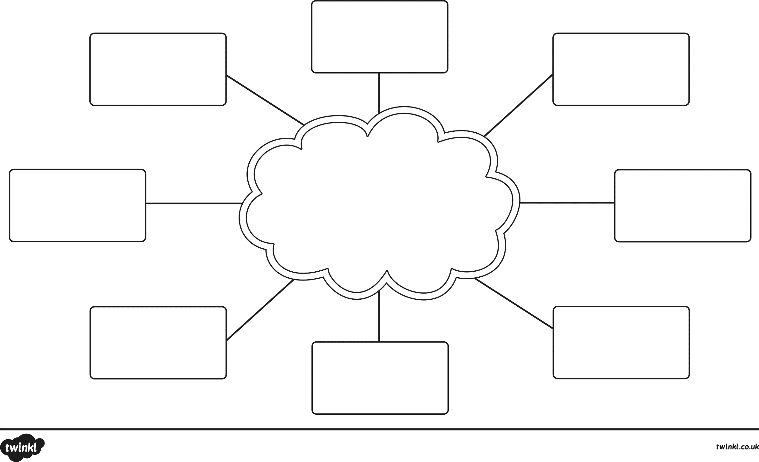
Thesaurus Challenge
Your teacher will choose a word for the middle. Your task is to try and think of other words which have the same meaning. Use a thesaurus to help you with this task.

