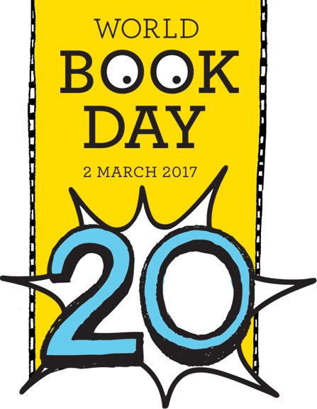

My World Book Day P4 & 5 Activity Book

OLM

2017

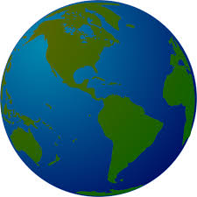

Name:

Class:



**Book Vocabulary Name: ___________**

**Can you describe the meanings of the following book related words?**

**Dictionary:____________________________________________________________________________________**

**Thesauras:_____________________________________________________________________________________Atlas:_________________________________________________________________________________________**

**Biography:______________________________________________________________________________________**

**Novel:_________________________________________________________________________________________Fiction:________________________________________________________________________________________**

**Non Fiction: _____________________________________**

**_______________________________________________**

**WORLD BOOK DAY Name: _________**

**How many smaller words can you make from the letters above?**

1. **____________________**
2. **____________________**
3. **____________________**
4. **____________________**
5. **____________________**
6. **____________________**
7. **____________________**
8. **____________________**
9. **____________________**
10. **____________________**
11. **____________________**
12. **____________________**
13. **____________________**
14. **____________________**
15. **____________________**

What did you like the most about the book?

|  |
| --- |
|  |
|  |
|  |
|  |

Book Illustration

Would you/would you not recommend the book? Why?

|  |
| --- |
|  |
|  |
|  |
|  |

Rating:

Book Review

Book review by: ___________________________________________

Title: _______________________________________________________

Author: ____________________________________________________

Non fiction Fiction

What is the book about?

|  |
| --- |
|  |
|  |
|  |
|  |
|  |



Imagine you were an author writing a book. Try and think of a brilliant title for your story, think of a great picture for the front cover and write a tag line along the bottom to make people want to read your book!

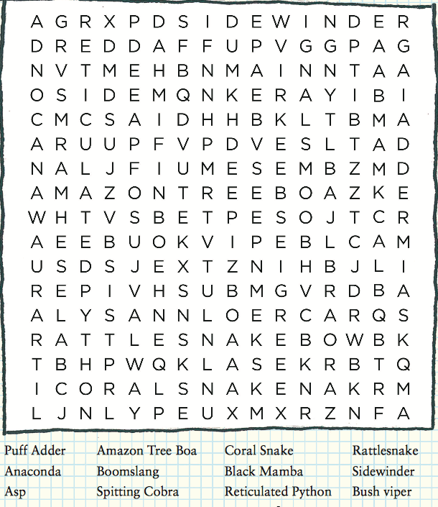

Can you try this word search based on David Walliams book ‘*There’s a Snake in my school!’*

With more than 3,000 species of snakes in the world, see if you can find just a few of them in this “*Ssseriously”* challenging word search!