Saint Ninian’s Cluster
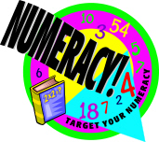

Parent and Pupil Guide to Division

Introduction

This information booklet has been produced as a guide for parents and pupils to make you more aware of how division is taught in the primary setting.

It is hoped that the information in this booklet may lead to a more consistent approach to the use and teaching of division across the cluster and consequently an improvement in progress and attainment for all pupils.

We hope you find this guide useful.

Table of Contents

Topic Page No.

Key Vocabulary 3
Method 1 Sharing 4
Method 2 Grouping 5
Method 3 Written Algorithm 7
Division by 10, 100 and 1000 10
Mental Strategies 11
Mathematical Dictionary (Key Words) 13
Useful Websites 14

Key Vocabulary

share
share equally
share between
share among
one each
two each
three each…
group in pairs
group in threes…tens
equal groups of
divide
divided by
divided into
divisible by
half, quarter, fifth, tenth etc.
remainder
fraction
factor

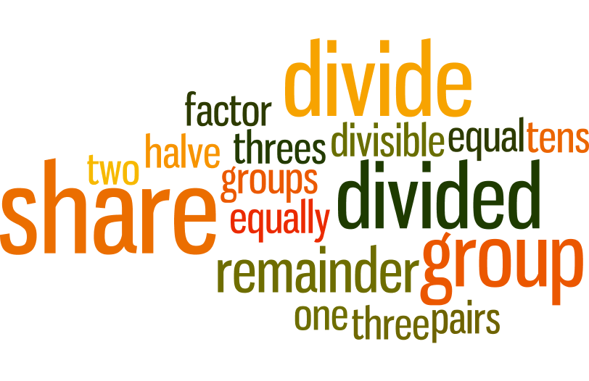
f
Method 1 – Sharing

Division is introduced initially by sharing. This is one of the simplest approaches. Children often have more real life experience of sharing objects. To introduce this concept we look at problems involving sharing a number of objects.

Children require lots of experience sharing physical items. We encourage them to talk about what they are doing before moving on to using symbols to express this.

Example

Ten football cards are shared equally between two children; how many will they each receive?

Pupils will use physical objects to help with this kind of problem.

Method 2 – Grouping

Grouping links to repeated subtraction and ideas of inverse multiplication. Pupils will be offered opportunities to explore patterns in the multiplication facts and to express them in all of the different ways possible, using words and symbols. It is important that children understand the equivalence of all of these different expressions. They will still be encouraged to use physical objects (concrete materials) to solve problems by grouping.

Example 1

If we have ten children, how many pairs can we make?

Pupils will use concrete materials to organise ten counters/cubes into pairs and count them.

Example 2

How many groups of five do you think we could make?

Children will draw rings round the groups of 5 to check.

Example 3

How many fives are in 40?

Encourage children to count along their fingers in fives.

Example 4

How many groups of 3 are there in 12?

This should lead to a discussion similar to this:
3 lots of 4 make 12

There are 3 groups of 4 in 12

4 x 3 = 12

4 lots of 3 make 12

12 ÷ 4 = 3

There are four groups of three in twelve

12 ÷ 3 = 4

If you share twelve things between three people they will have four things each
Once children can solve problems by sharing and grouping using physical objects, they will study the relationship between sharing and grouping.
Example 5
For 20 ÷ 5, share 20 between 5 and then show how you could also find how many groups of 5 there are in 20.

Establish that the answer is the same and discuss which way was quicker.
When they are confident in the equivalence of these methods, they will use their knowledge of multiplication to solve problems of sharing and grouping by the same written procedure.
Method 3 - Written Calculations

Initial written work will focus on the dividing by 2 and its equivalence to halving is explored. Children will then move on to dividing by 3, 4, 5 and 10, focusing on both mental and written calculations. In the next stage pupils move on to dividing by 6, 7, 8 and 9.
At this stage, it is imperative that pupils have a sound knowledge of multiplication facts and number patterns. They should also have familiar mental strategies to “chunk”, double, halve etc. in place.
Unlike other written methods for addition, subtraction and multiplication, the standard layout for division works from left to right and is displayed in a different way.
Example 1 – Dividing equally

16 strawberries are shared equally between 2 people. How many will they each receive?

16 ÷ 2

Pupils will use their knowledge of multiplication and previous experience of sharing and grouping to answer this question. If required, pupils can still utilise physical objects here to share 16 items between 2.

This horizontal written method is used to display division problems related to the multiplication facts (multiplication tables 2 to 9).

Children then move on to dividing with remainders.

Example 2 – Division with remainders

14 pencils are arranged in piles of 4. How many are in each pile?

14 divided by 4 is 3 remainder 2, written as 14 ÷ 4 = 3 r 2.
This means that there are 3 pencils in each pile and 2 left over.

Once pupils are familiar with the use of the “÷” symbol, we move on to displaying division calculations using a formal layout which enables children to display working for more complex problems.

Example 3 – Division of larger numbers
810 ÷ 6

We start at the left hand column and work to the right.

Start with 8 divided by 6 (8 ÷ 6 = 1 remainder 2). The 1 is written above the line in the same column as the 8.
(Pupils can be supported if necessary by saying “how many 6s in 8?”
Any remainders are carried over to the next digit. Here, the remainder 2 is carried over beside to the 1 and the next calculation is 21 divided by 6
(21 ÷ 6 = 3 remainder 3). The remainder is again carried over to the next digit. The next calculation is 30 divided by 6 (30 ÷ 6 = 5).

Example 4 – Division of decimals

When dividing a decimal number by a whole number, the calculation is the same as a division without decimal points, with the decimal point in the answer being inserted above the decimal point in the question.

0 8 1 . 9
4 3 ³2 7 . ³6

A decimal division is calculated in the same way as Example 3.
Each calculation is performed in turn and remainders carry over to the next digit. The decimal point does not change the method – the answer should contain a decimal point in the same place as the decimal you are dividing.

If there is a remainder when dividing a whole number, the calculation should be continued to give a decimal answer by adding a decimal point after the units and making use of trailing zeros. Keep adding trailing zeros until there is no remainder.

3 4 . 6 2 5
8 2 ²7 ³7 . ⁵0 ²0 ⁴0

Trailing Zeros

Example 5 - Division by a Decimal

When dividing by a decimal we use multiplication by 10, 100, 1000 etc to ensure that the number we are dividing by becomes a whole number.

Example 1 24 ÷ 0·3 (Multiply both numbers by 10)

= 240 ÷ 3
= 80

Example 2 4·268 ÷ 0·2 (Multiply both numbers by 10)
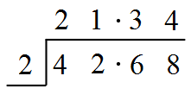
= 42·68 ÷ 2
= 21·34

Example 3 3·6 ÷ 0·04 (Multiply both numbers by 100)

= 360 ÷ 4
= 90

Example 4 52·5 ÷ 0·005 (Multiply both numbers by 1000)

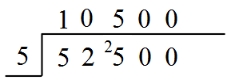
= 52 500 ÷ 5
= 10 500

Division by 10, 100 and 1000

When dividing numbers by 10, 100 and 1000 the digits move to the right, we do not move the decimal point.

Dividing by 10 - Move every digit one place to the right
Dividing by 100 - Move every digit two places to the right
Dividing by 1000 - Move every digit three places to the right

260 ÷ 10 = 26
H T U⋅
260⋅26⋅
Example 1
Zeros are not generally needed in empty columns after the decimal point except in cases where a specified degree of accuracy is required

439 ÷ 100 = 4⋅39
H T U⋅
439⋅4⋅39
Example 2

Example 3 This rule also works for decimals
32·9 ÷ 10 = 3⋅29
H | T | U | ⋅
 | 3 | 2 | ⋅ | 9
 |  | 3 | ⋅ | 2 | 9

We can divide decimals by multiples of 10, 100 and 1000 using the same rules as discussed above.

Example 4 Find 48·6 ÷ 20
24·3 ÷ 10 = 2·43
H | T | U | ⋅
 | 2 | 4 | ⋅ | 3
 |  | 2 | ⋅ | 4 | 3

48·6 ÷ 2 = 24·3
24·3 ÷ 10 = 2·43
Mental Strategies

There are a number of useful mental strategies for division. Some examples are given below.

Method 1 Checking by multiplying
Division is the inverse (opposite) of multiplication. Division calculations can be checked by multiplying.

27 ÷ 3 = 9
9 x 3 = 27

Method 2 Splitting the number you’re dividing into (to make it simpler)
Split 48 into 30 and 18 as these can both easily be divided by 3

48 ÷ 3
(30 ÷ 3) + (18 ÷ 3)
10 + 6
= 16

Method 3 Numbers can be split into factors to make dividing simpler
Split the 6 into factors 2 and 3 (2 x 3 = 6)
816 ÷ 6
816 ÷ 2 ÷ 3
816 ÷ 2 = 408
Then, 408 ÷ 3
= 136

Method 4 When dividing with even numbers, try a simpler case
Keep halving both numbers
120 ÷ 40 is the same as:
60 ÷ 20 is the same as:
30 ÷ 10 is the same as:
15 ÷ 5
= 3

Method 5 Estimating
Estimate a rough answer first, then check.

94 ÷ 3 is approximately 90 ÷ 3, which is 30.
4 are left over, so divide 4 by 3, which is 1 with 1 left over.
1 ÷ 3 = $\frac{1}{3}$ = 0·333…
30 and 1 and 0·3333
= 31·333

Using mental strategies is about choosing the method that works best for you and the numbers you are dealing with. It is useful to discuss strategies in a group to get ideas of how others solve mental problems and to reinforce your own preferred methods.
Mathematical Dictionary (Key Words)

Approximate | An estimated answer, often obtained by rounding to the nearest 10, 100, 1000 or decimal place.
Calculate | Find the answer to a problem (this does not mean that you must use a calculator!).
Division (÷) | Sharing into equal parts  e.g. 24 ÷ 6 = 4
Equals (=) | The same amount as.
Estimate | To make an approximate or rough answer, often by rounding.
Factor | A number which divides exactly into another number, leaving no remainder.  e.g. The factors of 15 are 1, 3, 5 and 15.
Multiple | A number which can be divided by a particular number leaving no remainder  e.g. the multiples of 3 are 3, 6, 9, 12, …
Multiply () | To combine an amount a particular number of times  e.g. 6 4 = 24
Remainder | The amount left over when dividing a number by one which is not a factor.
Share | To divide into equal groups.

Useful websites

There are many valuable online sites that can offer help and more practice. Many are presented in a games format to make it more enjoyable for your child.

The following sites may be found useful:

www.amathsdictionaryforkids.com

www.woodland-juniorschool.kent.sch.uk

www.bbc.co.uk/schools/bitesize

www.topmarks.co.uk

www.primaryresources.co.uk/maths

www.mathsisfun.com

