
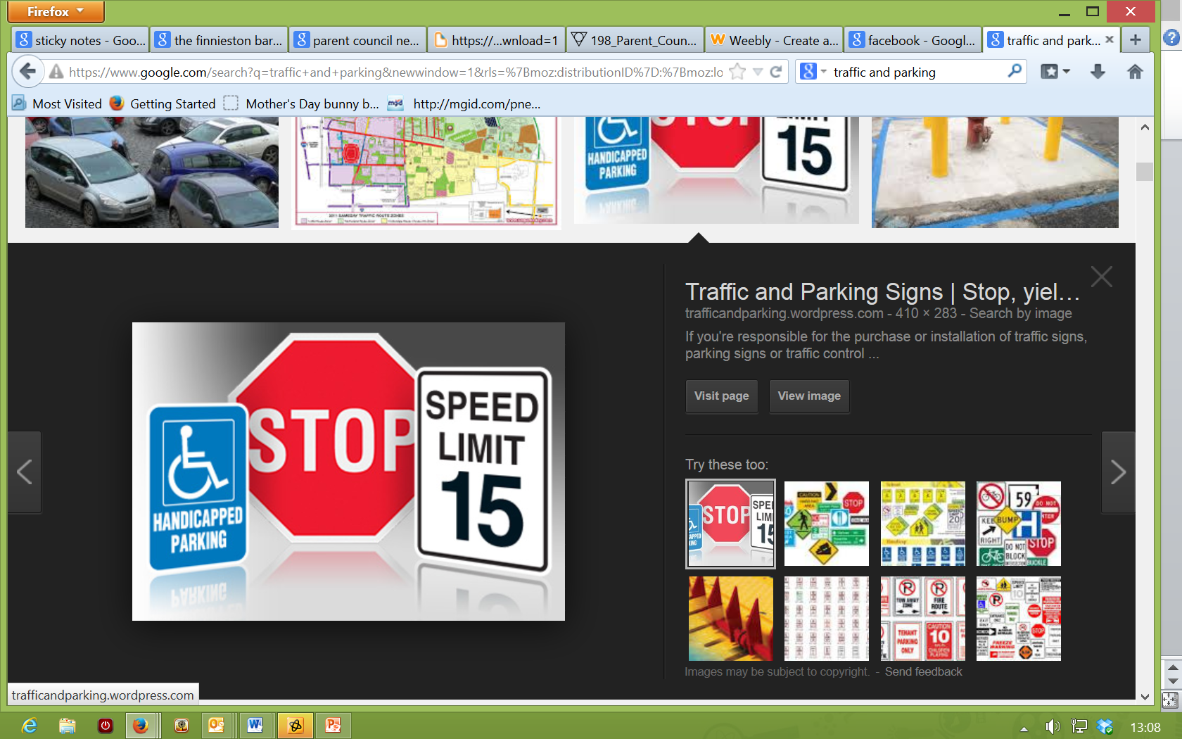
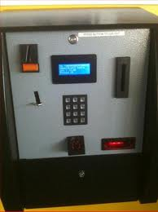

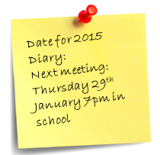
Our Lady of the Missions Primary School Parent Council
Newsletter Christmas 2014

TRAFFIC & PARKING

This is an ongoing frustration. The actions of a selfish few continue to cause congestion and endanger our children. Our current traffic action plan is on the school website. Please read it to find out what we’ve done and are planning – if you have any additional suggestions, please contact us. We will shortly launch a series of direct bulletins focussing on problem areas. If you see any near misses, please report them to us as this helps back up our ongoing discussions with ERC/ the police.
CASHLESS CATERING Once the corridor
is finished, the machine in the junior dept
can be used – this needs to be linked to
the school system via cabling in the
corridor. Unfortunately, changes we had
hoped (and pushed) for to allow balances selected meals to be checked on line are not going
to happen for now. We appreciate this is disappointing news but the old fashioned method of mental arithmetic and talking to our children remains!
IDEAS PROJECT
Our new project aims to capture your ideas to improve the experience of our children. Our first idea is creating a “parent to parent” insight on the transition to St Ninian’s. If you have any other ideas (particularly if they could be parent led), please contact us on olm-parentcouncil@hotmail.com to share them.

Contact us:
Get in touch at any time with your views or questions – contact us by phone (Anne 07952 251303); by email (olm-parentcouncil@hotmail.com) or message us on Facebook.
We hope you and your children have enjoyed their year so far and that you have a wonderful Christmas break when it comes! Get in touch any time with issues, comments and ideas to help improve the school experience. Meantime, we wish you all a very happy and peaceful festive season.

Membership
Thanks to all our members for coming forward at the AGM in September – a mix of known and new faces. Thanks also to previous members who stepped down, some after many years of contributing.
TRANSITION NEWS
The children have settled in fantastically well to the new junior department – feedback from parents has also been great. The coffee and cake afternoon was wonderful and a beautiful mass blessed the building in September. The new nature garden and additional IT suite / music room / gym / cafe are making a huge difference already in releasing pressure on facilities and space.
Latest info suggests the link will be completed by the end of January. This will help hugely in ensuring the school remains one integrated and dynamic hub, not 2 mini schools. Meanwhile, we are focussing on reinstatement of the outdoor space between the 2 buildings. Details can’t be fully considered until the New Year but we will report further news when we can.

Over 230 parents now follow our Facebook page to get updates on our activities and reminders for school events. If you haven’t already “liked” us, please do so to keep in touch.
SCHOOL MEALS FOR P1 TO 3
The school has been working hard with ERC to ensure the implementation of free school meals for P1 to 3 goes smoothly. ERC has prepared new menus and more information will follow nearer the time.
PARENTAL INVOLVEMENT
We recently brainstormed ideas to improve communications with parents and parental involvement / sharing of views re our children’s education. Along with some great ideas from school staff, we will be working with Mr Jamieson to collate the best of these in an action plan – hopefully you will notice the results in due course. If you have any ideas, do share!



