
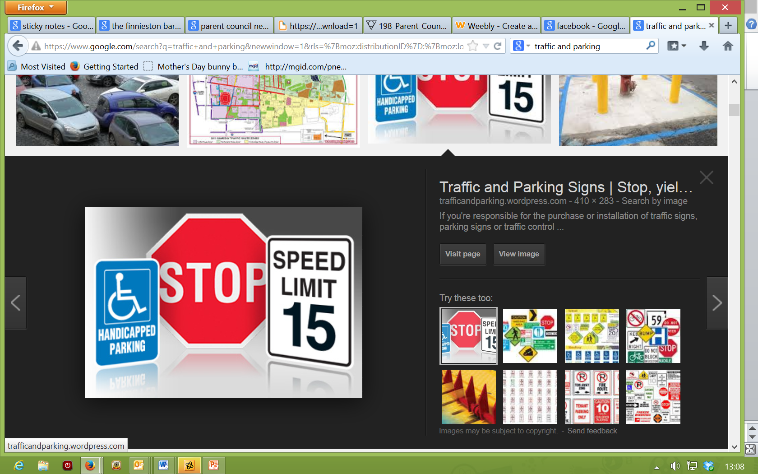
TRAFFIC AND PARKING AT OUR LADY OF THE MISSIONS

Our Lady of the Missions Parent Council – Traffic Bulletin - December 2014

SHOW YOU CARE – PARK ELSEWHERE

Please ask yourself the following – answer honestly!

Do you park:
- In or at the entrance of the (clearly marked) “staff parking only” car park at the junior department (or drop off in this vicinity), endangering children at the crossing?
- Around the bottom of Berryhill Drive/corner of Arden Drive or in /around the entrance to the Pavillion car park causing severe blockages and endangering children crossing?
- In the (clearly marked) “drop off – only” zone in the main car park, causing tailbacks and delays for other parents/carers and staff?
- Past the “no parking beyond this point” sign in the Woodfarm Pavillion car park, just to get a few feet closer to the school gate?
- On the access road to the Woodfarm cages car park (despite bollards being put up to prevent this) so that cars can’t get in or out?
- On the corner of Inglestone Avenue / Woodfarm Road or in the (clearly marked) “Keep clear” turning point outside the Junior Dept gates or across driveways in this area, all causing dangerous congestion where children cross and complaints about our school from residents?
If any of sounds familiar, here are another few things to think about:

- Do you have relatives / friends / child minders who pick up your children and may have no idea about the improvements we are encouraging to keep your children safe (unless you tell them of course...)
- Do you think staff time patrolling car parks is well spent or would you rather they were able to focus on their real jobs?
- Do we need an accident to shake things up or can we try harder to prevent this and show more courtesy to the rest of the school community?
The vast majority share our frustration. Everyone has commitments that can make the school run a challenge. Many would love to park as close as possible to the school but don’t because they appreciate the consequences and do not prioritise their convenience over safety and courtesy to others. However, if any of these questions ring an alarm bell for you then please think again....and don’t do it.

INCLUDEPICTURE "https://encrypted-tbn0.gstatic.com/images?q=tbn:ANd9GcThRQNEN072ddSgeahSxvLOMuv9D0dqjAfgLOPLE-P1tJAejUwhyw" \* MERGEFORMATINET 
INCLUDEPICTURE "https://encrypted-tbn0.gstatic.com/images?q=tbn:ANd9GcT8zxwVeYudi9XKtrkbUhMHkcHBqiiP62SewhIJsqneA-_5Znaa" \* MERGEFORMATINET 

