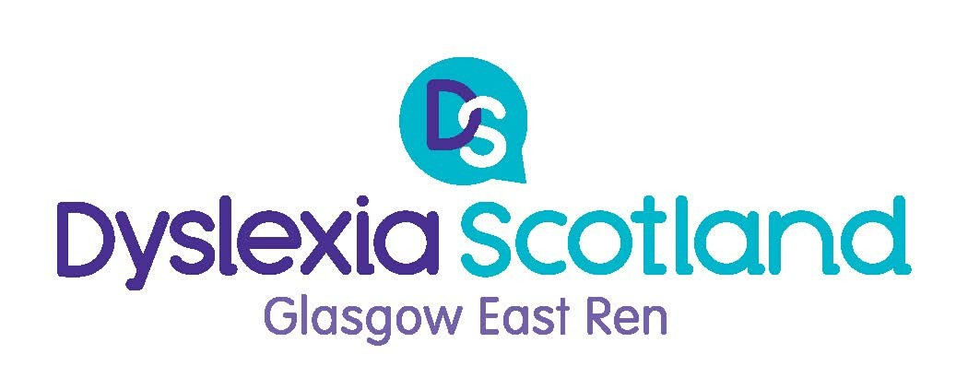

CALL Scotland

How technology can assist with learning

Accessibility & learning tools on iPad and Windows devices to support people with dyslexia
Suitable for all ages - you may want to bring along your iPad to work through some demonstrations.
Tuesday 28th January
7-8.30pm Mearns Castle High School
Waterfoot Road, Newton Mearns, G77 5GU
Dyslexia Scotland Helpline 0344 800 8484 helpline@dyslexiascotland.org.uk
Charity No: SC 000951 Reg No: SC:153321

