

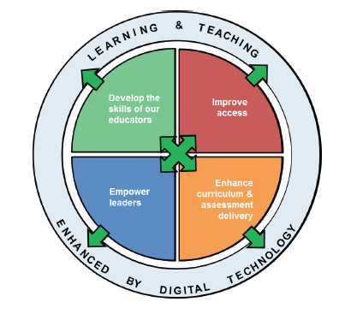

**A Strategic Overview of Digital Technologies**

**At Netherlee Primary School**

**References**

* **Enhancing learning and teaching through the use of Digital Technology: A digital Learning and Teaching Strategy for Scotland**
* **Cyber Resilience Strategy for Scotland**
* **Curriclum for Excellence: Technologies Experiences & Outcomes**

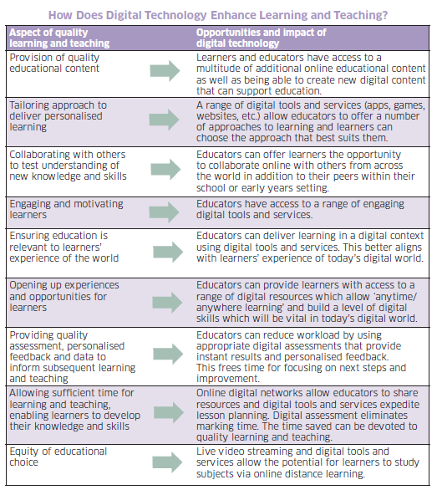

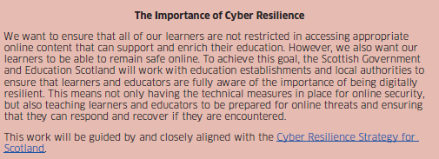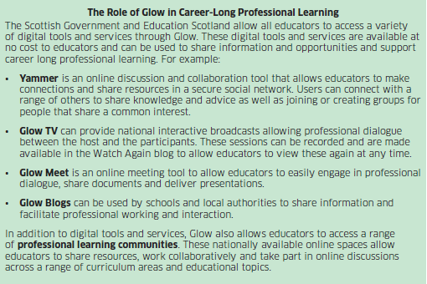

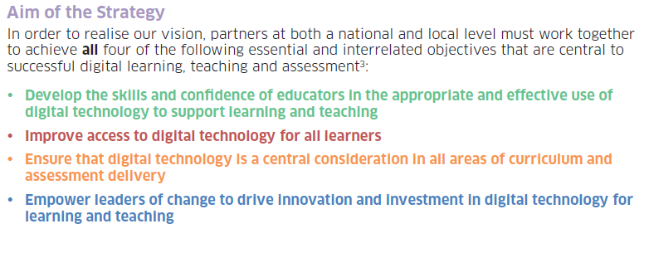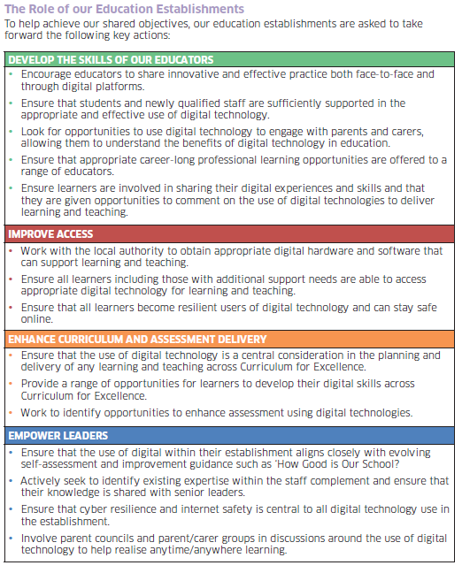

<http://www.gov.scot/Publications/2016/09/9494>

**Use of Glow in Netherlee Primary School**

**This grid outlines the skills taught through the use of glow and shows the linked experiences and outcomes.**

|  |  |  |  |
| --- | --- | --- | --- |
|  | Skills | E’s & O’s |  |
| **Log in to glow**  **Primary 4,5,6 & 7** | * Using password * Using a username * Changing a password to make it strong * Adding apps to Launchpad * Navigating between different launch pads * Searching for apps |  | |
| **Office 365**  **Primary 4,5,6 & 7** | * Adding Office 365 to Launchpad * Personalising settings theme * Accessing the ‘waffle’ * Navigating between different open tabs * know how to install Office through glow account * Access and use Immersive Reader * Use of Powerpoint, Word and excel |
| **Sway**  **Primary**  **4, 5, 6 & 7** | * Open new sway * Insert heading card * Insert text card * Insert video card * Insert image card * Insert embed card * Insert a web link * Create stacks or slideshows within sway * Change design * Change layout * Share sway using copied link * Share sway using mail * Share sway on yammer * Share sway with others and as read only or in edit mode |  | |
| **Yammer**  **Primary 6 & 7** | * Accept yammer usage policy * Search for group * Request to join group * Create new group * Use setting to create private group * Leave group * Remove users from group * Send private messages * Share sways and links * Change profile picture * Change group theme * Navigate between groups * Create new posts * Edit posts * Delete posts * Create a poll * Use the Praise feature * Follow pupils and teachers * Clear inbox * Clear notifications * Access network usage policy |  | |
| **Forms**  **Primary 4,5,6,& 7** | * Create new form or quiz * Use question choice appropriately e.g. text, multiple choice or rating * Use ‘what is your name? for first question * Insert images to title and questions * Add theme * Preview in computer and mobile mode * Assign points to questions * Assign correct answers option * Use long answer button * Use required button * Share form via QR code * Share form with copied link * Share form with embed code * Embed form into a sway * Analyse results data |
| **Mail**  **Primary 6 & 7** | * Access mail from waffle * Check mail * Read mail * Delete mail * Send mail * Send attachments * Send links * Search the directory for recipient * Mark as read |  | |

|  |  |  |
| --- | --- | --- |
| **Cyber Resillience**  **All Stages** | * Read and discuss Yammer usage policy * Create Sway/poster/presentation on internet safety rules * Using Yammer responsibly * Adding Report a Glow Concern to Launchpad * Contributing to Class workshops * National Safer Internet Day * Regular and routine across the curriculum |  |
| **Teams**  **Primary 7** | * Create content * Collaborate with others * Access Content * Share content |  |

|  |  |  |  |  |  |  |  |  |  |  |  |
| --- | --- | --- | --- | --- | --- | --- | --- | --- | --- | --- | --- |
| **Nursery**   * Understand that the internet can be used to find information * Know main features of a computer * Recognise navigation features, e.g. Home * Solve simple problems (ACTIVinspire, 2simple, websites, CDs) * Use tools to add simple text * Interact with others * Capture images *Record sound * Understand and use navigation terms *Use navigation symbols * Apply knowledge of navigation using electronic games, remote control toys and programmable toys. | | | | | | | | | | | |
| Primary 1 | General ICT skills | Computer hardware | Presentation Media  Tuxpaint  ACTIVinspire | Word processing  (Microsoft Word) | Web Research  (Curriculinks & Bookmarks) | Digital Technology Skills (Beebot, cameras, ipads) | Programming/coding  (see significant aspects grid) | Use of apps for digital literacy, digital story writing etc. |  | | |
| Primary 2 | General ICT skills | Computer Hardware | Word Processing  (Microsoft Word) | Presentation Media  Microsoft PowerPoint/ActivInspire | Web Research (Search Engines) | Digital Tech.  Ipads  Digital cameras | Programming/coding  (see significant aspects grid) | Use of apps for digital literacy, digital story writing etc. |  | | |
| Primary 3 | General ICT skills | Computer Hardware | Word Processing (Microsoft Word) | Presentation Media  (Microsoft PowerPoint)  ActivInspire | Web Research (Search Engines) | Digital Tech.  Cameras  ipads | Animation  Apps- stop motion etc. | Spreadsheets  (Microsoft Excel) | Email | Programming/coding  Kodu  (See significant aspects grid) | |
| Primary 4 | General ICT skills | Computer Hardware | Word Processing (Microsoft Word) | Desktop Publishing  (Microsoft Publisher) | Presentation Media  (Microsoft PowerPoint)  ActivInspire | Web Research (Search Engines) | Digital Tech.  Glow  Office 365 (word, sway, PPoint, forms) | Digital Music | Spreadsheets (Microsoft Excel) | Email | Coding  Kodu  (See significant aspects grid) |
| Primary 5 | General ICT skills | Computer Hardware | Word Processing  (Microsoft Word) | Desktop Publishing  (Microsoft Publisher) | Presentation Media  (Microsoft PowerPoint)  ActiveInspire | Website Design | Digital Tech.  Glow  Office 365 (word, sway, PPoint, forms) | Moviemaker  Photostory | Spreadsheets (Microsoft Excel) | Email | Coding  Hour of Code.org  Kodu  Ipad apps |
| Primary 6 | Blogging | Computer Hardware | Coding  Scratch | Desktop Publishing  (Microsoft Publisher) | Presentation Media (Microsoft PowerPoint)  Activinspire | Digital Literacy | Digital Tech.  Glow  Office 365 (word, sway, PPoint, forms, excel, mail, yammer, onedrive) | | |  | |
| Primary 7  Curriculum Map | General Word, Publisher & PowerPoint skills | Computer Hardware | Coding  Scratch | 3D Modelling/design  Google Sketch Up | App Design | Digital Tech.  Glow  Office 365 (word, sway, PPoint, forms, excel, mail, yammer, onedrive) | | |  | | |

|  |  |  |
| --- | --- | --- |
| **Programme of Work** | **Progression of Learning**  Primary 1 | Primary 1 |
| General ICT Skills | * Logging on and off * Closing a window/Software package * Functions of a keyboard (spacebar, enter/return, backspace, begin using Shift key) * Double click mouse to open software packages * Print and Save using on-screen buttons | Primary 1 |
| Computer Hardware | * Name and identify hardware (mouse, monitor, keyboard, CPU) | Primary 1 |
| Presentation Media | Tux Paint (or similar)   * Use tools to add text/graphics   ACTIVinspire   * Use pen, text, eraser, change colour, fill, create shape and undo | Primary 1 |
| Word Processing | Microsoft Word   * Open document * Type text * Delete text * Use Caps Lock/Shift key * Use the toolbar to change font, size, style and colour * Close document * Select ‘Save’ or ‘Don’t Save’ when closing document * Use ‘Print’ icon | Primary 1 |
| Web Research | Curriculinks   * Double click on Internet Explorer * Choose website from favourites (teacher directed) | Primary 1 |
| Glow | * Select Glow from Home Page * Type username and password * Log off | Primary 1 |
| Digital Technology | Beebots   * Understand and use symbols for navigation * Apply knowledge of navigation in a problem solving context   Digital Cameras/ipads   * Safe use * Capture and display an image * Capture and play a video   Ipads   * Unlock ipads with unlock code * Swipe to navigate * Access camera to take photos * Access video to take video * Access apps and navigate * Press power switch to turn off * **Notifications awareness-always show the teacher when a notification pops up** * **Press cross on any pop ups within apps**   Talking Photo Albums/Talking Tins   * Record sound to communicate experience |  |
| Programming | * Use a simple app or online programme to program a basic game   Introductory lesson-RECOMMENDED  <https://www.kodable.com/hour-of-code/lessons/lesson_beginner_kindergarten>  or flipchart on glow-technologies/p1 sharing folder | Primary 1 |

|  |  |  |
| --- | --- | --- |
| **Programme of Work** | **Progression of Learning**  Primary 2 | **Resources** |
| General ICT Skills | * Switch on, log on and log off * Resizing windows (Minimise, maximise and move) * Scroll up and down using mouse and on-screen bar * Discuss drop down menus and begin to use File, Edit & Insert * Use esc button to exit programmes |  |
| Computer Hardware | * Name and identify hardware (mouse, monitor, keyboard, CPU) |  |
| Presentation Media | Microsoft PowerPoint   * Locate PowerPoint through start menu/Double click icon to open * Add text * Format colour, style, size and font of text * Insert 🡪 New Slide * Insert ClipArt * View Slideshow using icon * Use keyboard and mouse to navigate through slideshow   ACTIVinspire   * Use pen, format text, eraser, change colour, fill, create shape and undo * Switch between user profiles – Language and Maths |  |
| Word Processing | Microsoft Word   * Highlight text * Use Edit to select all, copy and paste * Keyboard shortcuts (copy and paste) * File 🡪 Print * Insert ClipArt * Insert WordArt through drop-down menu and icon * Format ClipArt and WordArt (use text wrapping/dog icon to make image tight) |  |
| Web Research | Curriculinks   * Double click on Internet Explorer * Type in teacher-led search criteria * Select website from list * Navigate around website |  |
| Glow | * Select Glow from Home Page * Type username and password * Enter landing pages * Navigate to teacher-led resource, e.g. TigTag * Log off |  |
| Digital Technology/  programming | Programmable Toys-beebots   * Understand and use symbols for navigation * Use programmable language * Apply knowledge of navigation in a more complex problem solving context * Play online navigation games   Digital Cameras  Primary 2   * Safe use * Capture and display an image * Capture and play a video   ipads   * Unlock ipads with unlock code * Swipe to navigate * Access camera to take photos * Access video to take video * Access apps and navigate * Press power switch to turn off * **Notifications awareness-always show the teacher when a notification pops up** * **Understand the word ‘share’ on apps and know not to tap share.**   access apps, navigate through apps  Talking Photo Albums/Talking Tins   * Record sound to communicate experience   Kindles   * Switch on and off * Locate book   Coding  **Kodable**- when using computers. Teacher needs to register and create class code for pupils to access. The same code can be used on the app on the ipads. Lesson plans can also be found on the website  **Daisy the Dinosaur**- simple app, continued from P1, on ipads | * **Hour of Code**- select age-appropriate activity * <https://hourofcode.com/uk/learn> * **Codes Spark Academy**-The Foos (ipad) * **Box Island (ipad)-**create your own character and for new player, delete one and then create new nickname * **Daisy the Dinosuar** (on ipads) * **Kodable** (on ipads-class code required) * <https://game.kodable.com/hour-of-code> |

|  |  |  |
| --- | --- | --- |
| **Programme of Work** | **Progression of Learning**  **Primary 3** | **Resources** |
| General ICT Skills | * Create a folder in My Documents (right-click or drop-down File menu) * Save to a folder in My Documents * Save to different locations, e.g. USB * Retrieve files from My Documents * Retrieve files from different locations, e.g. USB * Viewing Toolbars in Microsoft Office * Use Search to find a document or application * Move between two open applications, e.g. Word and Internet Explorer * Copy and paste an image from internet * Formatting an image using text wrapping * Save an image from internet to My Documents * Use tab key * Navigate around a website, e.g. Home, Main Menu, Start… |  |
| Presentation Media | Microsoft PowerPoint   * Use Slideshow🡪Custom Animation to add effects and sounds * Use Format drop-down menu to change layout, slide design and background   Visualisers   * + Open software   + Align document underneath   + Zoom In and Out   + Capture images   + Use hand tool to move image   ACTIVinspire   * Use pen, format text, eraser, change colour, fill, create shape and undo * Switch between user profiles – Language and Maths * Use browser to insert background/objects * Insert text boxes |  |
| Word Processing | * Create a table using Table drop-down menu * Use tab key, arrows and mouse to navigate around cells * Move a table * Resize a table * Format font etc. within a table * Insert and format a picture within a table * Begin to use Table toolbar |  |
| Web Research | * Type in search criteria * Use the word ‘kid’ for child-friendly search * Understand the order of results * Understand order of words in a search * Type in web address * Select website from list * Navigate around website * Review similar websites (Efficiency, Effectiveness and Enjoyment) |  |
| Glow | * Select Glow from Home Page * Type username and password * Enter landing pages * Navigate to teacher-led resource, e.g. TigTag * Log off |  |
| Digital Technology | Digital Cameras   * Safe use * Capture and display an image * Capture and play a video * Begin to download images/videos from a camera   ipads   * Unlock ipads with unlock code * Swipe to navigate * Access camera to take photos * Access video to take video * Access apps and navigate * Review apps * Press power switch to turn off * **Notifications awareness-always show the teacher when a notification pops up** * **Understand the word ‘share’ on apps and know when to tap any share options.** * **Close tabs on the internet**   Kindles   * Switch on and off * Locate book   ActivExpression   * Be able to use activExpression devices with teacher led flipcharts. |  |
| Animation | * ipad Animation apps |  |
| Spreadsheets | Microsoft Excel   * Search for and open Excel application * Type text into a cell * Format font, style, size and colour of text * Highlight text * Use Chart Wizard to create Bar Charts * Format graph |  |
| E-mail | * Open Microsoft Outlook * Open an email * Reply to an email * Exit Microsoft Outlook |  |
| Coding | * **Kodable**- when using computers. Teacher needs to register and create class code for pupils to access. The same code can be used on the app on the ipads. Lesson plans can also be found on the website | * <https://game.kodable.com/hour-of-code> * **Hour of Code**- select age-appropriate activity * <https://hourofcode.com/uk/learn> * Lightbot- on ipads |

Primary 3

|  |  |  |  |  |
| --- | --- | --- | --- | --- |
| **Programme of Work** | **Progression of Learning**  **Primary 4** | | **Resources** | |
| General ICT Skills | * Create a folder in My Documents (right-click or drop-down File menu) * Save to a folder in My Documents * Save to different locations, e.g. USB * Retrieve files from My Documents * Retrieve files from different locations, e.g. USB * Viewing Toolbars in Microsoft Office * Use Search to find a document or application * Move between two open applications, e.g. Word and Internet Explorer * Copy and paste an image from internet * Formatting an image using text wrapping * Save an image from internet to My Documents * Use tab key * Navigate around a website, e.g. Home, Main Menu, Start… * Insert Hyperlink | |  | |
| Presentation Media | Microsoft PowerPoint   * Insert File * Insert Hyperlink * Further explore Format drop-down menu * Use Slideshow drop-down menu to add action buttons and change transition * View show using shortcut * Select and use pointer tool when viewing slideshow   Primary 4  Visualiser   * + Regular and routine use   ACTIVinspire   * Regular and routine (from P3 skills) * Use expresspoll in a presentation * Insert weblink into flipchart presentation | |  | |
| Word Processing | * Create a table using Table drop-down menu * Use tab key, arrows and mouse to navigate around cells * Move a table * Resize a table * Format font etc. within a table * Insert and format a picture within a table * Begin to use Table toolbar | |  | |
| Web Research | * Type in search criteria * Type in web address * Select website from list * Navigate around website * Review similar websites (Efficiency, Effectiveness and Enjoyment)   Web Research Skills   * Use different search criteria and symbols * Awareness of trustworthy sources, e.g. BBC, Museums, .org .gov etc. | |  | |
| Glow | * Select Glow from Home Page * Type username and password * Use Launchpad to add and access apps * Access Office 365 (see separate planner) * Log out of all open windows. | |  | |
| Digital Technology | Digital Cameras   * Safe use * Capture and display an image * Capture and play a video * Begin to download images/videos from a camera   Tablets   * Access apps * Navigate around app * Capture images and videos * Begin to edit images and videos   Kindles   * Switch on and off * Locate book   iPads   * Regular and routine | |  | |
| Desktop Publishing | Microsoft Publisher   * Search and for open Publisher application * Select a design template, e.g. invitation * Format and manipulate text * Use shift key to group and move | |  | |
| Spreadsheets | Microsoft Excel   * Search for and open Excel application * Type text into a cell * Format font, style, size and colour of text * Highlight text * Use Chart Wizard to create Bar Charts * Format graph | |  | |
| E-mail | * Open Microsoft Outlook * Open an email * Reply to an email * Exit Microsoft Outlook | |  | |
| Digital music |  | * Apps on iPads | |  | |
| Coding |  | * Kodu * Open software on desktop * Create a new world * Add Kodu * Personalise Kodu * Add other objects * Add land/water * Program Kodu to eat/move/bump object   (**Use Pathway for progression-to be continued in P5)** | | <https://www.youtube.com/watch?v=nKIu9yen5nc>  Use this clip to introduce coding  Tutorials on Kodu online and in application  Pathway for skills progression (1 for each child for assessment) on glow technologies/p4/shared folder  Kodu Booklet- on glow-same location as above | |

Primary 4

|  |  |  |
| --- | --- | --- |
| **Programme of Work** | **Progression of Learning**  **Primary 5** | **Resources/Activities** |
| General ICT Skills | * Regular and routine |  |
| Word Processing | Microsoft Word   * Split and merge cells in a table * Spelling and grammar checks * Change text direction * Bullet points and numbering * Add header and footer * Continue to use AutoShapes * Use tab bar to change rulers * Insert columns * Format paragraphs * Use border and shading |  |
| Desktop Publishing | Microsoft Publisher   * Revise P4 skills * Open a new blank publication * Insert and manipulate text and pictures * Insert and use guides * Select objects and change border and fill colours * Use AutoShapes and drawing tools * Group objects * Rotate and flip |  |
| Presentation Media | Microsoft PowerPoint   * Insert Chart * Insert Diagram * Insert ‘Record Sound’ * Add Notes * Change order of slides * Print presentation as handout – change slides per page   Visualiser   * Regular and routine use   ActivInspire   * Regular and routine * Use a wider variety of tools |  |
| Website Design | * Use software to design and produce a website (not live) |  |
| Digital technology | Cameras   * Upload an image/video to another device * Edit image/video on other device   Kindles   * Access   iPads   * regular and routine   ACTIVExpression Devices   * regular & routine |  |
| Moviemaker/I-Movie  Photostory | * Upload video and images on to programme * Change animations * Change Visual Effects * Add audio * Set start and end points * Change themes * Insert text * Change durations * Change music tools * Use video tools * Save to Onedrive on glow * Locate and open on computer * Create new * Import photos * Add sound, effects, text appropriate to presentation |  |
| Spreadsheets | Microsoft Excel   * Insert simple functions using symbol keys and drop-down menu where appropriate * Use Chart Wizard to create different types of charts |  |
| E-mail | * Attach a document to an e-mail and send * Open an attachment in an e-mail and save * Use Send To 🡪 Mail recipient by right clicking on a file to e-mail |  |
| Coding | * Add more objects and characters to a world * Explore action commands and use to develop a simple game | Tutorials on Kodu online and in application  Pathway for skills progression (1 for each child for assessment) on glow technologies/p4/shared folder  Kodu Booklet- on glow-same location as above  Apps on iPad  Hour of code website |
| Glow | * Select Glow from Home Page * Type username and password * Use Launchpad to add and access apps * Access Office 365 (see separate planner) * Log out of all open windows. |  |

Primary 5

|  |  |  |
| --- | --- | --- |
| **Programme of Work** | **Progression of Learning** | **Resources** |
| General ICT Skills | * Regular and routine |  |
| Desktop Publishing | Microsoft Publisher   * Continued use across curriculum |  |
| Presentation Media | Microsoft PowerPoint   * Continued use across curriculum   Visualiser   * Regular and routine use   ActivInspire   * Regular & Routine |  |
| Spreadsheets | Microsoft Excel   * Continued use across curriculum |  |
| Digital Literacy | * Use all previous skills (Garageband, MovieMaker, Apps, etc.) to plan, create and produce a digital story. | Inanimate Alice  Literacy Shed  Shared Resources |
| Coding | * Introduction to Scratch | * Resources on glow in Technologies/P6 sharing folder   -Puff collector  -Maze collector  -Block Breaker  Save onto your class folder so that pupils can access pdf’s as they work on scratch.   * Apps on ipads |
| Website Design | * Use software to design and produce a website (not live) |  |
| Blogging | * Create a blog on glow (regular & routine) |  |
| Glow | * Select Glow from Home Page * Type username and password * Use Launchpad to add and access apps * Access Office 365 (see separate planner) * Log out of all open windows. |  |

**Primary 6**

|  |  |  |
| --- | --- | --- |
| **Programme of Work** | **Progression of Learning** | **Resources** |
| General ICT Skills | * Regular and routine |  |
| Mind Mapping  Desktop Publishing  Presentation Media  Spreadsheets  Word Processing  Web Research  Digital Technology  Email | * Regular and routine |  |
| Coding | * Develop own game using Scratch * Use Scratch to code * Further explore programming software |  |
| 3D Modelling | * Use software/app to create a product that could be manufactured/design a building (google sketch up) |  |
| App Design | * Investigate use of apps * Explore three Es – Effective, Enjoyable, Efficient * Compare apps using the three Es * Investigate inclusive design * Create a mind-map for the design of a new app * Use a presentation package, e.g. PowerPoint, to create a prototype of app (screen shots) * Explore marketing of app (in app purchases/add-ons/advertising) * Plan and design product for app – maximise marketing opportunities (characters, viral advert, jingle/song, merchandise, accessories) * Present using all available digital technology |  |
| Glow | * Select Glow from Home Page * Type username and password * Use Launchpad to add and access apps * Access Office 365 (see separate planner) * Log out of all open windows. |  |

**Primary 7**

[Type a quote from the document or the summary of an interesting point. You can position the text box anywhere in the document. Use the Drawing Tools tab to change the formatting of the pull quote text box.]

All resources are available through the staffroom on glow. All contexts/programmes of work are updated regularly in line with new digital developments and advances.