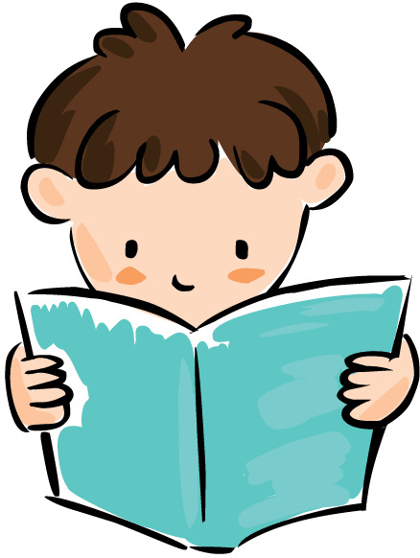

**Neilston Primary School**

**What if my child struggles or is a reluctant reader?**

Some children do not find reading easy. They struggle to read words or to understand the meaning. Children develop at different rates and it may be that in time and with appropriate support your child will become an accomplished reader.

If your child is a reluctant reader the following may help:

* Try not to worry as your tensions will pass on to your child.
* Follow your child’s interests. Whatever their interests, there will be something out there to grab their attention while also improving their reading skills.
* Be crafty- ask them to read the recipe for something you’re cooking or information from a newspaper. All reading helps!
* Read to your child in a relaxed, cosy setting; Make it a pleasant, special one to one experience.
* Share books with them - you read a page ask your child to read a page. Some children and parents carry on reading together for years which is great and should be encouraged.
* Allow your child to read books which are easy to build their confidence then gradually move to more challenging material when your child is ready.
* If your child has a busy social life, allow them to read for 15 minutes before going to sleep.
* Let your child see you reading and enjoying books.

**Into the Future**



Reading can be a wonderful, relaxing experience and can open up a whole new world for our children. Even in this technological age we need to be able to read, and read a variety of styles and texts. As parents and teachers we must help our children to become accomplished readers but we also want then to enjoy the experience so that they can forward into the world with confidence and a skill for life!

Happy Reading!

**Developing Reading**

**at**

**Second Level**

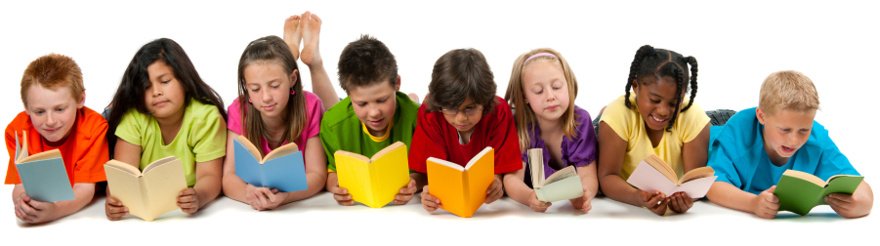



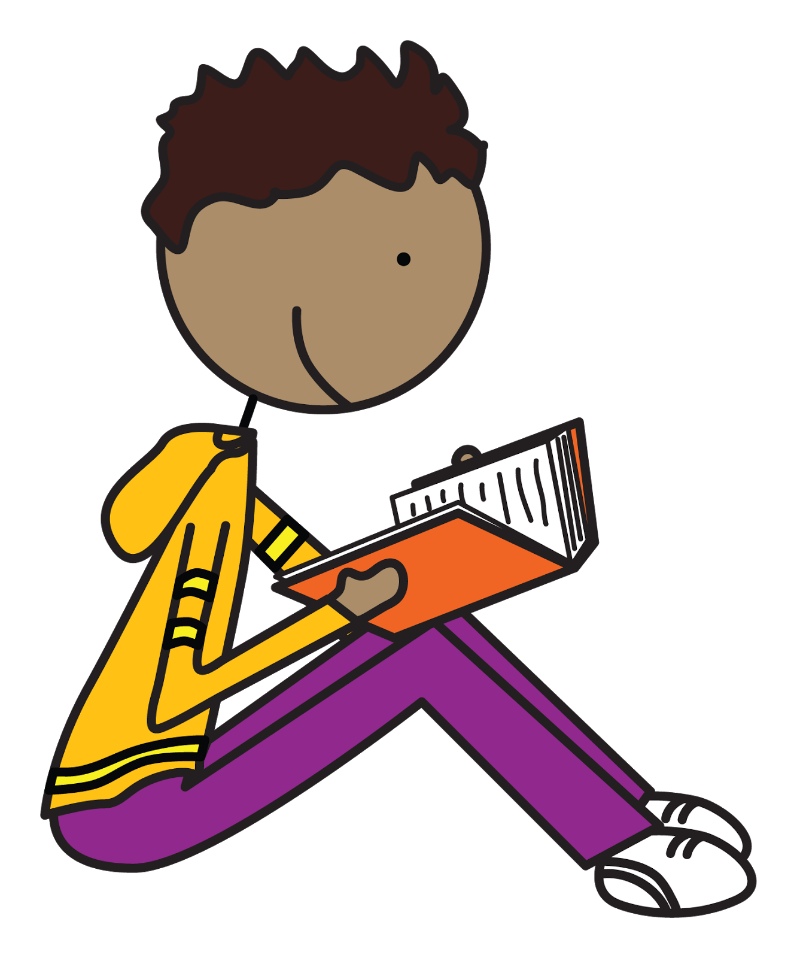

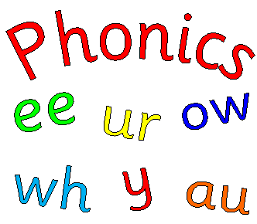

**Range of Reading**

As children get older they are expected to read a wide range of both fiction and non-fiction material.

Fiction: Adventure, Historical, fantasy, Science Fiction, Mystery, Horror, Myths and Legends

Non-Fiction: Newspapers and Magazines, Diaries, Journals, Biographies and Autobiographies, Letters, Leaflets, Signs and Posters

**Reading Skills**

For your information some of the reading skills being developed at school are:

**Literal Comprehension**

Understanding the stated information in a passage.

**Scanning**

Read quickly and accurately to find a specific word or information.

**Skimming**

Read quickly to get the gist of what the text is about.

**Prediction**

Discuss what might happen next or how the story might end.

**Character Analysis**

Look closely at the main characters, their appearances, actions, personalities, temperament and emotions.

**Sequencing**

Understanding that events can be ordered in time sequence. The ability to discuss the story in time sequence and in your own words.

**Genre**

Identify different types of text.

**Main Idea**

Identifying the main theme and important ideas in the text. The ability to express the main ideas in your own words.

**Using Contextual Clues**

Reading round about unknown words to deduce meaning.

**Cause and Effect**

Discuss what effects one character or one event has upon another.

**Inference**

Understanding that some information may be implied rather than explicitly stated. The ability to read between the lines.

**Fact and Opinion**

The ability to distinguish between the two.

**Evaluating**

Recognising, appreciating and making judgements on the author’s writing skills.

**Introduction**

Reading opens the door to learning and to the world. It underpins everything we do and is essential to everyday life. In order to survive, we need to be able to read instructions, signs, and safety information as well as reading for pleasure. Reading happens in school in all curricular areas, whether it is reading instructions from the whiteboard, information from the internet or during library visits where the children can read for enjoyment using audio books, kindles and traditional books.

By the time children reach second level most of them can read, many read fluently. Our job is to further improve their reading skills by developing higher order reading skills; to increase the range of texts our children read and to foster a lifelong love for reading and books.

**Successful readers use many strategies to help them understand a text.**

* Phonic (sounds and spelling)
* Grammatical knowledge
* Knowledge of punctuation
* Word recognition and graphic knowledge
* Knowledge or context
* Knowledge of spoken language

Children working within second level have been taught and use most of these strategies. At second level we build on these and develop high order reading strategies which we will now outline.

**Ways to help your child with Reading**

Children have very busy lives today and reading sometimes gets forgotten. However, even if children can read fluently it is still important that they read daily. It is a great help if parents can encourage their children to read – even if it is only for 15 minutes a day – and discuss aspects of the book with them. Show children that you value reading, let them see you reading, share books with them. Encourage them to read a wide range of texts from a variety of authors.