**Neilston Primary School**

**Paired Reading**

This is a great way to help your child with reading and can be done with any book (library books, non-fiction etc.)

* Allow your child to choose the book with a little direction.
* A short period of time – 10 -15 minutes daily.
* Sit in a quiet area, side by side.
* Discuss the title of the book and the pictures before reading.
* Read the story together, pointing at the words as you and your child read. If your child is, or as they become more confident, allow them to read on their own.
* If a mistake is made, gently tell your child the correct word, but make sure you keep the story going.
* Use lots of praise and encouragement.
* If your child gets bored with his/her choice of book then change it.

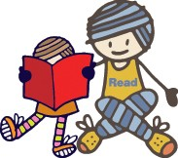

**Developing Reading**

**at**

**First Level**

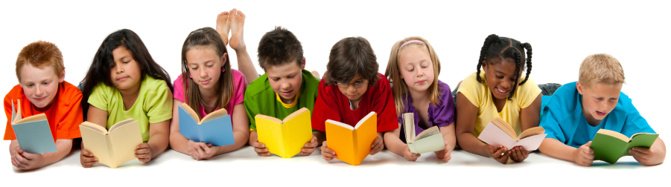

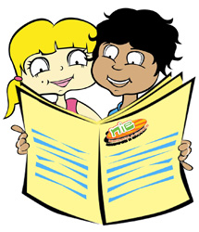

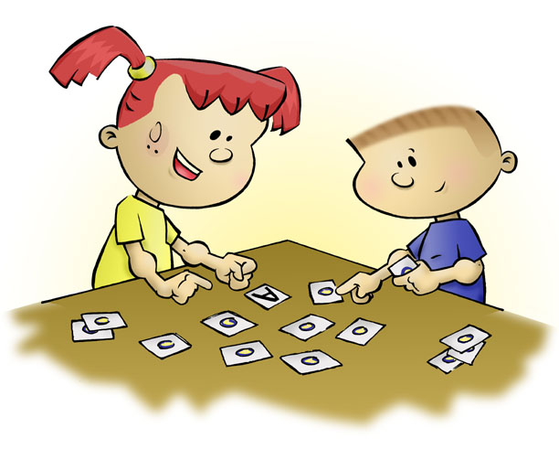

**Reading Skills**

For your information some of the reading skills being developed at school are:

**Literal Comprehension**

Understanding the stated information in a passage.

**Scanning**

Read quickly and accurately to find a specific word or information.

**Skimming**

Read quickly to get the gist of what the text is about.

**Prediction**

Discuss what might happen next or how the story might end.

**Character Analysis**

Look closely at the main characters, their appearances, actions, personalities, temperament and emotions.

**Sequencing**

Understanding that events can be ordered in time sequence. The ability to discuss the story in time sequence and in your own words.

**Genre**

Identify different types of text.

**Main Idea**

Identifying the main theme and important ideas in the text. The ability to express the main ideas in your own words.

**Using Contextual Clues**

Reading round about unknown words to deduce meaning.

**Cause and Effect**

Discuss what effects one character or one event has upon another.

**Inference**

Understanding that some information may be implied rather than explicitly stated. The ability to read between the lines.

**Fact and Opinion**

The ability to distinguish between the two.

**Evaluating**

Recognising, appreciating and making judgements on the author’s writing skills.

Discussing reading with a child and developing the above skills will enable your child to become a thinking reader.

**Talking and Listening**

The most effective way of helping your child is through talking and listening. This can be done in an enjoyable way through various games, and the language skills gained from playing these games cannot be underestimated. Talking and listening is part of literacy and of almost everything we do. Ensuring that you spend time talking and listening will help your child to build an understanding of words and the use of language and communication.

**Ideas for games**

* There are many good board games that you can play which will help develop reading skills as well as memory skills
* Crosswords and word searches
* Quiz books
* Encourage your child to be imaginative and tell you stories about things that have happened during the day. Show that you are interested and take time to ask questions.

**Reading outside of the home**

* Have fun reading shop signs, labels on items in the supermarket, the menu in the restaurant and mail that comes through the door. Your child will start to recognise words that they see regularly.
* Make looking at books, magazines, comics or newspapers part of your daily routine, for example reading a newspaper at home or the notice board in the doctor’s surgery. This will help your child to understand what different texts can be used for.
* Visits to libraries and museums or other places of interest are also good.

**Reading**

At all times it is important to widen your child’s vocabulary by encouraging them to read a variety of texts e.g. Novels, magazines, newspapers and comics.