2016-2017

Eastwood Cluster Development Plan

Working together to Aspire, Drive and Excel

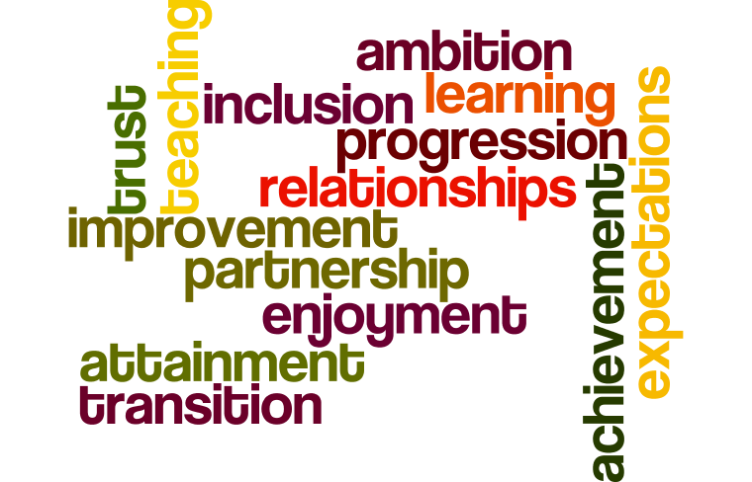

EHS – 3 Year Plan

Year 1 | Year 2 | Year 3
Numeracy and Maths | Numeracy and Maths | Numeracy and Maths
Literacy and Language  - Moving Images | Literacy and Language | Literacy and Language
Health and Wellbeing  - Science (transitions)  - BECS (transitions) | RME | Transitions
Maximising Attendance | Social Studies | Science
ELCC | Modern Languages | Expressive Arts
DYW | DYW | DYW
GLOW | Health and Wellbeing (progression) | Technology
HGIOS4 Self- Evaluation | HGIOS4 Self- Evaluation | HGIOS4 Self- Evaluation

Leadership and Management
How good is our leadership and approach to improvement?
Quality Indicator | Themes
1.1 Self-evaluation for self-improvement | - Impact on Learners’ Successes and Achievements
1.2 Leadership of learning | - Professional engagement and collegiate working  - Impact of career-long professional learning
1.3 Leadership of change | - Developing a shared vision, values and aims relevant to the school and its community
1.4 Leadership and management of staff | - Building and sustaining a professional staff team
1.5 Management of resources to promote equity

 | Outcome/ Impact | Action | Responsibility | Timescale | Resources | Monitoring/ Evaluation | GIRFEC | Capabilities
A | Senior leaders provide strong leadership that promotes and sustains our aspirational vision  All staff show commitment to the shared educational values of the cluster | - Share the draft vision for the cluster  - Consult with all stakeholders and review and adapt as appropriate  - Learners are supported to understand the vision aims and values through the four contexts for learning | All | Term 1 | Cluster Glow Site  Assembly Programmes | Staff, Pupil and Parent Feedback | Included | Community Engagement
B | Staff engage regularly in professional dialogue to  develop collective understanding  The cluster has a range of effective systems and  structures to facilitate regular collegiate working  Staff are confident in discussing how they have  improved their practice as a result of their  professional learning activities | - Share cluster Glow group at August in-service  - Rights Respecting School good practice guide  - Numeracy and Mathematics (fractions)  - Science  - Literacy and English (reading and talking & listening)  - Further develop cluster programme of CLPL opportunities in areas such as ICT and DYW and including CLPL Cluster Newsletter | CPD Coordinators  Education Officer – Assessment and Moderation  Moderation Facilitators | Term 1  Term 2 & 3 | Cluster Newsletter  Cluster Glow Site  LAR | Gateway  PRD Meetings  CLPL Evaluations  Moderation Event Evaluations | Achieving | Modernising The Way We Work
C | Staff will work to ensure that there is an Impact on learners successes and achievements | Our self-evaluation will focus on key aspects of learners’ successes and achievements to show clear evidence of improvement based on actions taken as a result of self-evaluation. All stakeholders, including children and young people, will have shared ownership of this evidence and use it to plan continuous improvement | Head Teachers  Depute Head Teachers  PTs | On-going | HGIOS4 | CMG Meetings  Minutes from Cluster meetings | Included  Responsible  Achieving
D | Pilot Maximising Attendance Policy on a Cluster basis | Reduce Absence Statistics and manage staff absence more efficiently | CMG  Business Managers (TBC)  Donna Clark  Claire Shaw  Margaret Hay | Termly CMG | Time | CMG Meetings  Minutes from Cluster meetings

Learning Provision
How good is the quality of care and education we offer?
Quality Indicator | Themes
2.1 Safeguarding and child protection
2.2 Curriculum | - Learning Pathways
2.3 Learning, teaching and assessment | - Planning, tracking and monitoring  - Learning and engagement
2.4 Personalised support | - Universal support
2.5 Family learning | - Quality of family learning programmes
2.6 Transitions | - Collaborative planning and delivery
2.7 Partnerships | - Impact on learners

 | Outcome/ Impact | Action | Responsibility | Timescale | Resources | Monitoring/ Evaluation | GIRFEC | Capabilities
Literacy and English | Learning pathways support children and young people to build on their prior learning and ensure appropriate progression for all learners  Learning pathways are based on the experiences and outcomes and design principles of depth,  progression, coherence, breadth, personalisation and choice, challenge and enjoyment and relevance | - Implement and evaluate curriculum mapping to ensure consistent pace of learning whilst ensuring breadth, challenge and application across the BGE  - Talking and Listening – 3rd & 4th  - Reading Nov 16  - Formulate a curriculum map for Writing to ensure consistent pace of learning whilst ensuring breadth, challenge and application across the BGE. Sept 16  - Support Cluster Staff in the preparation of materials relating to the cluster moderation event (Writing, Talking and Listening and appropriate bundling of Es and Os). Cluster  GLOW materials for listening.  Nov 16  - Evaluate analysis of cluster motivation and attitude survey (2015-16). Formulate action plan based on evidence gathered and incorporate CLPL on Moving Image Education. Share on Cluster GLOW. | Catherine Dillon-Ruddy  Education Officer – Assessment and Moderation  Moderation Facilitators | Termly  November School Event  February Cluster Event  By June 2017 | Progression Frameworks  Advancing Excellence and Equity paper  £2400 for cover | Cluster Glow site  Minutes of meetings  School QA activities | Achieving | Data, Evidence and Benchmarking
Numeracy and Maths | Raising attainment of lowest performing 20% of pupils in the area of numeracy and mathematics  Parents and carers are supported to actively and  meaningfully engage in their children’s learning within the context of mathematics  Practitioners develop skills in implementing a CGI informed approach  Process of assessment and moderation helps to inform teacher judgements and next steps in learning. | Track pupils attitude and attainment in maths through questionnaires, assessments, teacher judgements and standardised test information.  To engage parents of the target group to enable them to support their children at home, including the wide range of strategies and incorporating the common language and methodology.  Practitioners plan problem solving approach informed lessons, implement and evaluate.  Assessment and Moderation of problem solving approach based lesson with identified Experiences and Outcomes, using the significant aspects of learning and progression framework. | F Loudon  Working Group  School improvement partnership  Moderation Facilitator | Aug ’16 – March ‘17  Nov ‘16  March ‘17  May ‘17 | Tracking Database  Progression Framework  Advancing Excellence and Equity paper  National Improvement Framework  £1200 for cover | A group of pupils will be tracked and monitored in each school across the cluster  Evaluation by parents following targeted work  Evaluation of strategies used and common language and methodology  Assessment and moderation led by moderation facilitator  Final Report | Achieving  Attaining  Attainment and Achieving | Data, Evidence and Benchmarking  Prevention  Community Engagement
Early Years | To raise attainment within Baseline Assessment and Developmental Milestones results in p1.  At key milestones, our assessments provide reliable evidence which we use to report on the progress of all children and young people. Our assessment evidence is valid and reliable  Parents and carers are supported to actively and  meaningfully engage in their children’s learning and life within Early Learning and Child Care and transitioning into primary1. | Audit strengths and development areas identified through current data from Baseline and Developmental Milestones.  Share good practice on:  - Alliteration  - Rhyme  - Counting and Matching  - Position of Number in a Sequence  - Gross and Fine Motor Skills  Plan and implement opportunities to engage families in learning  - BookBug  - Read Write Count  - Book Bags and Story Sacks  - Science Bags  - Rhyming Bags  - Woodland Explorers | Rosemary Crossan  Julie MacLaren | By Oct 2016  Oct 16-May 17  Oct 16-May 17 | Tracking Database  Progression Framework  National Improvement Framework  Working group key workers  Staff observations  £400 for resources  Parental feedback |  | Attaining | Data Evidence and Benchmarking  Prevention  Community Engagement
Transitions | Increased Opportunity for Active Learning in Science Es and Os to improve Skills Development  Consistent approach and recording and sharing of Transitions Information  To develop a partnership project with cluster primaries and secondary with a specific focus on improving problem-solving skills, using equipment and software and making connections between specialised skills within DYW | Science champions and PT Science EHS to identify and provide CLPL opportunities for Staff. A series of joint lessons delivery agreed and undertaken.  - Evaluate Transition Policy/Programme  - Share examples of good practice in Pastoral Notes  - Relevant Staff to attend CLPL when available  Within the context of the Micro:Bit (BBC) introduction to basic coding. Moderation be incorporated into the project  Inclusive cluster sports event – netball, hockey, football, badminton | Science champions and PT Science EHS  Cluster HTs | By June 2017 | Time for meetings and team teaching  EWH Cluster Transition Policy/  Programme  Children and Young People’s (Scotland) Act 2014  Cluster newsletter for CLPL  DYW implementation plan  £445  Funding Bid  Active Schools  Young Leaders | Transitions Working Group and CMG  Feedback  Evaluations | Achieving  Active | Modernising how We Work

Successes and Achievements
How good are we at improving outcomes for all our learners?
Quality Indicator | Themes
3.1 Ensuring wellbeing, equality and inclusion
3.2 Raising attainment and achievement | - Overall Quality of Learners’ achievement
3.3 Increasing creativity and employability | - Digital literacy  - Increasing employability skills

 | Outcome/ Impact | Action | Responsibility | Timescale | Resources | Monitoring/ Evaluation | GIRFEC | Capabilities
C | As learners move through their learning pathways they take increasing responsibility for ensuring they continue to add value to their achievements. | There is evidence that children and young people are applying and increasing their achievements through active participation in their local community.  Track achievements using the Tracking Database and the 4 Contexts for Learning. | CMG  Joe McCaig QIO | By June 2017 | Tracking Database | CMG meetings  Tracking database | Responsible  Achieving  Included | Digital  Data, Evidence and Benchmarking
DYW  B | Identify areas within cluster DYW provision requiring development in each school and across all schools  Increase the number and range of business partnerships in Cluster Schools  Enhance Skills for work development, such as problem solving, team work and leadership | Collate and analyse results from Cluster Audit undertaken in 2015/2016  Formulate action plan  Engage with West Hub and parents to secure al least one business partner for each school  Re-introduce and update the Cluster K’nex Challenge | S Maxwell  G Boyle  Cluster Working Group  Cluster Working Group  EHS Technical Dept | By Oct 2016  By April 2017  May 2017 | N/A  Posters (DYW)  West Hub  Updated K’nex Kits  £500  Printing Budget | Working Group  Working Group  Pupil Evaluations  Teacher Observations | Included, Active  Achieving  Respect  Responsible  A | Community Engagement Prevention  Maximising How We Work

Eastwood High School Cluster

Curriculum Development Audit

2011 | 2012 | 2013 | 2014 | 2015
Social Subjects | ICT | Science | Science | Science
 | RME | Technologies | GIRFEC | Transition
 | Writing |  | Assessment &  Moderation | Assessment &  Moderation
 |  | French | French | Motivation Reading
 |  | Listening & Talking | Listening & Talking | CGI – N&M

