*Designed by students and staff from Mearns Castle High School*

Friday 28th August 2020 Issue 20

Today’s weather: Generally dry with highs of 16 degrees

/,#

**The Mearns Times**

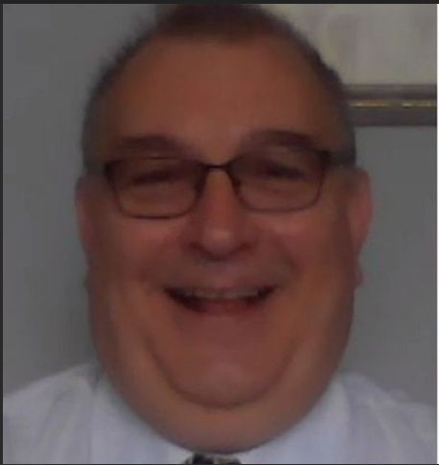

**EK DAD WINS LOTTERY**

Thrilled Graham Forrester has gone from life-saving surgery to a life-changing fortune after winning a share of £180,000 on People’s Postcode Lottery. The dad-of-five has recently been recovering at home following a heart bypass operation. But that didn't stop him jumping around the living room after being told of his £30,000 split of the windfall.

The 56-year-old said: "I was in the house with my son Lloyd, who is disabled and non-verbal, and I was jumping about the living room and Lloyd was just looking at me like I was completely mad. There’s a sense of it being unreal. This is a life changing amount for me and will make a tremendous difference to me and my family.” Autism care worker Graham was among five neighbours from East Kilbride, who shared a £180,000 jackpot win.

(source: mirror.co.uk).

Our email: [McKeeD@mearnscastle.e-renfrew.sch.uk](mailto:McKeeD@mearnscastle.e-renfrew.sch.uk)



The Oscars statue (source: huffpost.com)

**Sam’s Quiz**

Our school quizmaster Sam, tests your knowledge. This time, can you name the Movies that have received the Most Oscars in History? Answers in Monday’s newsletter!

Lottery winner Graham Forrester (source: derbytelegraph.co.uk)

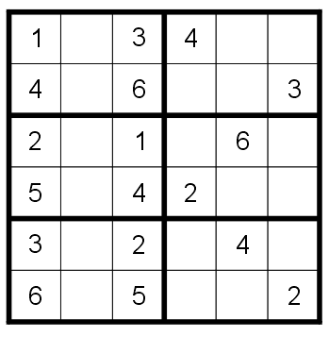

**Football Quiz answers**

On Monday we asked you to name the last 10 Champions League football winners in order, so here they are!

* 2020 – Bayern Munich
* 2019 – Liverpool
* 2018 – Real Madrid
* 2017 – Real Madrid
* 2016 – Real Madrid
* 2015 – Barcelona
* 2014 – Real Madrid
* 2013 – Bayern Munich
* 2012 – Chelsea
* 2011 – Barcelona

Real Madrid have won the trophy an incredible 13 times and have been runners up 3 times. AC Milan are next on the list, having won the trophy 7 times and been runners up 4 times. Celtic are the only Scottish team to have won the cup in 1967 and they were runners up in 1970.

**This day in History**

**1963 –** Martin Luther King delivers his famous “I have a Dream” speech in Washington D.C.

**1994 –** Tiger Woods wins the US Amateur Golf Championship for the first time

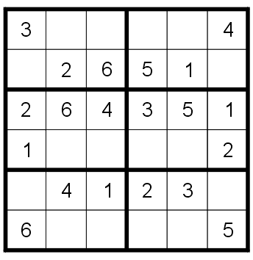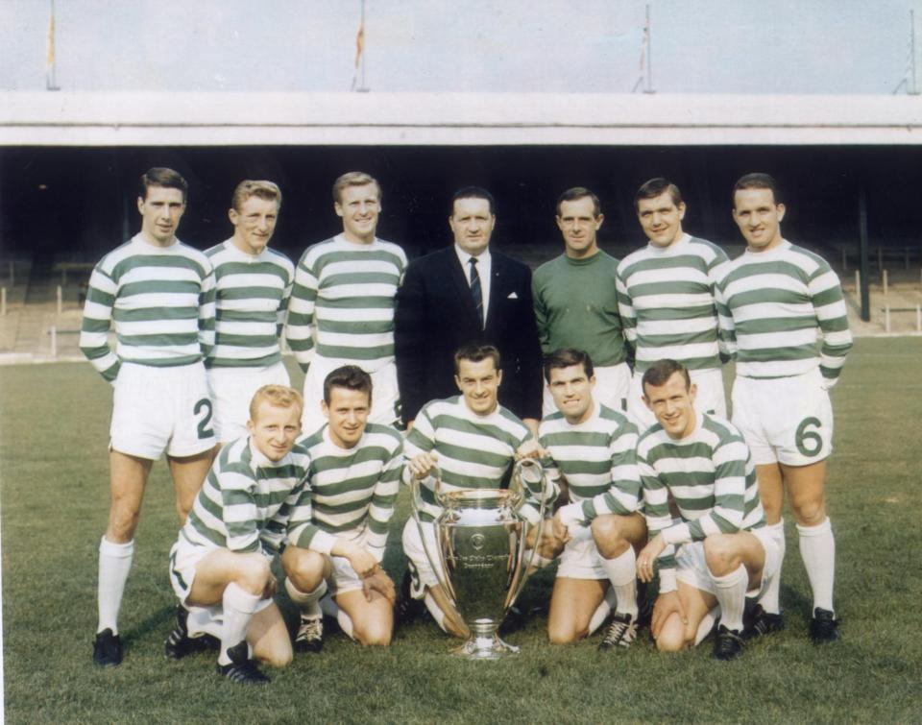

Source: printactivities.com

The Lisbon Lions Celtic team who won the cup in 1967 (source: www.scottishsun.co.uk)