MEARNS CASTLE HIGH SCHOOL

S1 Induction Booklet

Department of Mathematics and Numeracy

2020-2021

Full Name: ________________________________________

Current School: ___________________________________

Welcome to Maths at Mearns Castle.

Just as with Primary school, you will find that you’ll come across Numeracy in all the different subjects that you study in Mearns Castle. But when it comes to Maths you will be learning all your new skills in the Maths Department. It is easy to spot us. We are in the ‘F’ which is the rooms that you see on the upstairs bit of the school when you are standing in the car park, outside the main entrance.

There are a team of 14 Maths teachers. They are excellent, and you will love being in our department. We will be responsible for teaching and supporting you in all things Maths all the way through your secondary school career.

Please work your way through this booklet and keep all your work as neat as possible. In Mearns Castle, we expect the very highest standards, and your very best work. I know that your Maths teachers will be keen to see your best attempts at this booklet when you come to join us in August. Please do not worry if there is anything you have struggled with – especially the Sudoku Puzzles. The thing we are most interested in is that you give all challenges your very best shot. And don’t worry about mistakes – they are part of learning if we take time to think over what was wrong and practice getting it right.

I hope you have fun completing the challenges and I wish you a thoroughly enjoyable summer.

Look after yourself and your families,

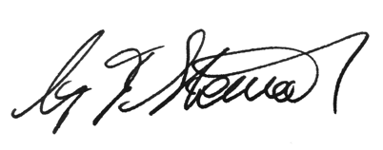
Mr Stewart
Principal Teacher of Maths and Numeracy.

SUDOKU
Easy - In the following puzzle, fill in the numbers 1 to 6 only once in each row, column and box.
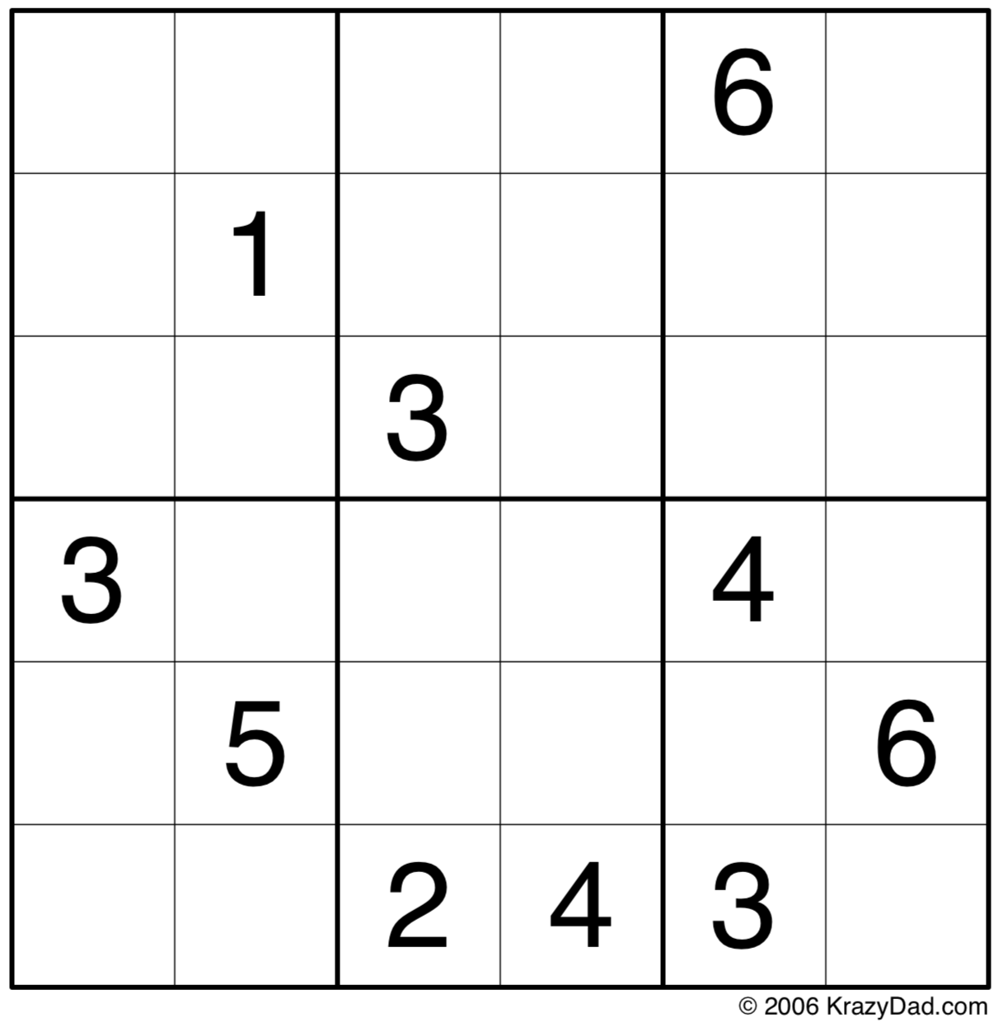

Hard - In the following puzzle, fill in the numbers 1 to 9 only once in each row, column and box.
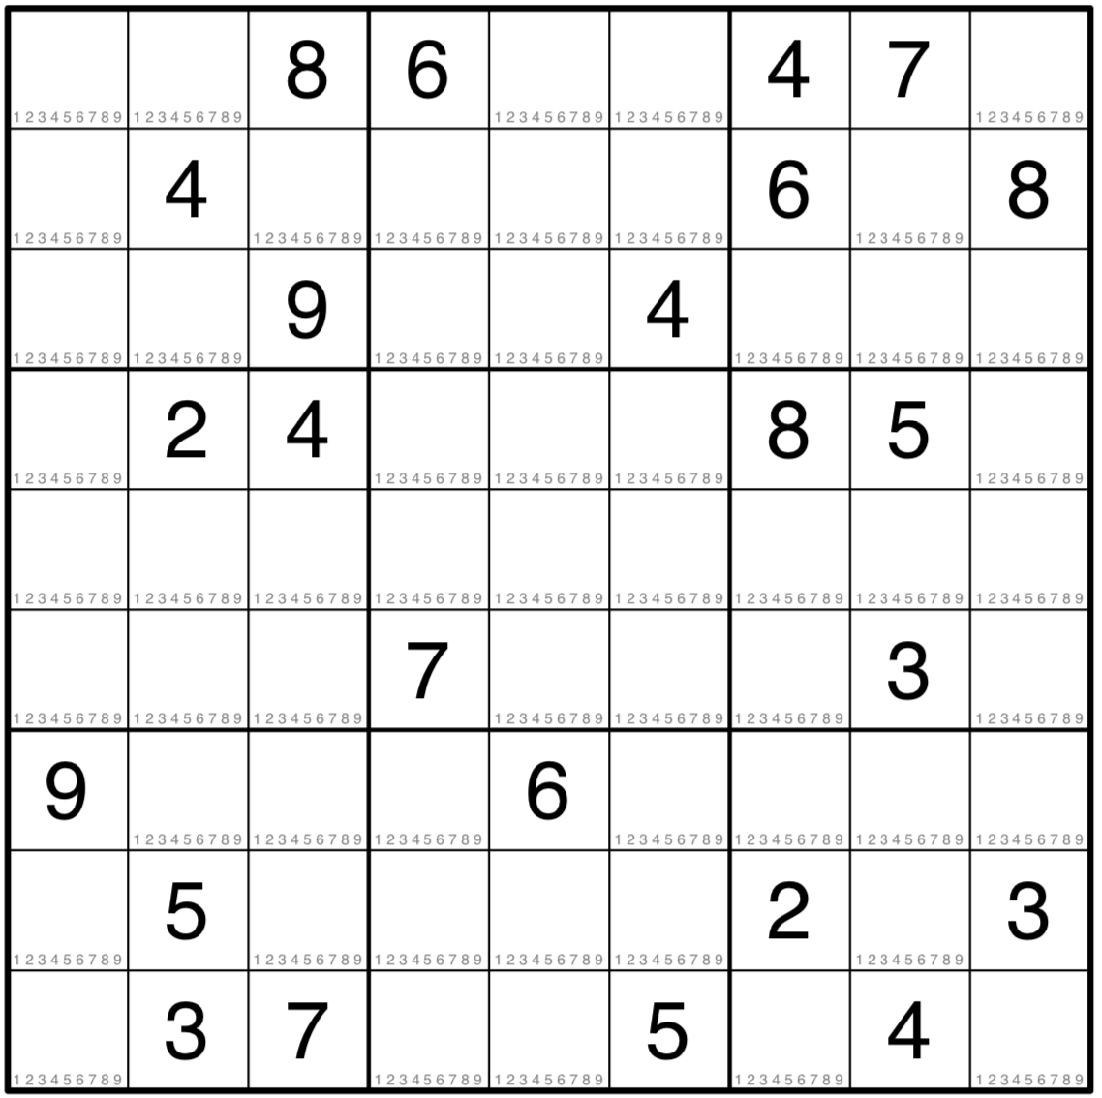

Maths Wordsearch

Y | U | F | V | N | Z | N | G | E | K | F | T | N | M | N
S | R | H | R | E | O | E | U | A | A | N | V | U | H | O
H | S | T | U | A | O | I | R | M | E | O | L | M | M | I
A | I | U | E | M | C | B | T | M | B | T | H | E | S | T
P | F | Q | E | M | E | T | E | I | I | E | R | R | U | C
E | P | T | W | G | O | R | I | P | D | G | R | A | L | A
S | R | D | L | N | U | N | L | O | G | D | S | C | U | R
Y | A | A | Y | S | B | I | O | A | N | X | A | Y | C | T
N | R | N | A | O | C | I | L | G | J | S | C | B | L | B
G | F | E | D | A | N | O | I | S | I | V | I | D | A | U
C | M | M | T | S | R | E | R | Q | D | R | K | N | C | S
O | A | I | B | V | S | T | A | T | I | S | T | I | C | S
S | O | S | E | G | A | G | A | T | N | E | C | R | E | P
N | A | G | Y | M | D | E | C | I | M | A | L | S | C | G
Y | E | N | O | M | T | S | B | G | B | U | X | N | D | O

ADDITION | ALGEBRA | BODMAS
CALCULUS | DECIMALS | DIVISION
FRACTIONS | GEOMETRY | MEASUREMENT
MONEY | MULTIPLICATION | NUMBER
NUMERACY | PERCENTAGAGES | SHAPES
STATISTICS | SUBTRACTION | TRIGONOMETRY

