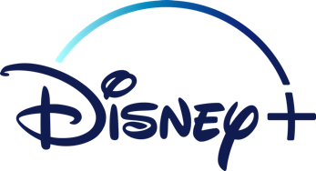**THE WONDERFUL WORLD OF DISNEY**

Having used digital technologies to search, access and retrieve information I can justify my selection in terms of validity, reliability and have an awareness of plagiarism.

**TCH 3-02a**

**Task 1**

In this activity you will use the Internet to explore Disney. You should find out the following information using the website below:

<https://thewaltdisneycompany.com>

When was the Walt Disney company founded?

­­­­­­_________________________________________________

Name the 2 people who founded the company.

­­­­­­_________________________________________________

Where are the *headquarters* of the Walt Disney company located?

_____________________________________________

­­­­­­_________________________________________________

Name 3 different products or services Disney offer.

_____________________________________________

­­­­­­_________________________________________________

How many countries does Disney operate in? Name at least 2.

_____________________________________________

­­­­­­_________________________________________________

**Task 2**

For this task you may need to use to a search engine (Google) to search for the answers or you might already know them!

What is the name of the boy who owns Buzz Lightyear in Toy Story?

_____________________________________________

­­­­­­_________________________________________________

How many Toy Story films are there altogether?

_____________________________________________

­­­­­­_________________________________________________

In Finding Nemo, what is the address of the dentist office in which Nemo is kept?

_____________________________________________

­­­­­­_________________________________________________

The villain, Randall Boggs, appears in which Disney film?

_____________________________________________

­­­­­­_________________________________________________

In Snow White how many dwarves are there?

_____________________________________________

­­­­­­_________________________________________________

Name the actress who played Anna in frozen?

_____________________________________________

­­­­­­_________________________________________________

We hope you enjoyed researching these questions from the Business & Computing department. The answers are also included, for self-marking. As a reward, you can now watch a Disney film of your choice!