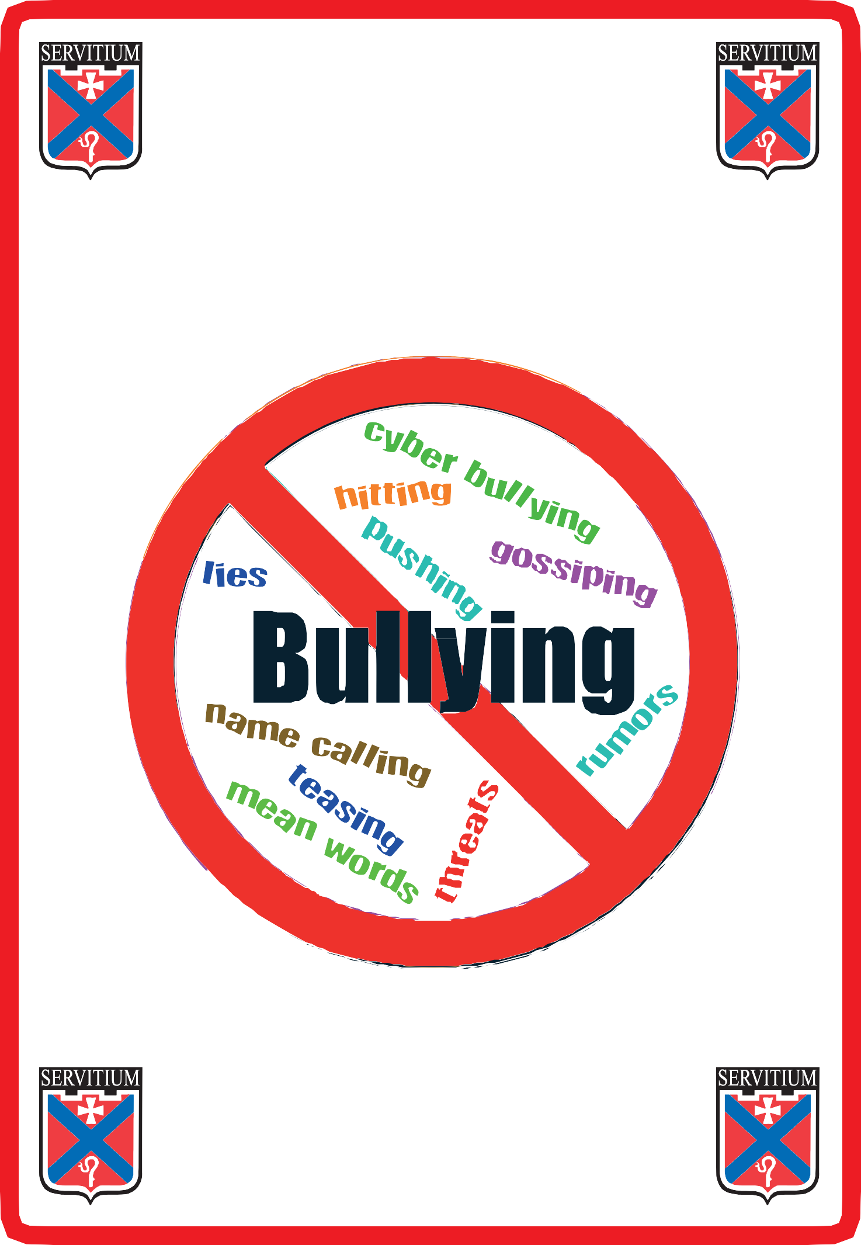

Mearns Castle High School
All About Bullying Behaviour

Pupils’ guide to Mearns Castle High School’s
zero tolerance approach to bullying behaviour.

What is Bullying Behaviour?

Bullying behaviour is repeated overbearing behaviour that is unpleasant, un- wanted or intimidating.

It is often done deliberately to hurt, humiliate or target someone, though it does not have to be intentional, as pupils may be unaware of the impact of their behaviour.

Some examples of bullying are:

• Being called names that are upsetting
• Being kicked, hit, pushed or threatened
• Having possessions stolen or damaged
• Being left out and having rumours spread about you
• Being sent abusive text messages or e-mails
• Being targeted because of who you are or who you are perceived to be

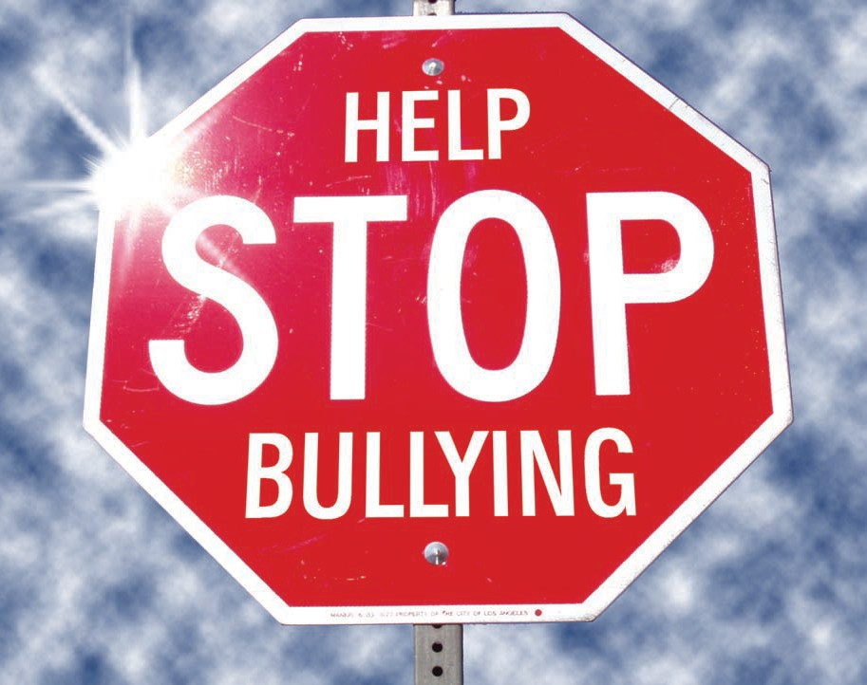

Types of Bullying Behaviour

Cyber Bullying

Cyber Bullying is when an individual is targeted through modern technology. This form of bullying behaviour can make people feel more vulnerable as they can be reached at any time of the day through social networking sites, texting and e-mail.

Verbal Bullying

Verbal Bullying is when a person is abused through words said behind their back or even to their face. Verbal Bullying can be anything from calling someone horrible names to teasing them about something they can’t control.

Physical Bullying

Physical Bullying is any kind of aggressive contact, when someone is physically abused or hurt or has their personal items stolen.

Emotional Bullying

Emotional Bullying is when someone is consistently excluded from activities and made to feel unwanted. This can make people feel worthless and can have a long-term effect on them.

All forms of bullying can have an emotional impact on the individual.

How Bullying Behaviour Affects Individuals

When someone is being bullied it may affect them in various ways. In order to help you notice the signs, these are the ways that some children may be affected by bullying behaviour:

- Makes them feel unhappy
- Makes them feel frightened or unsafe
- Lowers their confidence
- Makes them feel left out
- Makes them not want to take part in certain things or go to certain places
- Makes them feel anxious, worried or isolated
- Makes them feel scared to talk to people (including family and friends)

Pupils who exhibit bullying behaviour may do so for a number of reasons. At Mearns Castle, we aim to support all pupils and encourage them to behave in an appropriate way.

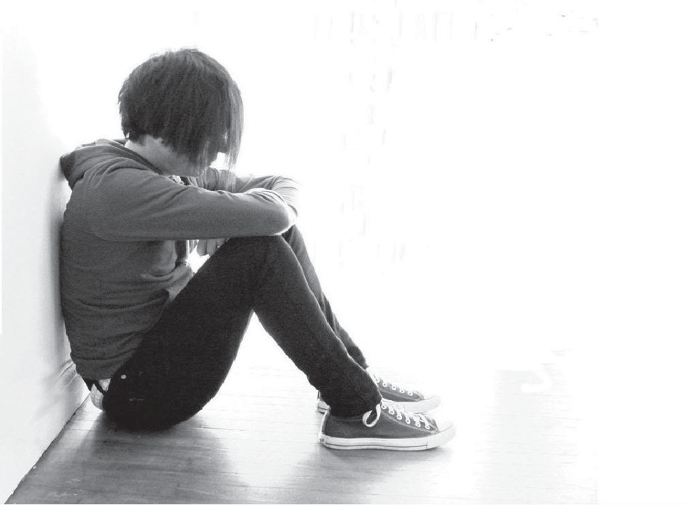

What Support Can Mearns Castle High School Offer You?

MCHS pupils and parents can contact a range of people in school who are able to help them if they feel unhappy for whatever reason:

Pupil Support Teachers:

Miss Cartledge (Wallace House: L, P, Q, T-Z) Mr Gooch (Gleneagles House: G, H, I, K)
Mr Cairney (Caledonia House: A, C, J, Mac) Miss McCafferty (Ramsay House: M, N, O, R)
Ms Oram (Sutherland House: S, Mc) Mrs Crilley (Balmoral House: B, D, E, F)

Year Heads:

Mr Hale – S2 Mrs Mitchell – S5
Mr Donnelly – S3 Mr Phillips – S6
Mr McGarry – S4

Head Teacher - Mr Smith
Campus Police Officer - Mrs Angela Mitchell

Other Supports:
Class teachers
S6 Buddies for S1 Pupils
Youth Counsellor

Many issues surrounding bullying behaviour and emotions are covered in PSE, Citizenship and other subject classes during school. Topics such as bullying, embracing diversity, respecting self and others are explored at these times. Group work is used in many subjects to encourage the development of social skills, making friends and including others.

Where Else Can You Get Help?

The internet is a great source of information on bullying behaviour. Below are a selection of websites that have useful sections for both parents and pupils:
www.kidscape.org.uk
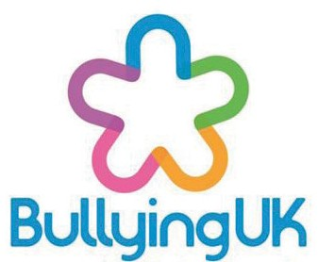
(click on Advice and scroll down to Parents and Carers or Children & Young People.)

www.bullying.co.uk
(click on Young People or click on Parents to get advice.)
www.respectme.org.uk
(click on Information and Advice then choose Parents or Children. There is also a great section on Cyberbullying.)
www.stopbullying.gov 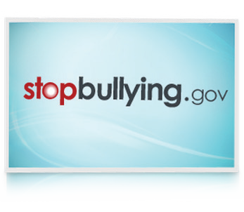
(scroll down to Get Help Now and you can call the helpline “Lifeline”.)

Mearns Castle High School

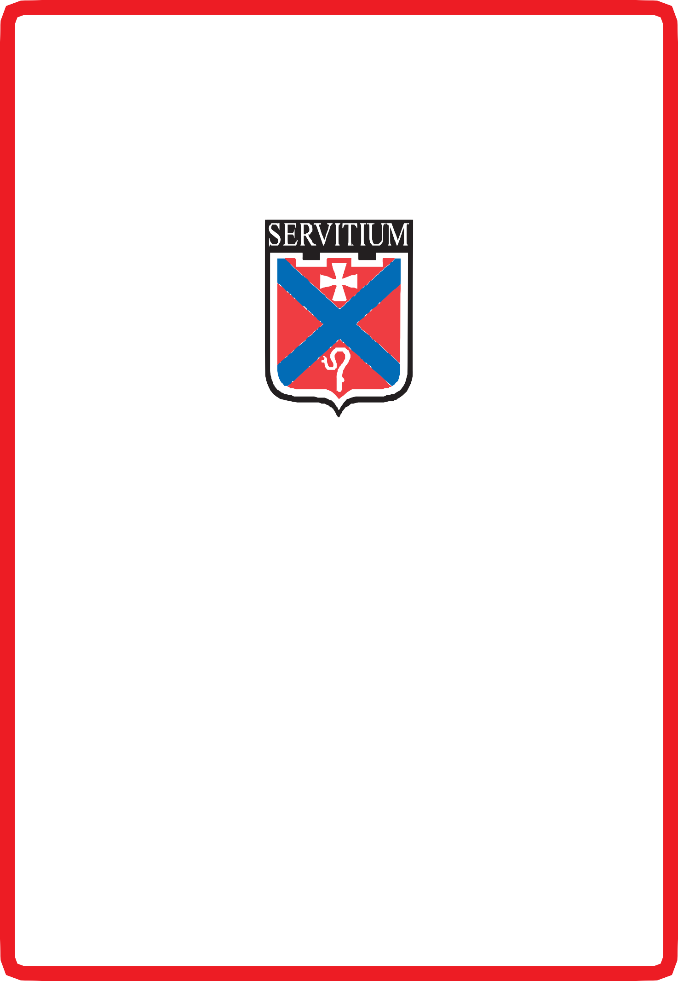

Zero Tolerance of Bullying Behaviour

This booklet was created and designed by pupils of MCHS.

Contact Us:

Mearns Castle High School Waterfoot Road
Newton Mearns Glasgow G77 5GU
Telephone Number: 0141 5772300
Fax Number: 0141 577 2314
Web Address: http://www.ea.e-renfrew.sch.uk/mearnscastle e-mail: schoolmail@mearnscastle.e-renfrew.sch.uk
School Office Hours:
Monday - Thursday: 08:20 - 16:30
Friday: 08:20 - 15:15

