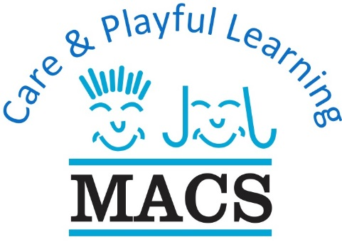

Newton Mearns Area: Crookfur Primary * Mearns Primary * Kirkhill Primary * St. Cadoc’s Primary
Clarkston Area: Carolside Primary * St. Joseph’s Primary * Busby Primary
Barrhead Area: Neilston Primary * Cross Arthurlie Primary * Carlibar Primary Glasgow Area: Scotstoun

Career Opportunities
Unqualified Care & Playful Learning Support Worker’s for our
Mearns, Clarkston and Barrhead Projects

Benefits of a Childcare Support Worker
- In House SVQ Training provided, to enhance career progression, from Unqualified Support Worker –Qualified Support Worker - Practitioner – Depute Manager, Project Manager.
- 22 days Holiday (including 9 public holidays)
- Competitive rate of pay £8.05 per hour – April 2019 Increase pending
- Uniform Provided

Requirements of Unqualified Childcare Support Worker
- Must be willing to undertake an SQA Playwork SCQF L6 Qualification.
- Childcare experience required, this experience can be gained through Employment, Childminding / Baby Sitting (no Family members), Volunteering within Organisations i.e. Scouts, BB, Girl Guides, Sport Coaching.
- Must undergo Protection of Vulnerable Groups Scheme checks.
- Must undergo Reference checks and complete SSSC registration.
- Must be able to provide at least 1 Childcare Reference.

Responsibilities of Childcare Support Worker
- Promote high-quality child led play by promoting children's individual choice and development through imaginative, fun and interesting play.
- Demonstrate the continuous development of the play setting to meet the needs of each child.
- Demonstrate a commitment to quality service delivery through continuous professional development.
- Reflect on practice to act on and improve their own practice.
Hours of Work Monday to Friday, term time only as follow:-
22.5 hours per week (split shifts) 7:45am to 9am returning 2.45pm* to 6pm, *some of our projects 3pm to 6pm or 3:15pm to 6:15pm or 16.5 hours per week, working Afternoons Only

To apply please either complete the online application form by following the link (link can also be found on the Careers page of the MACS website):
https://mearnsafterschoolcare.formstack.com/forms/applicationform

Newton Mearns Area: Crookfur Primary * Mearns Primary * Kirkhill Primary * St. Cadoc’s Primary
Clarkston Area: Carolside Primary * St. Joseph’s Primary * Busby Primary
Barrhead Area: Neilston Primary * Cross Arthurlie Primary * Carlibar Primary Glasgow Area: Scotstoun

Career Opportunities
Qualified Care & Playful Learning Support Worker’s for our
Mearns, Clarkston and Barrhead Projects

Benefits of a Childcare Support Worker
- In House SVQ Training provided, to enhance career progression, from Unqualified Support Worker –Qualified Support Worker - Practitioner – Depute Manager, Project Manager.
- 22 days Holiday (including 9 public holidays)
- Competitive rate of pay £8.75 per hour – April 2019 Increase pending
- Uniform Provided

Requirements of Qualified Childcare Support Worker
- Minimum SVQ Level 2 in Playwork or equivalent
- Childcare experience required, this experience can be gained through Employment, Childminding / Baby Sitting (no Family members), Volunteering within Organisations i.e. Scouts, BB, Girl Guides, Sports Coaching.
- Must undergo Protection of Vulnerable Groups Scheme checks.
- Must undergo Reference checks and complete SSSC registration.
- Must be able to provide at least 1 Childcare Reference.

Responsibilities of Childcare Support Worker
- Promote high-quality child led play by promoting children's individual choice and development through imaginative, fun and interesting play.
- Demonstrate the continuous development of the play setting to meet the needs of each child.
- Demonstrate a commitment to quality service delivery through continuous professional development.
- Reflect on practice to act on and improve their own practice.
Hours of Work Monday to Friday, term time only as follow:-
22.5 hours per week (split shifts) 7:45am to 9am returning 2.45pm* to 6pm, *some of our projects 3pm to 6pm or 3:15pm to 6:15pm or 16.5 hours per week, working Afternoons Only

To apply please either complete the online application form by following the link (link can also be found on the Careers page of the MACS website):
https://mearnsafterschoolcare.formstack.com/forms/applicationform

