ParentPay - online school payment service coming soon.
We are pleased to announce that we will be accepting payments online using a secure website called ParentPay.
Payment can be made using your credit or debit card. ParentPay will be our preferred method of making payments to school.

What are the benefits to parents/carers and pupils?

- ParentPay is easy-to-use and will offer the freedom to make online payments whenever and wherever you like, 24/7

- Payments can be made by credit/debit card

- Full payment history and statements are available

- Meal and tuck selections will be available to view online for primary pupils only.

What are the benefits to our school?

The more parents/carers use ParentPay, the greater the benefit to our school.

- Reduces the administrative time spent on banking procedures
- Keeps accurate records of payments made to every service for every student
- Reduces paper ‘waste’

- Allows for easy and quick refunds to be made
- Offers a more efficient payment collection process, reducing the amount of money held on school premises

How to get started with ParentPay

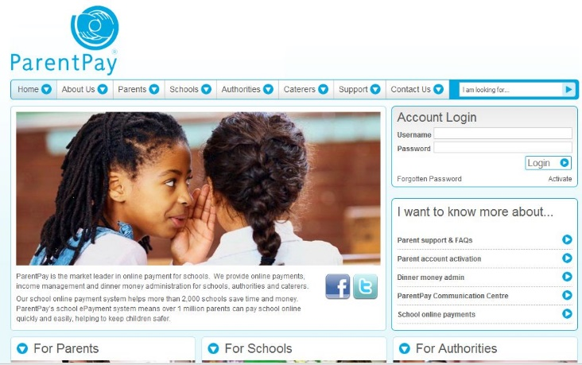

We will shortly be sending you more information on launch dates as well as your account activation details, just follow the instructions in the letter we give you to get started.

If you want to find out more about ParentPay go to:

www.parentpay.com/Parents

