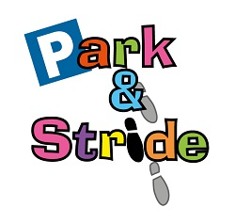**Mearns Primary School**

Park and Stride

The Eco Committee and JRSO have been working hard to reduce congestion in our school car park. We have carried out surveys to encourage drivers to park safely. In assemblies, we have been talking to pupils about ways they can actively travel to school; such as walking, cycling or car sharing.

We are planning to pilot three new ‘park and stride zones’ around our school. We hope that many people will use these drop off zones instead of driving all the way to school, therefore reducing the congestion in and around our school car park.

**What is Park and Stride?**

Park and Stride is particularly good for people who live more than ten minutes from school and cannot walk to school. Park and Stride is a brilliant way to add some physical exercise to your journey. It is also a great opportunity for parents/ carers and their children to meet with others, walk together and chat. The idea is that you park in one of the designated zones and then walk with your child the remainder of the way to school.

**Now the fun part**

We are asking you to help us to promote our Park and stride zones by taking part in our Park and Stride competition. Here are some of the things you could do:

* Design an A4 or A3 poster promoting one of our park and stride zones
* Come up with a catchy slogan which could be used on a banner
* Write an eco-code that could be used as part of our Park and Stride campaign
* Make a short campaign video to advertise our park and stride zones

The winning slogans, eco-codes, videos and posters will be made into banners or showcased during the launch of our Park and Stride zones later this term.

Please hand in your competition entries to Mrs McGregor P3.10 by Friday 6th May

[](http://www.google.co.uk/url?sa=i&rct=j&q=&esrc=s&source=images&cd=&ved=0ahUKEwi-sbTB5u3LAhWEchQKHTrhAhEQjRwIBw&url=http://www.woodlands.northayrshireschools.co.uk/&psig=AFQjCNFzD_T1UEUw26NJMO6cnqK_PshuWA&ust=1459612520378539)

**Netherplace Crescent/ Road**

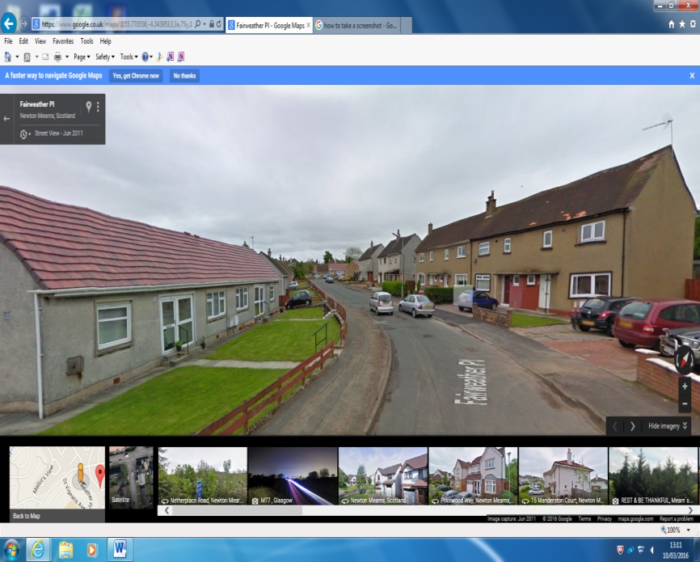

* This area doesn’t require you to cross any roads at all
* It is roughly 600 steps
* It would take around five minutes to walk to school.

**Paidmyre Road**

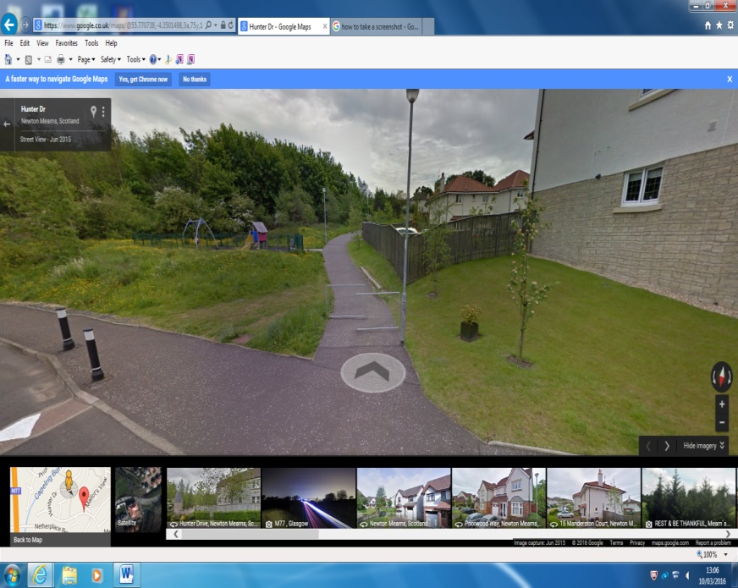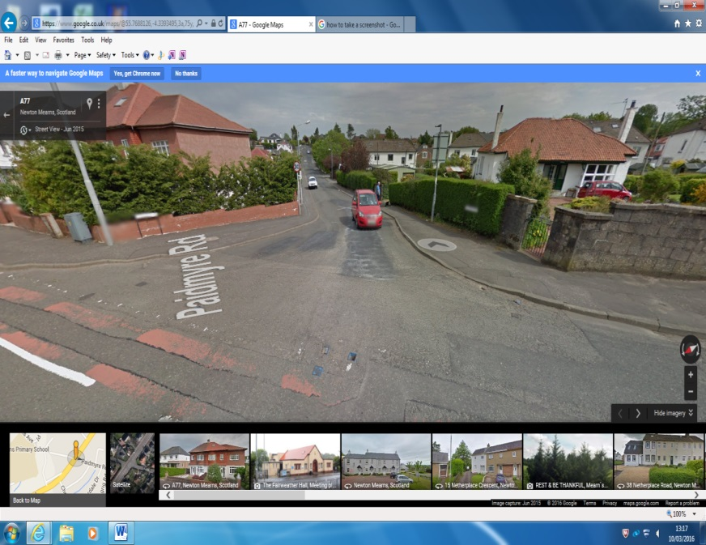

* Park along Hunter Drive
* Walk along pathway, passing the park on your left
* Cross two minor roads and a one way road
* This route is also around 700 steps and would take less than 10 minutes.
* Park on Paidmyre road
* Cross Ayr Road with the help of our crossing patrol
* Walk along St. Vigeans Place
* Cross a minor road and enter the school’s back entrance
* This route would take less than 10 minutes and is around 750 steps.
* If you were to walk to school and back each day, you would walk around 234 000 steps in a year.
* This is equivalent to 117 miles
* Did you know when you walk; you use over 300 muscles in your body.

**Hunter Drive**