**Mearns Primary School**

**Paired Reading**

This is a great way to help your child with reading and can be done with any book (library books, non-fiction etc.)

* Allow your child to choose the book with a little direction.
* A short period of time – 10 -15 minutes daily.
* Sit in a quiet area, side by side.
* Discuss the title of the book and the pictures before reading.
* Read the story together, pointing at the words as you and your child read. If your child is, or as they become more confident, allow them to read on their own.
* If a mistake is made, gently tell your child the correct word, but make sure you keep the story going.
* Use lots of praise and encouragement.
* If your child gets bored with his/her choice of book then change it.

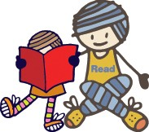



**Developing Reading**

**at**

**Early Level**

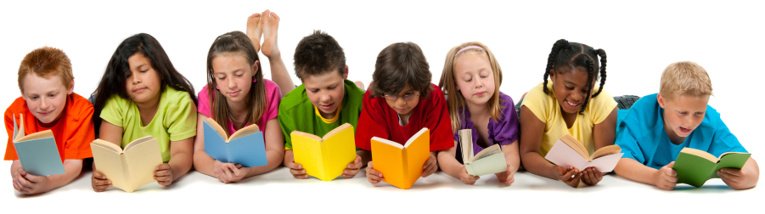

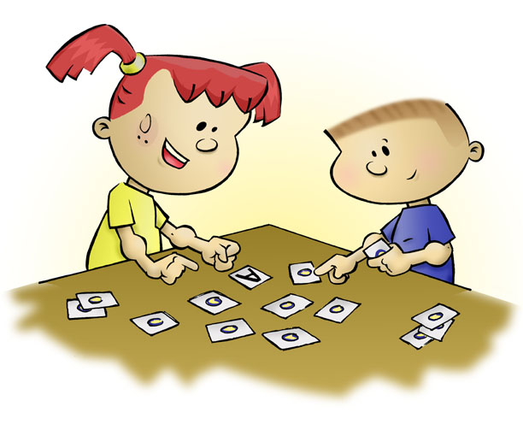

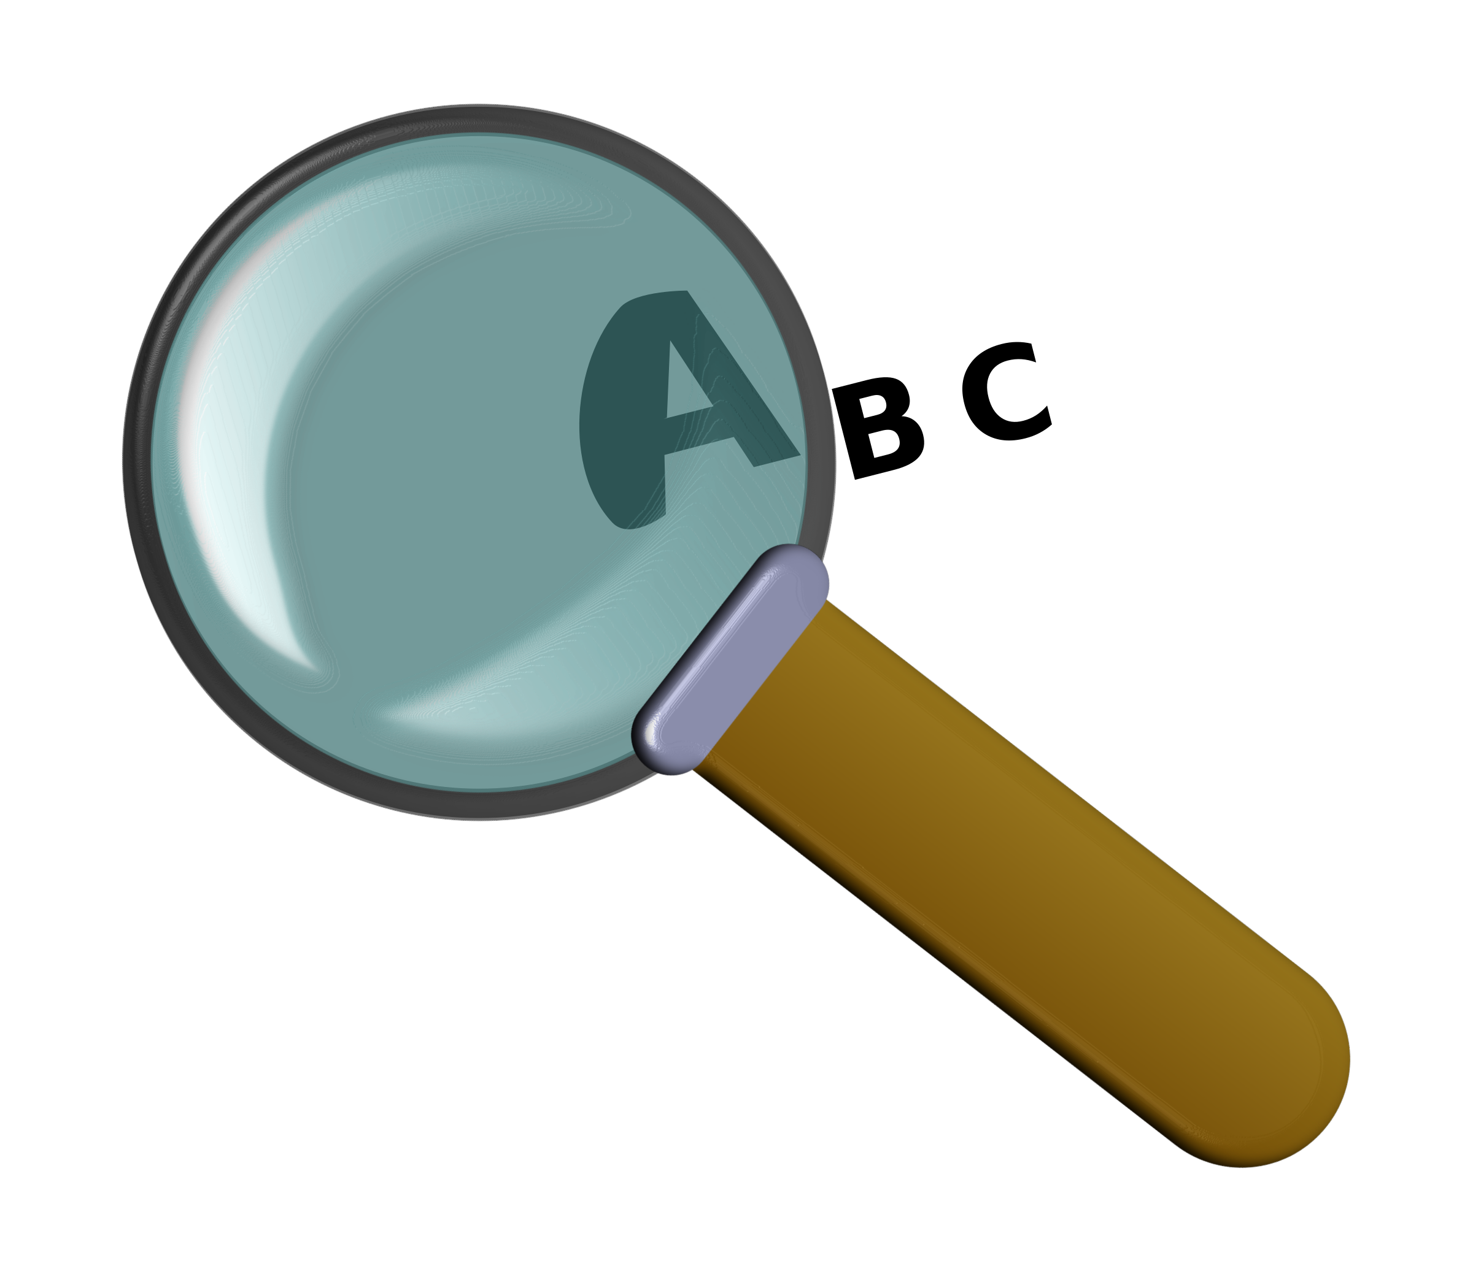

**How do children learn to read?**

Children learn to read by developing the skills of decoding and then by understanding what they read.

This involves learning:

**Sounds (Phonics)**

* Phonics is learned through the use of the Jolly Phonics programme.
* Children first learn the initial sounds of the alphabet and how they blend together to make words. For example, when they learn **s a t** they learn how to blend it to read **sat.**
* When they know all the initial sounds, they learn that letters can go together to make different sounds, for example, **‘sh’** in the word **shop.**
* A list of these phonemes or sounds is given in the table below:

|  |  |  |  |  |  |  |  |  |  |
| --- | --- | --- | --- | --- | --- | --- | --- | --- | --- |
| sh | th | ch | wh | oo | ai | ee | ie | oa | ue |
| oi | ou | ng | qu | ar | er | or |  |  |  |

**Rhyme**

* It is important that children can ‘hear’ rhymes in words.
* We teach children to recognise words that rhyme. If a child can read tin, they may also be able to read pin and bin.

**Common Words (Tricky Words)**

* These are the most difficult words to remember and often can’t be sounded out.
* We teach children these words by sight, using cards and games.

**Understanding**

* Our main reading resource is ‘Storyworld’. It is used to give children the opportunity to practise their decoding skills.
* We also utilise unseen texts to help children develop their understanding skills.

**How can I help my child at home?**

**Sounds (Phonics)**

* Phonics games: Pairs, lotto, swat the sound
* Education City and other online phonic games
* Look for letters in print and in the environment.

**Rhyme**

* Use magnetic letters to make new words by changing the first letter.
* Read nursery rhymes.

**Common Words**

* Hunt for the words in different texts.
* Read the word list then time it to see if your child can get faster.
* Mix up the words so they are not always in the same order.

**Understanding**

* Read books together.
* If your child comes across a word that they do not know, help them to decode it, recognise it as a common word or use a clue from the picture.
* Encourage your child to use their finger to follow the words as they read.
* Discuss the characters and events within the book.

**Reading outside of the home**

* Have fun reading shop signs, labels on items in the supermarket, the menu in the restaurant and mail that comes through the door. Your child will start to recognise words that they see regularly.
* Play eye spy when driving to find words with given initial sounds.
* Make looking at books, magazines, comics or newspapers part of your daily routine.
* Visit the library and encourage your child to choose their own books.
* Listen to books on CD when travelling.