

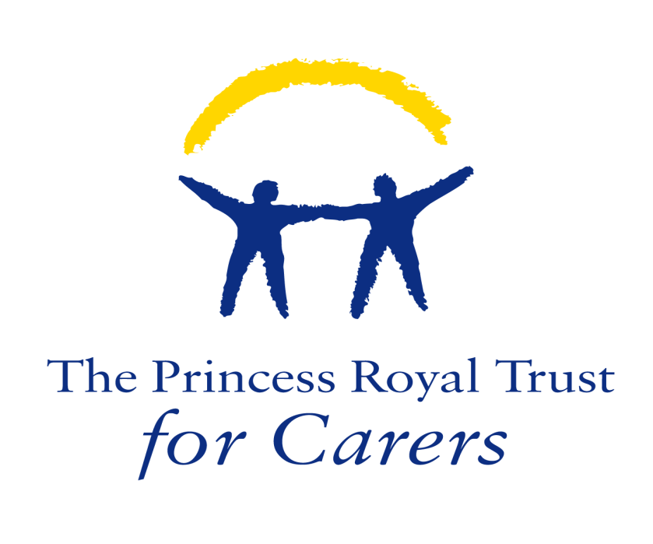
East Renfrewshire Carers’ Centre

NAS Parent Seminars
Eastwood House, Eastwood Park
Rouken Glen Road, Giffnock
Glasgow, G46 6UG
10am – 2.30pm
Lunch and Hot/Cold beverages will be provided

About the Family programme parent seminars

The family programme in partnership with East Renfrewshire carers centre would like to invite you along to our one day parent seminars. Help! Seminars provide information and advice to families of children affected by Autism (including Asperger Syndrome) up to and inclusive of 18yrs old.

The seminars are:

- Understanding Autism (First Steps) Monday 21st January
- Managing Anger Monday 28th January
- Sensory Monday 4th February
- Common Toileting Difficulties Monday 18th February
- Teen Life Monday 25th February

Seminars can be booked individually or as a block.

Family seminars - two family members Free!
Families can book two places on any of the one day help! seminars for free which includes a full resource pack of useful information, advice and support guidelines. help! Seminars are delivered by experienced and trained professionals of The National Autistic Society (NAS).
Contact us
For further details of forthcoming seminars and/or to book a place contact;
Tanya Tennant at Tanya.tennant@nas.org.uk
or call 0808 800 0075

East Renfrewshire Carers’ Centre
How will the seminars support families?
Understanding autism (First steps) This seminar will support families to;
- Develop an understanding of autism
- Discuss experiences of getting a diagnosis
- Identify how autism can affect families
- Explore practical ideas for developing communication strategies
- Clarify support that families may be entitled to and ways to access this
Sensory needs This seminar will support families to;
- Consider sensory systems and how effective these may be
- Examine how sensory information may be processed differently
- Discuss how people with Autism may experience different senses
- Suggest support strategies
Managing Anger This seminar will support families to;
- Discuss why children with autism often have challenges with anger
- Identifies a low arousal approach for support through stressful situations
- Explore the cycle of anger and possible support strategies
- Examine strategies for managing feelings
Common toileting Difficulties This seminar will support families to;
- Consider how having autism can lead to various toileting difficulties
- Discuss the general process of toilet training
- Look at difficulties that children with autism may experience regarding toileting including constipation, smearing, fear of using the toilet and the sensory issues associated with this
- Suggest tips and strategies to help minimise the problems
Teen Life This seminar will support families to;
- Develop a better understanding of autism in the teenage years
- Explore strategies to help with motivation and self esteem
- Discuss strategies around Puberty and Relationships
- Clarify support that families may be entitled to and ways to access this

