|  |
| --- |
|  |
| September 2015 Newsletter |
|  |

Mearns Primary PTA



# Upcoming Events

**September 7th**

7pm AGM & Meeting

## September 11th

P1 Party with Kidneticks

**October 23rd**

Halloween Disco

**November 6th**

Ladies Night

**December 5th**

Christmas Fayre

|  |
| --- |
|  |
| **Please support our events help us reach our target of £12,000 for 2015/2016**  **We are raising money for Fitness equipment for the playground.** |

|  |
| --- |
|  |
| Dear Parent/Carer  Welcome to all new parents and returning Mum’s & Dad’s, we hope you all had a great summer.  We are delighted to announce that this year we have broken our fundraising target by raising over £12,000.  Thank you to everyone for supporting the PTA, with your help we have been able to donate the following:  **Visualisers**  **Ipads**  **Sensory Spelling Boxes for each class**  **Vikingar trip subsidy**  **Playground kits**  **Nursery Leavers Gifts**  **P7 Leavers Gifts**  **P7 Leavers Band**  **Sports Day medals**  **Easter Egg Hunt**  **Theatre workshop**  **Homework diaries**  **Donations total £12,085** |
|  |

## P1 Party Friday September 11th 6.30 – 8.15

Tickets are on sale at the school office, cost £5.

All new Mum’s/Dad’s/carers and P1 children welcome.

## Mearns Primary PTA AGM

## We need your support

We would like to invite you all to attend our AGM on Monday 7th September at 7pm in the P3 Staff Base. The PTA is changing this year due to the departure of several key members. We are delighted to announce that we have secured kind volunteers to fill the Office Bearing roles but as the PTA Secretary only has one year left at the school we would ideally like someone to shadow this position with a view to taking over in year 2016/2017.

If anyone is interested in this please either come along to the AGM or contact Janet Olverman – [janet.olverman@ntlworld.com](mailto:janet.olverman@ntlworld.com) or 0141 639 0212 for further information.

As a parent everyone is very welcome to attend our monthly meetings where we discuss fundraising ideas and organise events.

Meetings are usually held on the 1st Monday of the month at 7pm in P3 Staff Base. We are a friendly informal group of Mums (and sometimes Dads) who like to try and make a positive difference to our children’s education. Without our fundraising efforts the items listed would not have been provided for your children.

If you are interested in attending the meetings please come along to our next one on Monday 7th September – give it a go and make a real difference to your child’s time at Mearns Primary.

**Mearns Primary PTA Facebook Page**

If you wish to be kept informed of our upcoming events and notifications via Facebook you need to turn on notifications. First **like** our page then click the down arrow at the right hand side of any of our posts and click **turn on notifications**. That way you won’t miss out on any of our posts.

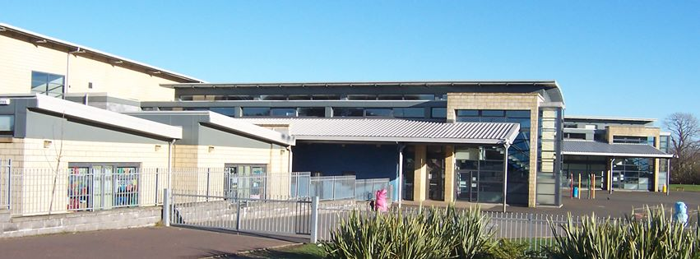

|  |
| --- |
|  |
| Meeting Dates 2015/2016 All meetings 7pm-8.30pm in P3 staff base Sept 7th AGM & Meeting **October 5th**  **November 2nd**  **December 7th**  **January 11th**  **February 1st**  **March 7th**  **April 25th**  **May 9th**  **June 6th**  All welcome |