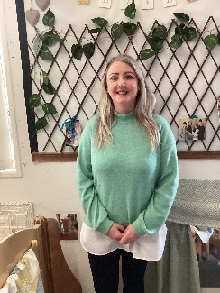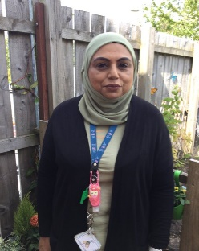VISION STATEMENT

In McCready Family, we work with our families and community to build foundations that enable each child to build a sense of curiosity, creativity and develop a thirst for lifelong learning.

AIMS

*We aim to:*

* *To create a challenging, engaging and responsive learning environment that supports individual interests, skills and stages of development.*
* *To ensure that all children enjoy and uphold their rights and the rights of others as enshrined in the UNCRC.*
* *To work in partnership with other Family Centres, agencies and the community.*
* *To build a staff team of nurturing, respectful and professional practitioners who have a sound knowledge of child development.*
* *To nurture hearts and minds and help build resilient children who develop the strength to face challenges with confidence.*
* *To foster empathy and support friendships.*

**LOVED**

NURTURED

HAPPY

SAFE

**HEALTHY**