
Staff Booklist 2019
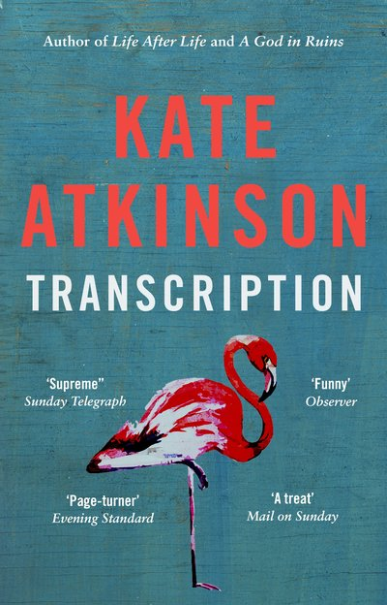
Transcription – Kate Atkinson
If I had to choose my favourite book this year, then it would be this one! It’s 1940 and eighteen-year old Juliet Armstrong is reluctantly recruited into the world of espionage. Sent to an obscure MI5 department which is monitoring the activities of British Fascist sympathizers, she discovers the work to be both tedious and terrifying. But after the war has ended, she assumes the events of those years have been consigned to the past forever. However, ten years later, now a radio producer at the BBC, Juliet is unexpectedly confronted by figures from her past and finds herself once more under threat. I absolutely loved this book and felt bereft when it ended!

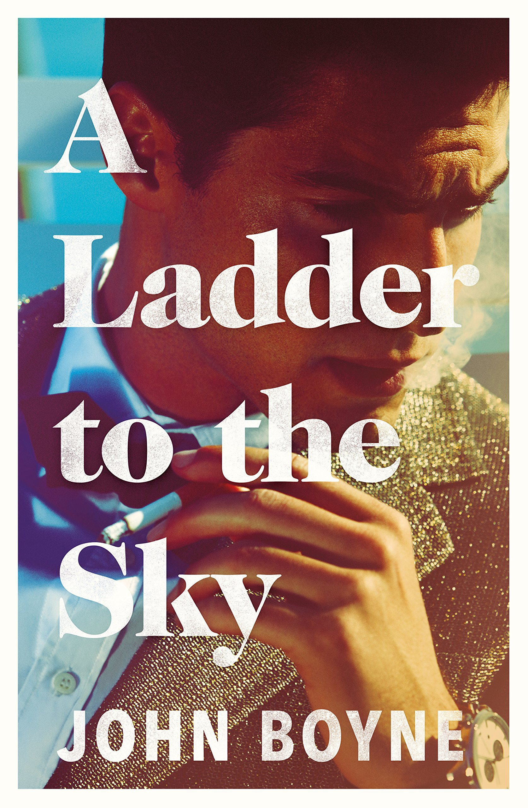
A Ladder to the Sky – John Boyne
Maurice Swift is handsome, charming and hungry for success as a writer. The one thing he doesn't have is ideas - but he's not going to let that stand in his way. Working as a waiter in Berlin in 1988, Maurice engineers the perfect opportunity: a fortuitous encounter with celebrated novelist Erich Ackermann. He quickly ingratiates himself, teasing out a terrible, long-held secret about Erich’s activities during the war. Perfect material for Maurice's first novel. As time passes, Maurice hones his talent for deceit and manipulation in his cold-blooded rise to the top. What a brilliant novel about a literary psychopath – I treasured every (stolen) word of it!

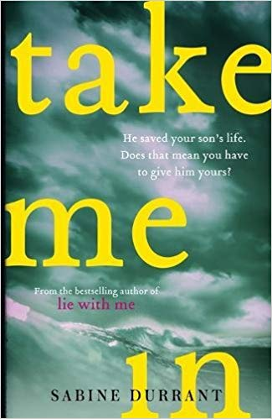

Take Me In – Sabine Durrant
Tessa and Marcus go on holiday to save their marriage. Instead they almost lose their son. In a near-fatal moment of inattention a stranger steps in. And now Dave Jepsom is in their lives. They owe him - but he seems to want everything. He's on the streets they walk down. He's at the office where they work. He's knocking at their front door. And he's exposing secrets they would do anything to hide. I love Sabine Durrant’s books – they are always very twisty and this gem is no exception. Bet you won’t guess the ending!

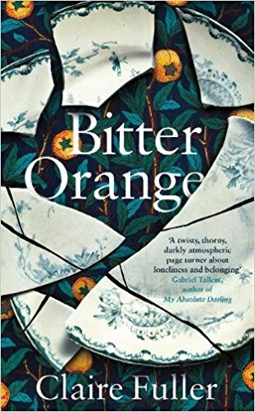
Bitter Orange – Claire Fuller
Loner Frances is spending the summer of 1969 in a dilapidated English country mansion researching the garden architecture for its owner when she is befriended by a bohemian younger couple – Cara and Peter – who are also working in the house. As they begin to spend each day together, Frances is dazzled by her new friends. But as the long hot summer rolls on, she begins to realise that all is not well between the couple and that the stories Cara tells don’t add up. Before long, a small crime is committed which leads to a bigger one which will ultimately scar their lives forever. A wonderfully atmospheric tale of simmering tension which makes perfect (hopefully heatwave) summer reading!

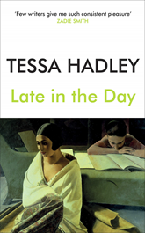
Late in the Day – Tessa Hadley
Alex, Christine, Zach and Lydia have been friends since they first met in their twenties. But the lives of these two close-knit couples are irrevocably changed by an untimely death. In the wake of this bereavement, the three surviving friends turn to each other for comfort but instead of loss bringing them closer, they find over the following months that it alters their relationships, as old entanglements and grievances rise from the past, and love and sorrow give way to anger and bitterness. We are in classic Hadley territory with her latest novel – I love all her books!

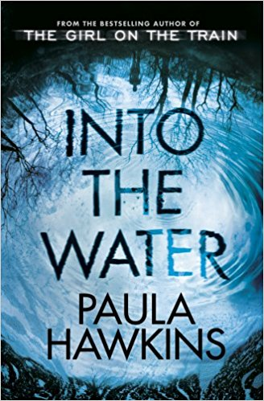
Into the Water – Paula Hawkins
So how do you follow a massive hit like “The Girl on the Train”? Hawkins manages just fine with another gripping psychological thriller. The story – told by multiple narrators - opens with the death of Nel Abbott in the Drowning Pool, a death that her teenage daughter Lena believes was suicide, but that Nel’s estranged sister Jules believes was something else. As Jules looks for answers, in her own past and among the locals, she finds that Nel has made a number of enemies and that she is far from the first victim of the Drowning Pool!

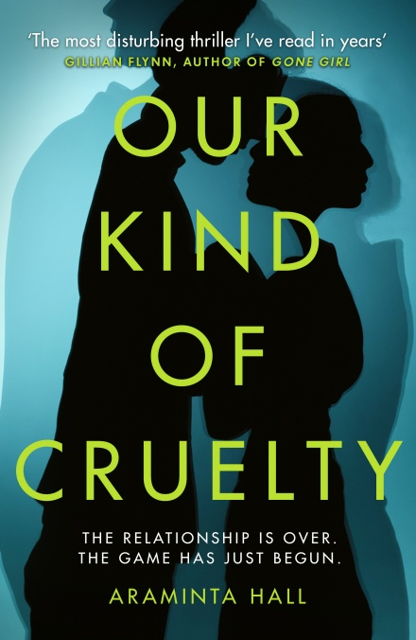
Our Kind of Cruelty – Arminta Hall
Mike fought his way out of a brutal childhood and into a quiet, lonely life, before he met Verity. V taught him about love, and in return, Mike has dedicated his life to making her happy, finding the perfect home and job and turning himself into the ideal V has always wanted. It doesn’t matter that she hasn’t been returning his emails or phone calls. It doesn’t matter that she says she’s marrying someone else! It’s all just part of a secret game they play - the Crave. If Mike watches V closely, he’ll see the signs. If he keeps track of her every move he’ll know just when to come to her rescue…a fantastic tale of obsessive love.

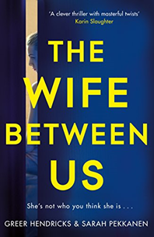

The Wife between Us – Greer Hendricks & Sarah Pekkanen
If you like surprising twists in your stories then this is the book for you. I counted at least two that I did not see coming! In fact there are so many twists that I can’t really say much about the story without revealing spoilers. So expect the unexpected and assume nothing in this thriller as you delve into the complexities of a dysfunctional marriage. A movie version is already in the pipeline so read it first because the book is always better.

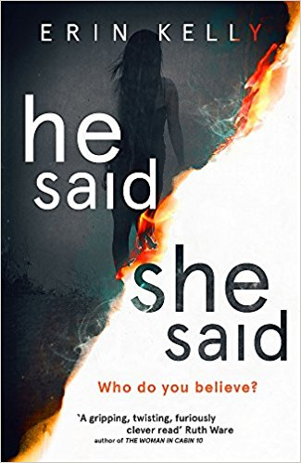
He Said/She Said – Erin Kelly
Its summer 1999, Kit and Laura travel to a festival in Cornwall to see a total eclipse of the sun. Young and in love, they are certain this will be the first of many they’ll share. But in the quiet moments after the eclipse, Laura interrupts a man and a woman. She knows that she saw something terrible. The man denies it. It is her word against his.
The woman seems very grateful. Months later, she turns up on their doorstep like a lonely stray. But as her gratitude takes a distorted turn, Laura begins to wonder—did she trust the wrong person? With twist after gob-smacking twist, this controversial thriller will keep you guessing to the very end.

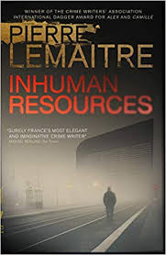
Inhuman Resources – Pierre LeMaitre
Alain Delambre is a 57-year-old former HR executive, drained by four years of hopeless unemployment. He has reached his lowest ebb, and can see no way out. So when a major company finally invites him to an interview, he is ready to do anything to get the job, even if it involves participating in the ultimate recruitment test: a role-playing game that includes hostage-taking! But when secrets are revealed and the truth about the interview comes out, what began as a role-play could quickly become a bloodbath. More stylish noir from my favourite Gallic author. You’ll never look at a job interview in the same way again!

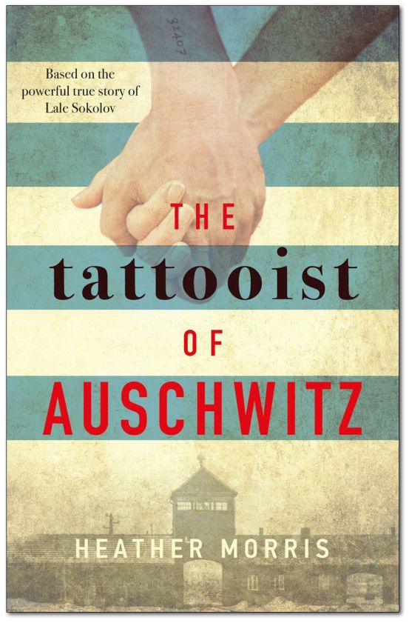
The Tattooist of Auschwitz – Heather Morris
A vivid, harrowing account of Lale Sokolov's true-life experiences as the man who tattooed the arms of thousands of prisoners in the concentration camps at Auschwitz-Birkenau. Imprisoned for over two and a half years, Lale witnesses horrific atrocities - but also incredible acts of bravery and compassion. Risking his own life, he uses his privileged position to exchange jewels and money for food to keep his fellow prisoners alive. One day he comforts a frightened young woman waiting in line to be tattooed. Her name is Gita, and in that first encounter, Lale vows to somehow survive the camp and marry her.

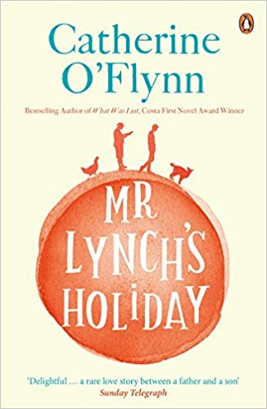
Mr Lynch’s Holiday – Catherine O’Brien
The recession has reduced Lomaverde - a new Spanish utopia for those Brits seeking a place in the sun - to a ghost town where feral cats outnumber the handful of anxious residents who cannot sell their homes to escape. Here, widowed Dermot Lynch turns up one morning to visit his son Eammon and his girlfriend, Laura. Except Eammon never opened his father’s letter announcing his trip. Just like he can't quite get out of bed, or fix anything, or admit Laura has left him. So it'll just be the two of them for two long, hot weeks. Swept up in the British expats' incessant barbecuing and quarrelling, both father and son slowly discover the truth about each other. But at the same time they uncover a shocking secret at the heart of this troubled community. A wonderful read.
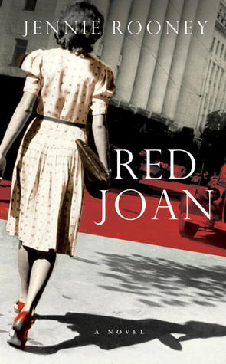
Red Joan – Jennie Rooney
Based on the real life story of Melita Norwood, an eighty seven year old woman who was unmasked as the KGB's longest serving British spy in 1999, this is a superb book. Joan Stanley is a loving grandmother, living quietly in the suburbs, but she has a dark secret and it is about to come back and haunt her. The novel switches effortlessly between the present, and Joan's interrogation by MI5, and flashbacks to her earlier life and her meeting with Leo and Sonya Galich at Cambridge in 1937. Both are known communist sympathizers with ties to Russia and, as Joan grows closer to them, her loyalties are put to the test. I did not see the recent movie adaptation with Judi Dench, but I don’t think it could better the book!

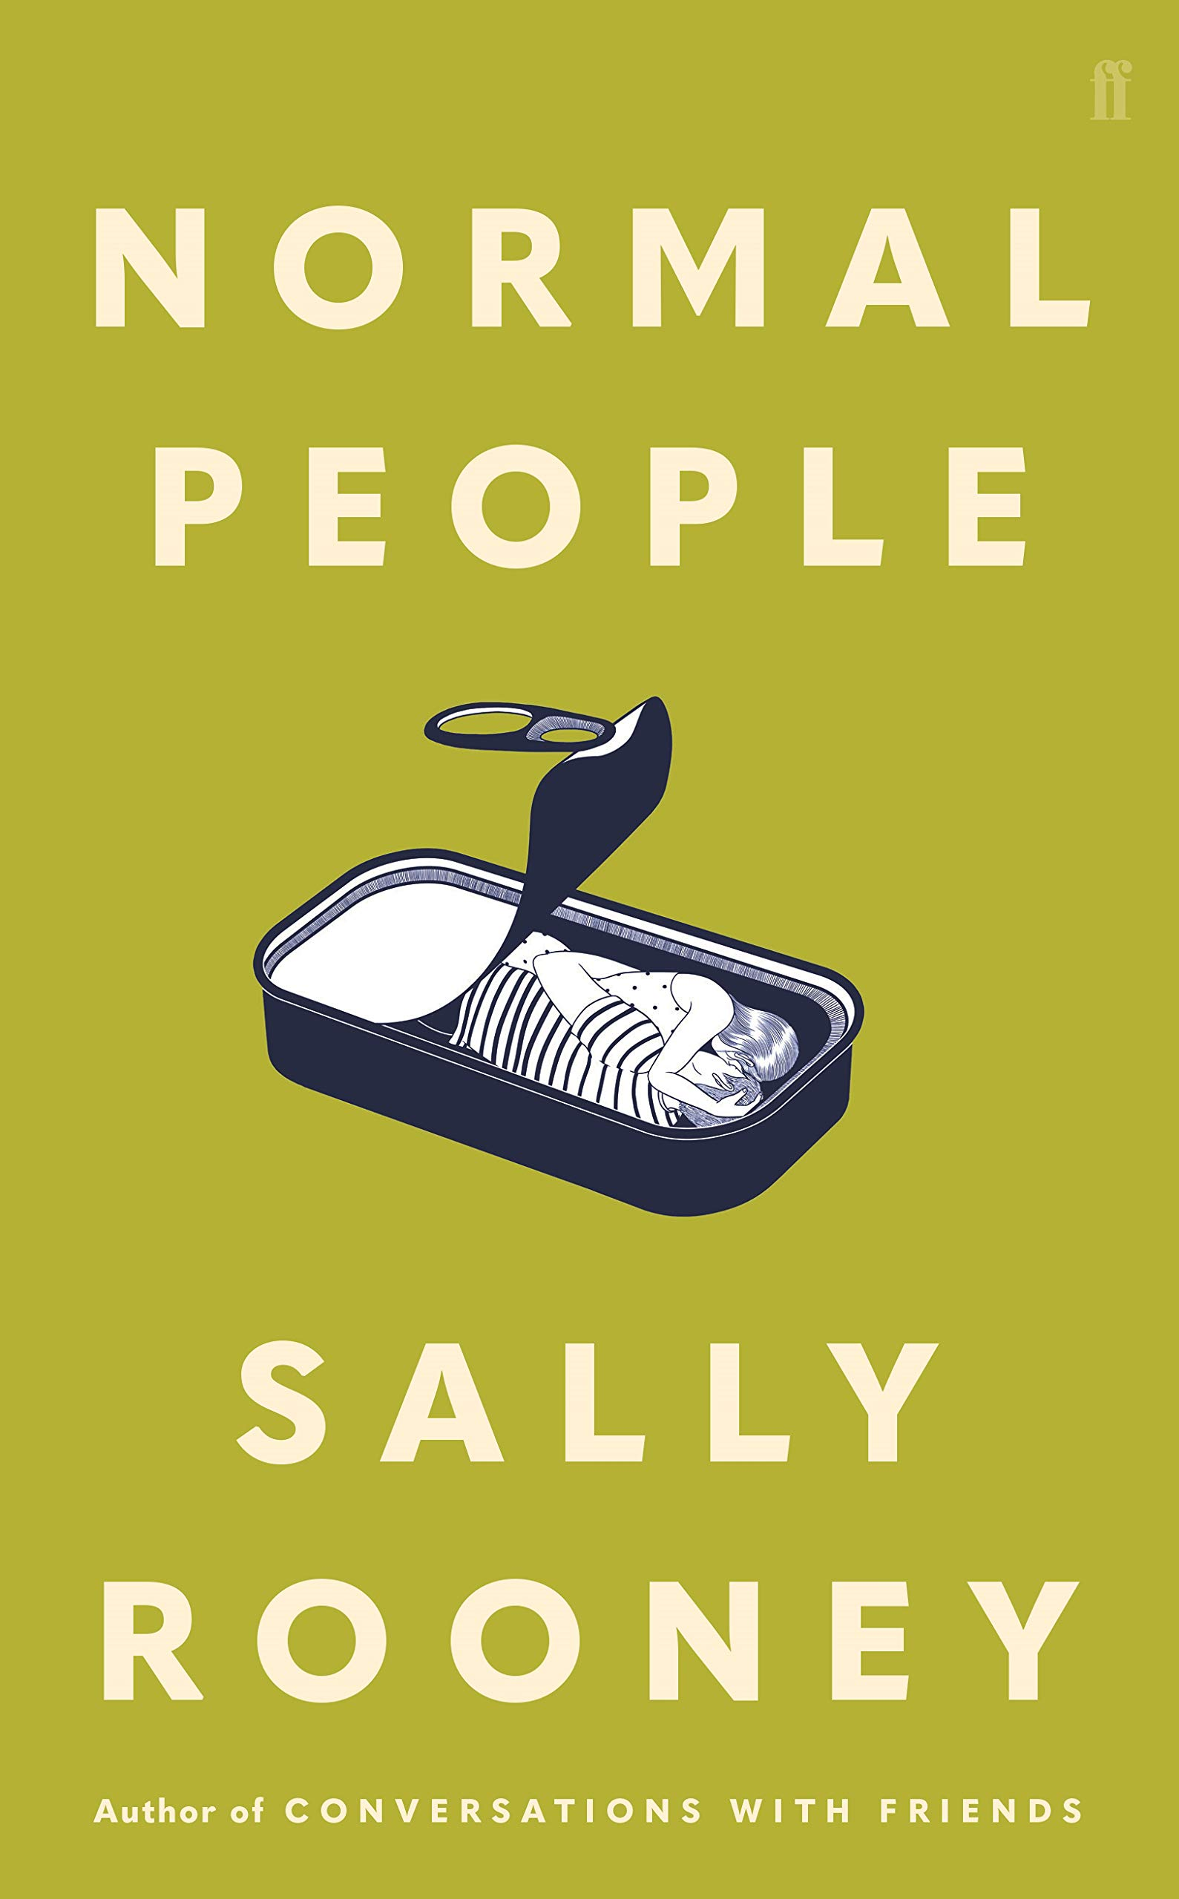
Normal People – Sally Rooney
This is only Sally Rooney’s second novel but has already garnered enormous critical acclaim and won last year’s Costa Novel Award and Waterstones Book of the Year. That said, I find Rooney a bit Marmite and whilst I enjoyed the book I wasn’t swayed by the hype. It is essentially a love story. Connell and Marianne grow up in the same town in rural Ireland but are from very different worlds. They both get places to study at university in Dublin, and a connection that has grown between them despite the social hurdles of school lasts long into the following years. Please try this book…I would be really interested to hear your views. I’m sure some will love it whilst others – like me - won’t quite understand what all the fuss is about!

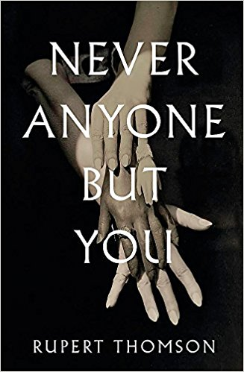
Never Anyone But You – Rupert Thomson
A remarkable and true story. Two young women meet in France just before WW1 – shy Suzanne who has a wonderful talent for drawing and brilliant but troubled Lucie – and embark on a clandestine love affair. Stifled by convention they reinvent themselves in Paris and are swept up in the most glamorous circles and burgeoning surrealist movement. As WW2 breaks out, they flee to Jersey but get caught up in the German occupation of the island. Embarking on a secretive propaganda campaign, they risk capture, torture and even worse. This superb book traces the lives of these brave women as they not only fight gender boundaries but tyranny and oppression.

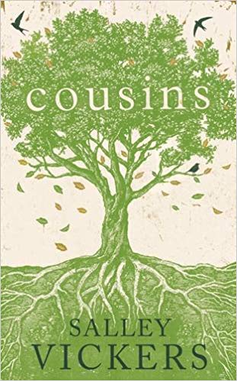
Cousins - Salley Vickers
Brilliant and impulsive Will Tye suffers a life changing accident. The terrible event echoes through three generations of the complex and eccentric Tye family, bringing to light old tragedies and dangerous secrets. Told through the eyes of three women close to Will, his sister, grandmother and aunt, the book takes us on a fascinating journey from the outbreak of World War Two to the present day as each woman takes turns, searching out past events that might have foretold Will’s passion for his cousin Cecelia, his accident and its tragic outcome. I’m a big fan of Salley Vickers’ stories. She recently wrote a wonderful book called “The Librarian” which I loved – with a title like that what’s not to love! If you enjoy “Cousins”, try it too.

Happy Summer Reading Everyone!

