S1/S2 Good Reads
In The Library

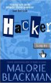  Hacker – Malorie Blackman  When Vicky & Gib’s dad is accused of a crime he did not commit, they hack into a bank’s computer to prove his innocence and find a shocking surprise!  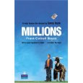  Millions -Frank Cottrell Boyce  What would you do if you found a bag of money and only had a week to spend it? That’s the dilemma facing brothers Damian and Anthony in this hilarious adventure story.  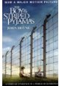  The Boy in the Striped Pyjamas – John Boyne  Two young boys are caught up in the horrific events of the holocaust during World War Two. Bruno – innocent of his surroundings - befriends Shmuel with tragic consequences.  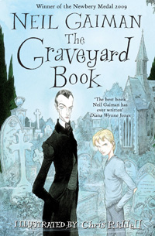  The Graveyard Book – Neil  Gaiman  When his family is killed by the  evil ‘man Jack’, Bod escapes to  the local grave-yard, where the  ghostly inhabitants adopt him.  But can he survive when the  killer is on his trail?  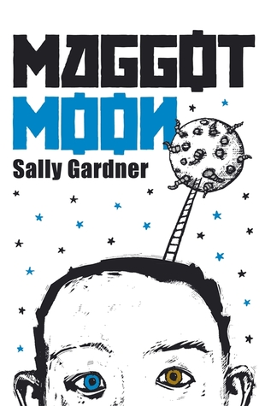  Maggot Moon – Sally Gardner When his best friend Hector is suddenly taken away, Standish realises that it is up to him, his grandfather and a small band of rebels to defeat the evil forces of the Motherland in its race to be first to the moon. |   Noughts & Crosses -Malorie Blackman  Calum & Sephie live in a segregated world. As they grow to love each other, can their friendship survive the evils of apartheid?  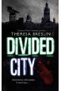  Divided City -Theresa Breslin  A story of racism, bigotry, Rangers, Celtic, football and friendship against the odds. Can Graham and Joe help another boy in trouble?  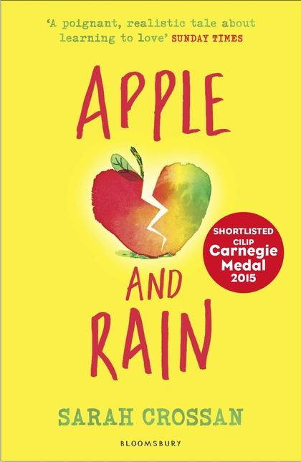  Apple and Rain  Sarah Crossan  Apple’s mum returns after eleven years much to her initial delight. But she soon discovers that her mum is not everything she dreamt of and slowly begins to see things as they really are.  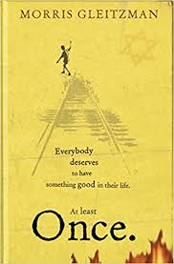  Once – Morris Gleitzman  Felix is a young Jewish boy who escapes the orphanage to save his parents from the Nazis in the occupied Poland of the Second World War. First in a series of six books which tell Felix’s remarkable story.  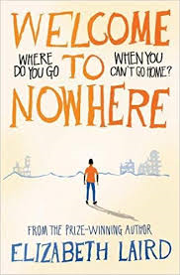  Welcome To Nowhere – Elizabeth Laird  Twelve-year-old Omar and his brothers and sisters were born and raised in Syria. But when the war begins, Omar and his family have no choice but to flee their home with only what they can carry. But where do you go when you can't go home?
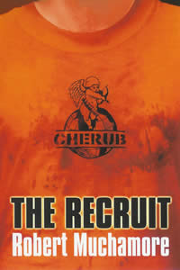  The Recruit – Robert  Muchamore  CHERUB is not James Bond –  there are no master criminals or  high tech gadgets. CHERUB  kids live in the real world. They  slip under the adult radar and  get information that sends  criminals and terrorists to jail.  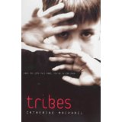  Tribes - Cathy MacPhail  Set in Greenock, Kevin joins a gang and discovers just how dangerous being a member can be. When he decides he’s had enough, he finds leaving the gang could cost him his life!  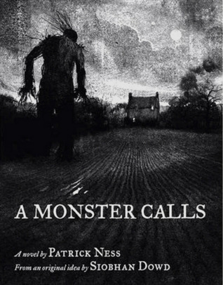  Monster Calls - Patrick Ness  The monster showed up after  midnight. But it isn't the  one Conor expected: the one from his nightmare, the one he's had every night since his mother became ill. This monster is different and it wants the truth.  Carnegie Award winning book.  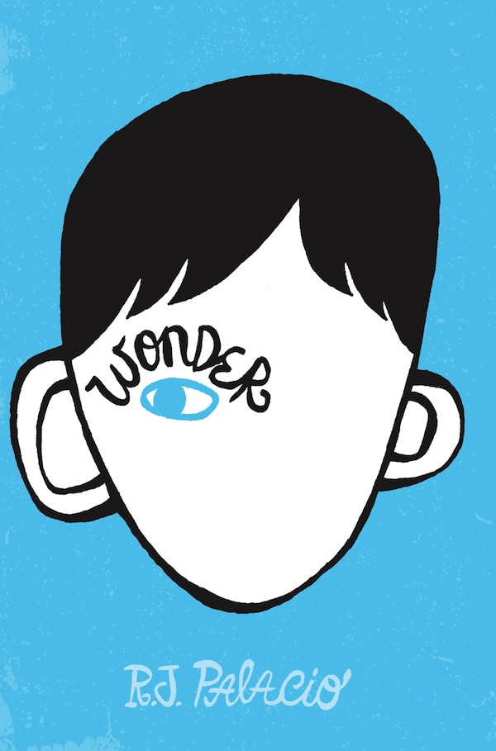  Wonder - R.J. Palacio  Auggie wants to be an ordinary 10 year old. But ordinary kids aren't stared at wherever they go. Born with a severe facial deformity and sent to real school for the first time, can he convince his new classmates that he’s just like them, underneath?  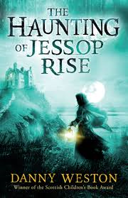  The Haunting of Jessop Rise – Danny Weston  When orphan William arrives at his uncle’s grand house, Jessop Rise, he encounters a ghostly figure!  Who is the spectral creature and what are they trying to tell William? And what is the dark secret that Uncle Seth has been keeping for so long? | 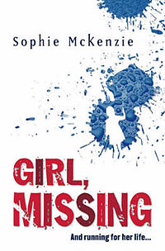  Girl Missing – Sophie McKenzie  Lauren has always known she was  adopted but learns that she  could have been snatched as a  baby! Who are her biological  parents and did her adoptive  parents really kidnap her?  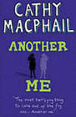  Another Me – Cathy MacPhail  A spooky mystery where Fay discovers she has an evil clone or body double. People say that she has done and said things that she knows she hasn’t. Can she defeat this “other me” or will it take over her life?  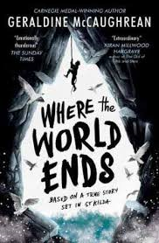  Where the World Ends -  Geraldine McCaughrean  In 1727, a group of men and boys are put ashore on a remote sea rock to collect birds for food. No one returns to collect them. Why? Surely nothing but the end of the world can explain why they have been abandoned. How can they survive?  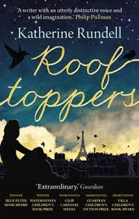  Rooftoppers – Katherine Rundell  Sophie survives a shipwreck and is cared for by her kind rescuer, Charles. When the Welfare Agency threaten to send her to an orphange, they flee to Paris and together search the city and its rooftops for her mother who Sophie is convinced also survived.  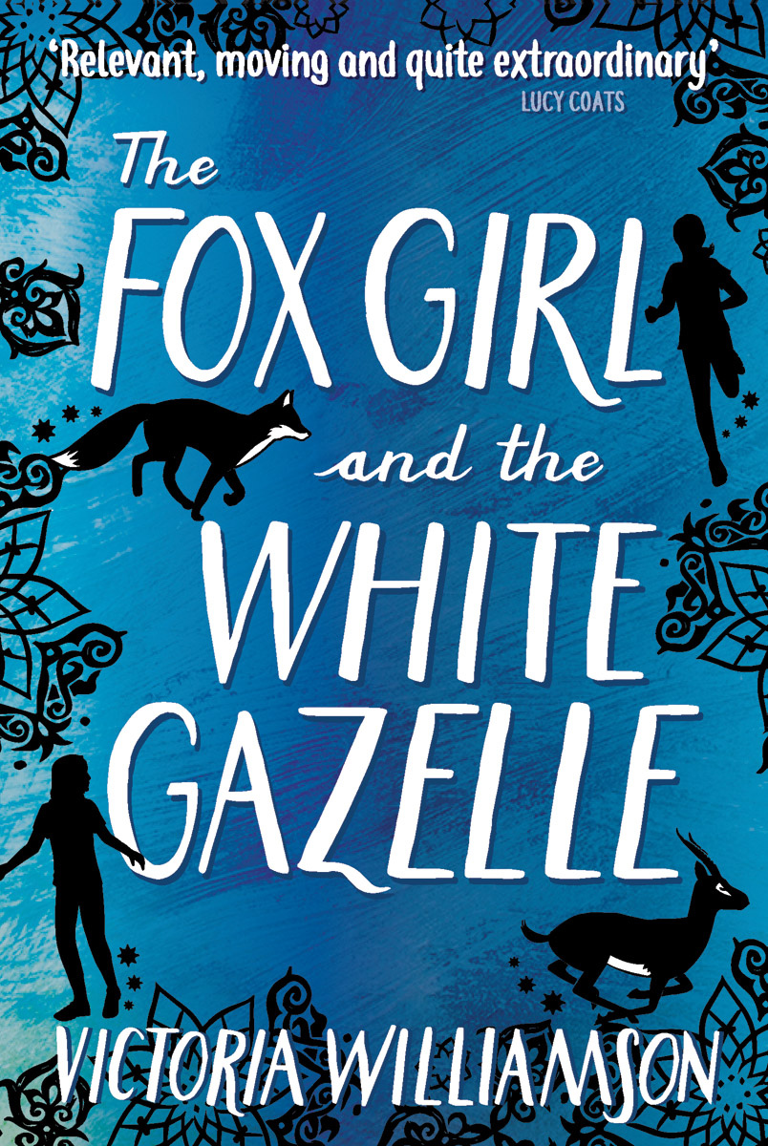  The Fox Girl and the White Gazelle – Victoria Williamson  The uplifting story of two girls, one a Syrian refugee, the other from Glasgow, who have more in common than they could imagine. Reema and Caylin form a unlikely friendship when they discover an injured fox and together learn to believe again, in themselves and in others.

