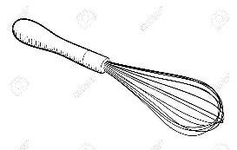
CONCOURS RECETTE DE CUISINE
COMPETITION: WRITE A RECIPE IN FRENCH
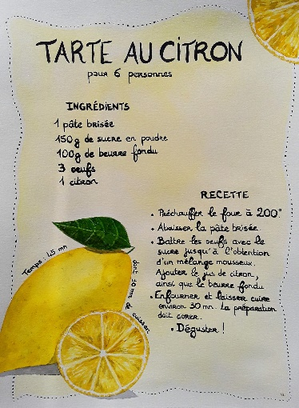
Think about a dish that you like to eat or you know how to cook.
You are going to write this recipe in French on a word/google document.

- Select the ingredients and make sure you write the quantities correctly in French
- Explain the different stages of the recipe – drawings or photos are optional
(you could use phrases like : on met, on mélange, on étale, on rajoute….)
- Get all those info together to create a colourful recipe sheet to share with your class
(you may even try the recipe at home and tell us if your relatives like it….)
- Email your recipe sheet to Madame Parisot gw20parisotettaouchi@glow.sch.uk by 15th February
- The best recipes will appear in the next issue of MCHS Language and Culture Magazine
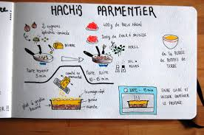

Here are some ideas:
http://boutdegomme.fr/wp-content/uploads/2015/04/La_pate_a_crepes_BDG_2020.pdf
https://www.gulli.fr/Activites/Cuisine/Plats/Lasagnes-a-la-bolognaise

