Discovering the Arabic World

We are very excited to announce that as of 25th May pupils at Mearns Castle High School will be able to participate in Arabic lessons. These classes will be done online through Glow and the initial block will take place from Monday 25th May.

In order to take part in these lessons, which will be initially open to S1-S6, you have to register using the below links:

S1-S3 (BGE): https://forms.office.com/Pages/ResponsePage.aspx?id=oyzTzM4Wj0KVQTctawUZKQlW8c52ipJPqHZrMEGKtM1UNkg5Mjk0QkoxSVdHMFFUTk1OV1JBUUhRQS4u

Senior pupils (S4-S6):
https://forms.office.com/Pages/ResponsePage.aspx?id=oyzTzM4Wj0KVQTctawUZKQlW8c52ipJPqHZrMEGKtM1UNFg0UE9WU0JWVzQyV1A4SkIwRklDQzhRNi4u

The live classes will take place at the following times:

Monday and Wednesday @ 10:40am
Or
Monday @ 13:15 and Wednesday @ 13:50

When you register you must commit to two slots per week and choose from the above options.

The initial block will have more of a cultural focus and introduce us to the customs of the Arab World, with a particular focus on Qatar. This opportunity has been organised in conjunction with the Qatari Education Department and SCILT.

After the summer holidays the plan is that an Arabic language assistant will join us at Mearns Castle High School in order to help pupils studying Arabic to develop their Arabic skills in conjunction with the online classes. In theory this second stage will only be open to S6 pupils – timetable permitting of course.
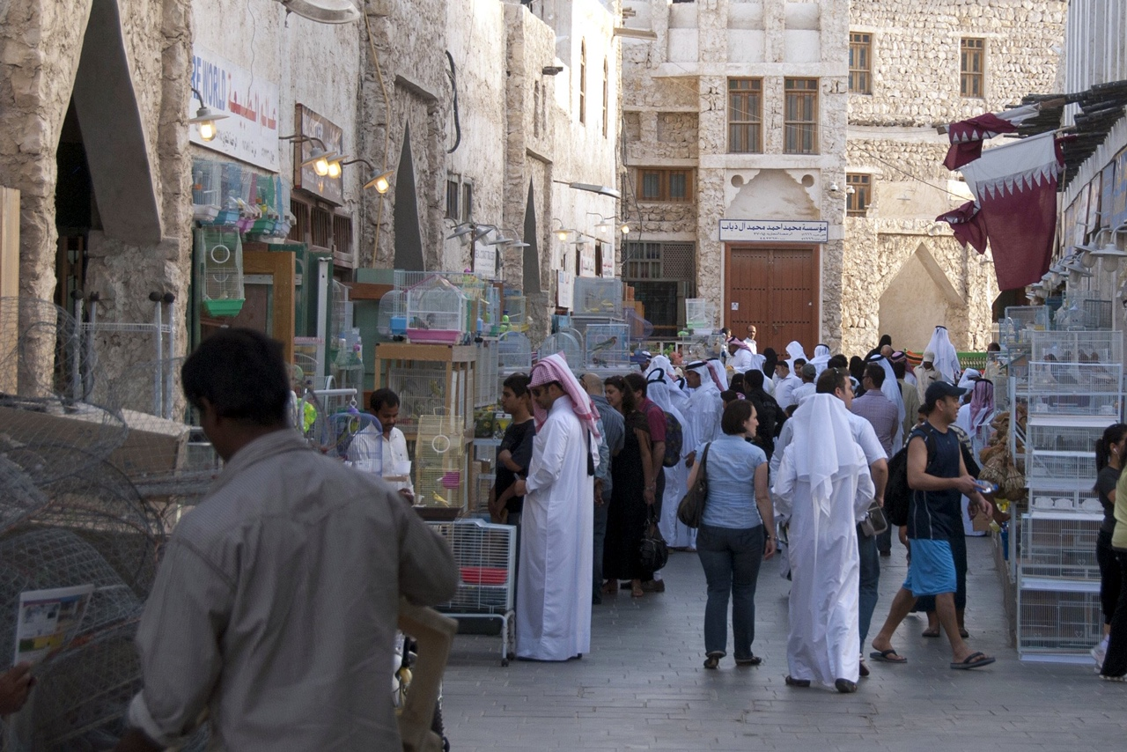

So what do you need to do now?

- Get excited!
- Register online for the classes which suit you. (links above)
- Put the time and days in your diary so that you do not forget.

I think you will all agree this is a great opportunity to widen our horizons and learn about the Arabic World. Maybe just what we need during these long days of home study.

مع تحياتي
السيدةRoss
(Think this means Regards, Mrs Ross!)

