NATIONAL 5 & HIGHER
Grammar booklet

In this booklet you will find 5 topics:
- Top 20 common used verbs
- Time expression
- Connecting word(N5 and Higher)
- Question word
- Useful phrases (N5 and Higher)
- Frequent words(Time, position, verb and exclamation)

NATIONAL 5
A. Top 20 common used verbs
- To have/there is, are有 (yǒu)  Originally, the top part of the 有 (yǒu) character resembled a hand 手 (shǒu) and the bottom radical looked more like meat 肉 (ròu). Now, man has forgotten about meat and strives to possess or have the moon 月 (yuè), which now makes up the bottom of the character. | 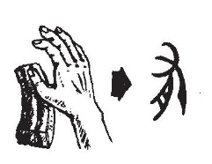
- To be 是 (shì)  In Chinese the character 是 (shì), not only means ‘to be’, but can also sometimes be used to say ‘yes’ or ‘correct’. 是 (shì) shows the sun 日 (rì) over the character for ‘exact’, 正 (zhèng). The meaning is that the sun is precisely on the meridian line and therefore a standard of correctness.  I am a teacher. 我是一个老师。 | 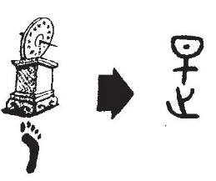
- To like 喜欢 (xǐ huan)  The 喜 (xǐ) character represents happiness which is often expressed with music and singing. The top half of the character depicts a drum on its stand and a hand striking it.  I like her. 我喜欢她。 | 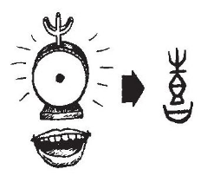  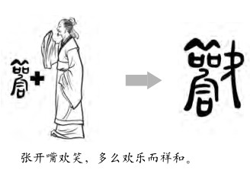
- To love 爱 (ài)  The simplified character of 爱 (ài) is made up of three parts: ‘breathe’ , ‘hand’ and ‘co-operation’. It suggests that love is more about friendship which is represented by the hand 手 (shǒu) than by the heart 心 (xīn) which is seen in the traditional character of love 愛 (ài) .  I love him 我爱他。 | 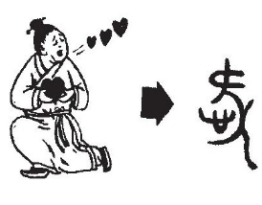
- to eat 吃 (chī)  The character 吃 (chī) has the mouth 口 (kǒu) radical, and the character 乞 (qǐ) meaning to beg.This right side of the character provides the pronunciation of the character (qǐ –>chī).  I am eating noodles. 我在吃面。 | 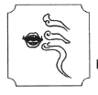
- To drink 喝 (hē)  The 喝 (hē) character features the mouth 口 (kǒu) radical to the left. On the top right-hand side is the sun 日 (rì), underneath there is a man 人 (rén) leaning against an object and sitting in the shade. This suggests that a person might drink something when taking a rest from working in the sun.  I drink tea. 我喝茶。 | 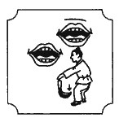
- To Go 去 (qù)  去 (qù) is a pictograph of an empty vessel 厶 (sī), say a bowl or pot and it’s cover, representedby the 土 (tǔ). Once the lid is taken off, the contents of the vessel are ready to ‘go’.  I go to Beijing often. 我经常去北京。 | 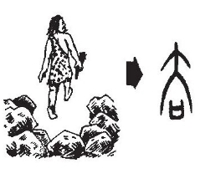
- To See 看 (kàn)  The character 看 (kàn) depicts a hand 手 (shǒu) covering the eyes 目 (mù) as it looks at the sun.  I like to watch movies. 我喜欢看电影。 | 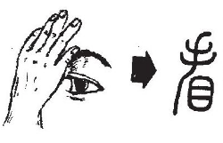
- To Think 想 (xiǎng) /觉得 (jué de)  The character 想 (xiǎng) is composed of three parts: the tree 木 (mù), the eye 目 (mù) and the heart 心 (xīn). An interpretation of the character is that the eye is behind the tree looking out for or inspecting for possible danger. The heart in Chinese culture often represents both heart and mind, and suggests the examination of the heart or to think or ponder.  I think it’s strange. 我觉得很奇怪。 | 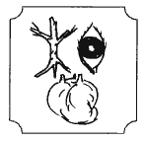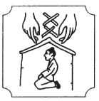
- to want 要 (yào)  The original meaning of this character was‘waist’ 腰 (yāo), and depicts a woman 女 (nǚ) pointing to her midsection 西 (xī).  I want an apple. 我要一个苹果。 | 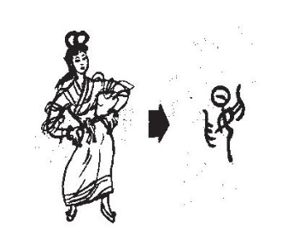
- To Do/Make 做 (zuò)
The character 做 (zuò) shows a man 人 (rén) causing 故 (gù) an effect by doing something.
I make dinner every day. 每天我都做晚饭。
- To Sit 坐 (zuò)  The character 坐 (zuò) is a pictograph depicting two men 人 (rén) 人 sitting on the ground 土 (tǔ)facing each other.  I usually sit there when I go to the library. 当我去图书馆我习惯坐那里。 | 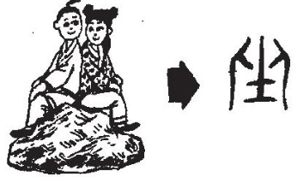
- To open 打开/开 (dǎ kāi / kāi)  It’s easier to look at the traditional character (開) of 开 (kāi) to understand why it looks the way it does. Once surrounded by a door 門 (mén), the 开 represented two hands removing a bolt or bar from the door in order to open it.  Open the door 开门 Drive 开车 Start 开始 | 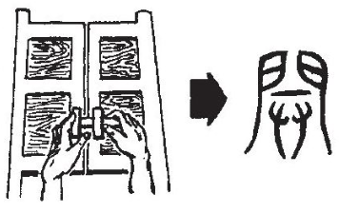
- To Use 用 (yòng)  The original form of the 用 (yòng) character was a water bucket 桶 (tǒng). The character 用 (yòng) takes its pronunciation from the 桶 (tǒng) character.  I use my mobile phone too much. 我用手机的频率太高了。 | 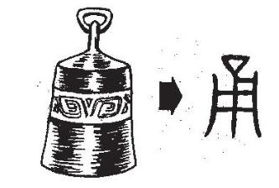
- To Find 找 (zhǎo)  The 找 (zhǎo) character is made of a hand 手 (shǒu) and a spear 戈 (gē) suggesting a time when food needed to be found.  I can find the book. 我可以找到那本书。 | 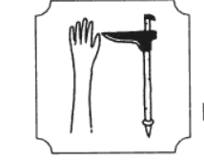
- To tell 告诉 (gào su)  The second character 诉 (sù) features the ‘speech radical’ 讠 (yán) and the character 斥 (chì) meaning ‘to reprimand’.  Tell me his phone number 告诉我他的电话号码。 | 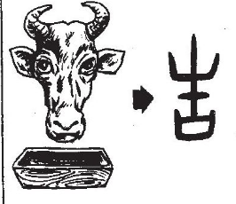  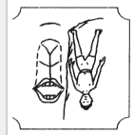
- To know 知道 (zhī dào)  The character 知 (zhī) is shown as an arrow 矢 (shǐ) and a mouth 口 (kǒu) which represents knowledge. The idea is that a person with knowledge speaks 口 (kǒu) with the precision of an arrow 矢 (shǐ).  I know. 我知道。 | 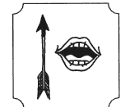  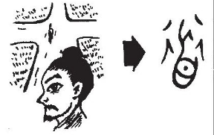
- To Ask 问 (wèn)  The 问 (wèn) character shows a door 门 (mén) surrounding a mouth 口 (kǒu). As many introductions would occur in the entrance to a house in Chinese culture, it would be a place where neighbours would ask or inquire about the family inside.  Please ask your friend. 请问你的朋友。 | 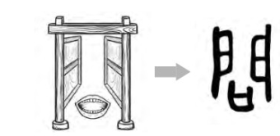
- To take 拿 (ná)  The 拿 (ná) character depicts a hand 手 (shǒu) on the bottom of the character, whilst on the top is the character for unity 合 (hé). If you take something into your hand then you have unity and togetherness.  Please take the book 请拿上这本书。 | 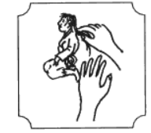
- To give 给 (gěi)  The radical on the left side of the character 给 (gěi) is silk 丝 (sī), traditionally given as a present. Combined with the character for unity 合 (hé) suggests happiness when giving something.  Please give me… 请给我…  I will show you. 我给你看。 | 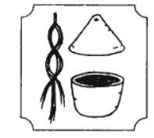
B. Time expression
1. Past tense: to talk about the past
English | Simplified | Traditional
 | 过guò  Eg:拿过,听过,看过  ná guò, tīng guò , kàn guò | 過  Eg:拿過,聽過,看過
- I have been to Paris.
- Have you seen that movie?
- I have bought chocolate here before, it's not good.
Before | 以前yǐ qián, | 以前
- Before, I could not speak Chinese.
- Before, I was a teacher.
- In the past, people would visit their relatives in Chinese New Year, but nowadays, we just use the phone to greet.
Before | Specific action or time + 之前 zhī qián | 之前
- Before I came to UK, I was an English teacher.
- Before you go to bed, you should brush your teeth.
- Before the examine, you need to review the lessons.
Completed the action, but is not needed when expressing a habit | 了le  Eg:拿了 ná le ,听了 tīng le,看了 kàn le | 了 Eg:拿了,聽了,看了
- The supermarket is about to close.
- He has gone to work.
- I saw this film; I think it’s very brilliant.
- My dad has gone to Tianjin.
2. Present perfect tense(1): for something that started in the past and finished in the past.
English | Simplified | Traditional
Already/ did/ done/ | 已经 yǐ jīng | 已經
  - I have already read that novel.
  - I have already made up my mind to be a translator in the future.
  - The Spanish course has already started.
Used to/ past experience | 曾经 céng jīng | 曾經
- I have been to China.
- My father has been working in France.
- I used to stay in Beijing for 6 months.
- I was a part-time waitress in a coffee shop.

3. Present perfect tense(2): for something that started in the past and
continues in the present.
English | Simplified | Traditional
 | 了le | 了
- I have (already) been learning Chinese for 5 years in Hillhead High School.
- Miss Lin has (already) been playing tennis for 3 hours.
- Xiao Ming has eaten 20 dumplings; he still wants to eat more.
4. Present continue tense: for something is happening at the moment of speaking or happening before and after a given time.
English | Simplified | Traditional
Now | 着zhe/正在 zhèng zài /目前mù qián/ 现在 xiàn zài  Eg:拿着 ná zhe/听着 tīng zhe/  看着 kàn zhe | 著/正在/目前/現在  Eg:拿著/聽著/看著
- I am reading a book.
- Currently, I am learning 7 subjects in school.
- At eight o’clock in the morning, we are usually having breakfast.
- It is class time, you shouldn’t chat with classmates.
5. Future tense: for something will happen in the future.
English | Simplified | Traditional
After/later | 以后yǐ hòu | 以後
- Later, I plan to find a job in China.
- He doesn't want to live in Japan later.
After | Specific time or action + 之后 zhī hòu | 之後
- After two weeks, I'm going to back (return) to America.
- After an hour, we'll probably go out to eat.
- After the school, I am going to have my violin lesson.
In the future | 未来 Wèi lái /将来 jiāng lái /打算 dǎ suàn | 未來/將來/打算
- I want to become a teacher in the future.
- I want to go to China for study in the future.
- I plan to buy a house in London.
- I plan to go to French seaside to go for a walk.
- My boyfriend plans to become a football player in the future.
Thinking of … | 想xiǎng (要 yào, 去 qù,做 zuò) | 想(要,去,做)
- My family and I want to visit China this summer holiday.
- I am thinking to study something relative with language in university.
- After I graduate from secondary, I want to take one year of gap year to travel around the world to gain the different experience.
C. Connecting word: National 5
1.
English | Simplified | Traditional
And | 和hé | 和
 | 跟gēn | 跟
With | 和…一起hé…yì qǐ | 和…一起
And… and… | 又…又…yòu …yòu | 又…又…
1. He and I are good friends.
2. Last year, I went to Germany with my parents for holiday.
3. She is an optimistic and self-confident person.
4. I can speak fluently English and French.
5. She dances and sings song.
6. This apartment is big and bright.
2.
English | Simplified | Traditional
Both/all | 都dōu | 都
- My parents and I all have travelled to China before.
- When it is Chinese Moon Festival, people will all go home to reunion with family.
- We all believe that education can change your future life.
3.
English | Simplified | Traditional
When | 当…的时候dāng …shí hòu | 當…的時候
1. When I was a kid, I wanted to be a lawyer.
2. My father was watching TV when I was doing homework.
3. When I have a lot of pressure from academic, I will go exercise or chat with my
best friends.
4.
English | Simplified | Traditional
The more… the more… | 越…越…yuè… yuè… | 越…越…
- Gasoline is getting more and more expensive.
- The more complex the work is, the more interesting it is.
- The more he drinks soda, the fatter he gets.
- 汉语受到各国越来越多人的重视。
- 普通话的学习风气越来越流行。

5.
English | Simplified | Traditional
Or | 还是hái shi | 還是
- Would you like coffee or tea?
- Do you want to learn Chinese or French?
- I don’t know if she watched a movie or did homework last night.
- I don't know if this book is his or mine.
6.
English | Simplified | Traditional
Because/Since… so | 因为…所以yīn wèi … suǒ yǐ | 因為…所以
- Because it’s too hot, (so) I'm going to drink some iced Coke.
- Since I want to go to China, I am going to study Chinese.
- Since he isn't here, I called him.
7.
English | Simplified | Traditional
But, however | 但是dàn shì/可是kě shì | 但是/可是
- Chinese is very useful, but it is very hard.
- I like that piece of clothing, but it is too expensive.
- That place is beautiful, but I think there are too many people there.
- I like this piece of clothing; however it’s a little bit expensive.
- This house is nice; however it’s a little bit far away.
- In the past, during the Chinese New year, people would visit each other in person, but nowadays people use social media to say Happy New Year instead.
8.
English | Simplified | Traditional
As soon as | 一…就…yì …jiù… | 一…就…
- As soon as I saw him, I was nervous.
- As soon as I think about going to Paris next month, I feel excited.
- As soon as the school finishes, he goes home.
- As soon as the teacher arrives, we will start our lesson.
9.
English | Simplified | Traditional
As… as… | 一边…一边… yì biān… yì biān | 一邊…一邊…
- As she watched TV, as she ate dumplings.
- As Glasgow is rainy, as is windy.
- As he is playing computer games, as listening to music.

10.
English | Simplified | Traditional
Also/too/either | 也yě | 也
- They are also French.
- I like to eat dumplings too.
- He doesn't know either.
11.
English | Simplified | Traditional
Not only…but also | 不但 bú dàn /不仅bù jǐn …还hái/而且ér qiě | 不但/不僅…還 /而且
- She can not only speak Mandarin, but can also speak Japanese.
- This kind of vegetable is not only delicious, but also nutritious as well.
- Some Chinese people in Britain not only celebrate the Spring Festival, but also celebrate Christmas.
- 如果你到中国游览， 不仅会看到一些让人难忘的名胜古迹，还能品尝各式美味和体验传统的节日。
12.
English | Simplified | Traditional
Besides/in addition to | 除了…还chú le… hái | 除了…還
- In addition to Hainan Island, I also want to travel to Taiwan.
- In addition to beef, she also likes to chicken.
- In addition to Jackie Chen, Jet Li is also very famous as a kung fu star.
13.
English | Simplified | Traditional
Except(for) | 除了…都chú le… dōu | 除了…都
- He will drink anything except white wine.
- Except for Xiao Wang, we can all speak English.
14.
English | Simplified | Traditional
As same as | 一样yī yàng | 一樣
- They are as cool as we are.
- The weather here is just as hot as Shanghai.
- This apartment is just as big as that apartment.
- I am just as busy as you.

15.
English | Simplified | Traditional
Although…but… | 虽然…但是…suī rán… dàn shì | 雖然…但是…
- Although he's American, he still hasn't been to Washington D.C.
- Although he‘s got a rich family, he never wastes money.
- Although she said she isn't hungry, she ordered a lot of food.
16.
English | Simplified | Traditional
From…right away | 从…就cóng… jiù | 從…就
- From now on, you start to learn Spanish right away.
- From tomorrow, you should prepare the national exam.
- From next year, I’m going to work in a Scottish high school.
17.
English | Simplified | Traditional
Sometimes…sometimes | 有时…有时yǒu shí …yǒu shí | 有時…有時
- At weekends, I sometimes go shopping, sometimes go to gym.
- Sometimes the weather is raining, sometimes is sunny.
18.
English | Simplified | Traditional
First…then | 首先…然后shǒu xiān… rán hòu | 首先…然後
- First we should finish the work, and then we can go to restaurant.
- You have to do your homework first, and then you can hang out with your friends.
- First, I would like to introduce myself, and then I would like to talk about my future plan.
19.
English | Simplified | Traditional
in order to/in order that /for the purpose of | 为了wèi le | 為了
- In order to have a good future, I have to study hard.
- In order to go to China, he learns Chinese six hours every day.
- In order to keep fit, you must exercise more.
20.
English | Simplified | Traditional
from the point of view of | 对…来说(informal)／而言(formal)… | 對…來說/而言…
- According to him, family is more important than anything else.
- For people born in the eighties, Internet dating is totally normal.

B: Connecting word: Higher
1.
English | Simplified | Traditional
And | 与yǔ | 與
 | 以及yǐ jí | 以及
- My friend and I like mountain climbing the most.
- Currently, I am learning Business and Computing.
- The other classmates and I are all going to celebrate Chinese New Year.
2.
English | Simplified | Traditional
Regardless | 无论…都… wú lùn…dōu… | 無論…
No matter/regardless of | 不管…还是… bù guǎn…hái shì... | 不管…還是…
- Regardless, our parents or overseas youngsters both don’t have the thought that it must buy the house when getting married.
- Either smoking or drinking is all bad to the body.
- It doesn’t matter rainy or sunny; I will go for the competition.
- No matter snowing or raining, we are going to climb the mountains on Sunday.
- No matter you are 18 or 80, you should insist doing the exercise regularly.
- 无论一个国家的经济发展多么迅速，政府都必须提供基本的生活保障。
- 无论在城市还是农村，家家户户都会贴上春联。
3.
English | Simplified | Traditional
Or | 或者huò zhě/ 或是huò shì | 或者/或是
- I like to eat Chinese food or French food.
- I want to play football or swimming on this weekend.
- She plans to go climbing or go skiing with her family.
4.
English | Simplified | Traditional
Just/only | 只zhǐ | 只
- I only have a few good friends.
- Why are there only 5 people here?
- There is nothing else we can do, this is the only way.
- We only went to Beijing and Tianjin those two cities.

5.
English | Simplified | Traditional
As long as | 只要…就…zhǐ yào… jiù… | 只要…就…
- As long as everyone does one good thing every day, then society will become harmonious.
- As long as it's raining, she will be in a bad mood.
- As long as you want to learn how to swim, I will teach you.
6.
English | Simplified | Traditional
If | 如果rú guǒ/假如 jiǎ rú /要是 yào shì | 如果/假如/要是
- If you're not busy, can you help me connect with customers?
- What would you do if you fail the exam?
- If there is no water, what would this world become?
7.
English | Simplified | Traditional
If…then | 如果rú guǒ/假如 jiǎ rú /要是 yào shì…就jiù… | 如果/假如/要是…就…
- If I can't find a job in Beijing, then I'm going to go back to Kunming.
- If we have enough money, then we will travel around the world.
- If you don't review well, then you won't be able to pass tomorrow's test.
- 许多人相信，如果学生能够熟练地运用中文，就会为他们将来的就业和发展事业增加优势。
8.
English | Simplified | Traditional
Even … still … | 即使…也… jí shǐ… yě… | 既使 …也…
- Even I am very busy, I still go exercise every day.
- As long as I like it, even it is very expensive, I will buy it.
- Even you don’t like her, you can’t treat her that way.
9.
English | Simplified | Traditional
Since as | 既然 jì rán…就 jiù /便biàn … | 既然…就/便…
- Since you are really busy right now, I will come back tomorrow to talk.
- Since you broke the light, you need to repair it.
- Since you chose to learn Chinese, don’t give up.

10.
English | Simplified | Traditional
Even though | 尽管…还… jǐn guǎn… hái… | 儘管... 還…
- Even though she said she isn't hungry, she ordered a lot of food.
- Even though it is raining heavily, she still prepared to go hiking.
- Even though I found the wallet, the money was gone.
11.
English | Simplified | Traditional
would rather … | …宁可…也… nìng kě… yě… | 寧可…也…
- Chinese parents would rather work harder to provide their child the best education.
- Nowadays, young generations would spend time with their friend, rather their parents.
- I would rather not sleep, I would finish this homework.

D. Question word
English | Simplified | Traditional
What | 什么shén me | 什麼
- What do you like to eat?
- What is your hobby?

Who/whom | 谁shuí | 誰
- Who do you like?
- Who is your favourite singer?

Where | 哪儿 nǎ ér /哪里nǎ li | 哪兒/哪裡
- Where are you planning to go?
- Excuse me, where is museum?
When/what time | 什么时候shén mē shí hòu | 什麼時候
- When do you plan to go to Spain for traveling?
- When is the best time to go for a walk?
How | 怎么zěn me/ 如何 rú hé | 怎麼/如何
- Excuse me, how to go to the library?
- How to make this kind of cake?
How about | 怎么样zěn me yàng | 怎麼樣
- How about we watch a movie first, then have a dinner?
- How about you to skiing with your family in summer holiday?
Which one/more than two | 哪个nǎ ge/哪些 nǎ xiē | 哪個，哪些
- In these subjects, which subjects are you interested in?
- Which city do you like the most?
- In those job advertisements, which ones do you prefer?
How many/how much | 多少duō shǎo，几 jǐ | 多少，幾
- How many students are there in you class?
- How many countries have you been?
Question particle for subjects already mentioned | 呢ne | 呢
- It's raining in Beijing. How about Shanghai?
- I like listening to the music and watching movies, you?
Question particle | 吗ma | 嗎
- Do you like playing tennis?
- Do you have English class today?
- Is Wednesday today?

E. Useful Phrases: National 5
1.
English |  | Simplified | Traditional
According to ; based on |  | 根据gēn jù | 根據
- According to my opinion, he is an active person.
- According to his experience, we can apply for a new job tomorrow.
- According to weather report, Glasgow might be raining tomorrow; the temperature is around ten degree.
- This film is rearranged basing on the novel.
- 根据新闻报导，我们应该过更健康的生活。专家不断告诉养成习惯，定期做运动。另外，还要饮食均衡和充足的睡眠。
2.
English |  | Simplified | Traditional
And then; after that |  | 然后rán hòu | 然後
- I'm going to eat, then I'll go to the supermarket.
- He told me the good news, then he told me the bad news.
3.
English |  | Simplified | Traditional
Compare with …. |  | 比 bǐ /更 gèng | 比/更
To compare/quite/rather |  | 比较bǐ jiào | 比較
- Don’t eat cakes, eating fruit is quite good.
- I run faster than my younger brother.
- Compared with Chinese education system, I more prefer Western education system.
- I think Chinese style eating habit is healthier than Western.
superlative | 最 zuì |  |  | 最
- Have you seen the latest movie?
- Where is the closest subway station?
- Do you know which the most effective way of learning Chinese is?
4.
English |  | Simplified | Traditional
Then; at that time |  | 当时dāng shí | 當時
- At that time, I didn't really know what to do.
- At that time, I was very thin.

F. Useful Phrases: Higher
1.
English | Simplified | Traditional
Regarding; as far as…is concerned | 对于 duì yú | 對於
- As far as swimming concerned, we both are very interested in.
- Regarding this situation, what do you think?
- As far as I am concerned, exam-oriented education is the cause of exam stress.
2.
English | Simplified | Traditional
Along with; in the wake of; with | 随着suí zhe | 隨著
- In the wake of development of Chinese economy, more and more foreigners want to work in China.
- Along with he got older, he became more mature.
- With the increasing population, there are more and more social problems in big cities.
- In the wake of the development of social networking sites, young people don’t often go out to bars.
- 随着互联网的不断壮大，你任何时候都可以浏览到感兴趣的最新消息。而且对许多人来说，在家用电脑比出去买报纸方便得多。
3.
English | Simplified | Traditional
Therefore; for this reason | 因此yīn cǐ | 因此
- She grew up in the country, therefore she understands the country people's way of life.
- He is a good writer; therefore his books are very popular.
- She has an excellent language skill; therefore she decided to learn a foreign language in the university.
4.
English | Simplified | Traditional
As a result; consequently; thus | 于是yú shì | 於是
- The dance show was cancelled, thus I go to see a movie with my friend.
- He cannot speak English, as a result, his parent hire an English tutor for him.
- Today is Sunny, thus they are going to the beach.
- She ate too many sweet snacks and oily fast food; consequently, she has recently become obese.

5.
English | Simplified | Traditional
Instead of; in place of | 代替 dài tì/而不是ér bú shì | 代替/而不是
- It is better to try taking stairs instead of using lift, and walking instead of driving.
- If you want to lose weight, you should eat more fruit instead of dessert.
- I prefer traditional Chinese medicine instead of Western medicine when I am sick.
- Some politicians believe that adopting a system of education for all-around development in place of exam- oriented education is the most efficient way to teach students.
6.
English | Simplified | Traditional
In fact; actually; as a matter of fact | 其实qí shí | 其實
- The way you dealt with it actually didn't solve those problems of our clients.
- Actually I like to drink coffee, don’t like to drink tea.
- As a matter of fact, being over-optimistic is not a good thing.
7.
English | Simplified | Traditional
And; furthermore; moreover | 并bìng | 並
- Controlling your diet and also exercising more will give you a better and better figure.
- He is not merely studying Chinese, but also teaching it at a basic level.
- She can speak fluent French, and has excellent communication ability.
8.
English | Simplified | Traditional
Not | 并不bìng bù | 並不
- Miss Li doesn’t want to get married.
- Complaint can’t solve the problem.
- High scores can’t help you get a good job.
9.
English | Simplified | Traditional
But; however; only | 不过 bú guò/ 然而rán ér | 不過/然而
- Homemade food is healthier; however it’s not as cheap as the supermarket's.
- He's only sixteen, but he is studying in the university.
- She is good at swimming; however she didn’t win the game.

10.
English | Simplified | Traditional
At the same time/simultaneously/while | 同时tóng shí | 同時
- I think drinking alcohol and dancing at the same time is very hard.
- That guy laughs while he talks.
- I listen to music while working.
- Apart from having discipline, Wushu also requires people to be flexible at the same time.
11.
English | Simplified | Traditional
Due to; because of; owing to | 由于yóu yú | 由於
- Due to differing opinions, two bosses started to argue.
- Due to the fact that he didn’t finish reading the careers guidance booklet, he chose an unsuitable job.
- Because of air pollution, air of Beijing is very bad.
- 由于肥胖问题在中国越来越严重，政府因此提出了新的解决方法。
12.
English | Simplified | Traditional
On the contrast | 相反地xiāng fǎn dì | 相反地
- Before the exam, instead of studying, Ted went out with friends to have some fun.
- We thought he would choose that bigger company, out of our surprise, he chose the other smaller company instead.
- The customer was rude to the hotel receptionist, but the receptionist was not angry, on the contrast, she showed her best customer skill and manner to the customer.

E. Frequency words

时间Time
English | Simplified | Traditional
Today | 今天jīn tiān | 今天
Tomorrow | 明天míng tiān | 明天
The day after tomorrow | 后天hòu tiān | 後天
Yesterday | 昨天zuó tiān | 昨天
The day before yesterday | 前天qián tiān | 前天
Last month | 上个月shàng gè yuè | 上個月
Next month | 下星期xià xīng qī | 下星期
Last year | 去年qù nián | 去年
The year before last year | 前年qián nián | 前年
morning | 早上zǎo shàng | 早上
Afternoon | 下午xiàwǔ | 下午
Evening/night | 晚上wǎn shàng | 晚上
Two days ago | 两天前liǎng tiān qián | 兩天前
Weekday | 平时píng shí | 平時
Weekend | 假日jiàrì/周末 zhōumò | 假日/周末
During | 期间qī jiān/中 zhōng | 期間/中

位置position
English | Simplified | Traditional
Front | 前 qián | 前
Back | 后 hòu | 後
Left | 左 zuǒ | 左
Right | 右 yòu | 右
Upside | 上面 shàng miàn | 上面
Bottom side | 下面 xià miàn | 下面
Side | 边 biān | 邊
In | 里 lǐ | 裡
Out | 外 wài | 外

动词Verbs
English | Simplified | Traditional
Can/be able to | 能néng/能够néng gòu | 能/能够
Can/be able to | 可以kě yǐ | 可以
Can/be able to | 会huì | 會
- After school, I am able to go shopping with you.
- After school, I can go shopping with you.
- I can speak 4 languages.
- My doctor said I can leave the hospital and go home. But I still can’t go back to work.
Want | 要yào | 要
Want (future tense) | 想要 xiǎng yào | 想要
Need | 需要xū yào | 需要
Must | 必须bì xū | 必須
- Being a teacher, you need to have a lot of patience.
- Having this job, you must be able to drive.
- Being a hotel receptionist, you need to have well customer service skill.
- After high school, I would like to go travel with my good friend.
- After school, I am going to exercise in the gym.
Should | 应该yīng gāi | 應该
Worth | 值得zhí de | 值得
Maybe | 可能kě néng | 可能

感叹词Exclamation
English | Simplified | Traditional
Too | 太tài | 太
Very | 很hěn | 很
Extreme | 非常 fēi cháng/极了jí le | 非常/極了
Of course | 当然dāng rán | 當然
Really | 真的zhēn de | 真的

