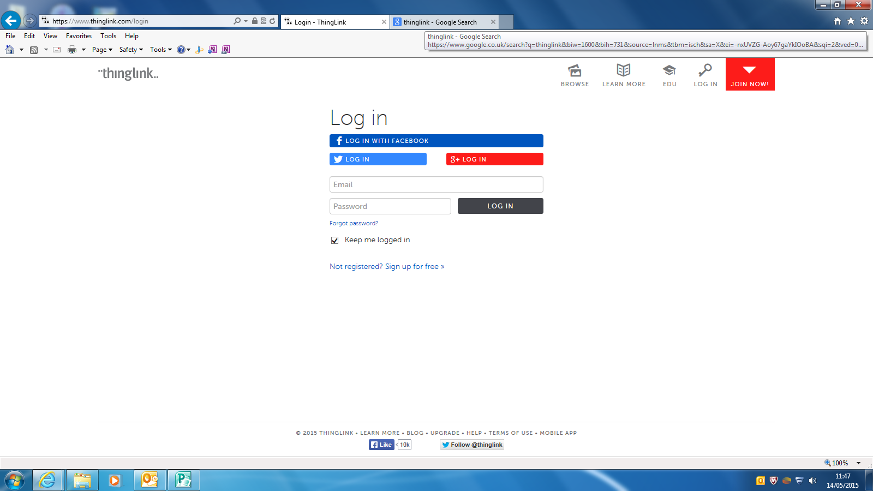

First you will have to create your own thinglink account.

**THIS IS NOT A PRIVATE SITE AND ANY MATERIALS YOU CREATE HERE CANNOT MAKE YOUR GRANNY BLUSH!**

Email—LOGIN@st-ninians.e-renfrew.sch.uk

Password—name of your group

CHANGE THIS PASSWORD AT THE END OF THE PROJECT FOR SECURITY

**Choosing your picture for this project is very important so make sure it has no watermarks, is not blurry, reflects an aspect of what we are studying AND that you take a note of it’s origins for a bibliography.**

Save your selected image to your MY PICTURES folder and then upload it from your HARD-DRIVE—click on **+ CHOOSE IMAGES.**

**If you are happy with how this images looks you can then save it.**

**If not change to another image that looks more effective.**

If you want to add a pin—click on the area of your poster you wish to attach it to.

You can change how your icon looks by clicking on the icon button—use the one icon throughout. Use the edit box to add your URL links to your web sites/Animotos etc.

Remember to save your work as you go along and check

**1/your links lead to the right place and 2/ links are spaced well on the poster.**

