Title: Your exclusive Super Saturday invitation is enclosed!

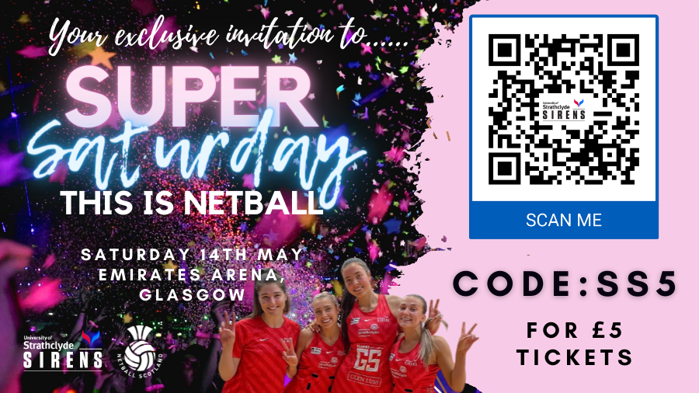

Your exclusive Super Saturday invitation is attached! For just £5 per person, you can receive full-day access to our Super Saturday event. Valid for all students, staff, friends, and family.

Join us for an exciting celebration of netball! Netball Scotland’s pinnacle competition, the Scottish Cup and Scottish Youth Cup Finals will take place on Saturday 14th May at Glasgow Emirates Arena. Our Super Saturday showcase event will see all finalist teams take to court on the official VNSL match court played on by the Strathclyde Sirens this season and not only that, but we have secured the Main Arena for the occasion!

Then at 4pm you can catch Scotland’s only semi-professional netball club, Strathclyde Sirens vs London Pulse in the Vitality Netball Superleague.

All the exciting entertainment will be hosted by Capital Scotland’s Katy J!

We will also have lots of activities, entertainment, food & drinks, and some amazing competitions throughout the day;
- Support Netball!
- Show up for the Strathclyde Sirens!
- Get your school together and let’s raise the roof off the Emirates arena!

How to claim;
- Scan the QR code on the above & attached invitation and follow the link
- Enter code SS5 in the coupon box
- Select your seats and book your tickets!

