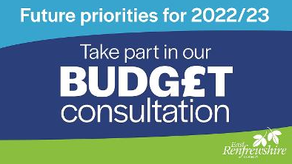
East Renfrewshire Council
Budget Consultation
Friday 26th November 2021
Dear Parents and Carers,

Please find below a link to the East Renfrewshire Council website, where you will be able to access a survey to gather views on the council’s budget and future priorities for 2022/23.

https://www.eastrenfrewshire.gov.uk/article/4462/Budget-consultation-will-help-shape-the-Council-s-future-priorities
‘Covid-19 has impacted all aspects of our lives, and the Council's work supporting people through the pandemic has highlighted how future priorities might change. Digital connectivity is now even more important to enable businesses and communities to remain connected while physically distanced. More people are also in need of support from the Council's welfare and other frontline services as a result of the pandemic. The budget consultation - which will run for seven weeks - gives residents the chance to have their say on how the Council should refocus its efforts to best support the people of East Renfrewshire.’

The consultation is now open and will close on Sunday 12th December 2021.
Kind regards,
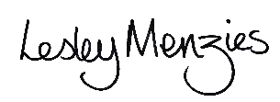

Depute Head Teacher

