

(We will do this part for you)

Your name here

Some of my favourite memories...

Put your picture here.

Please make it fit the entire box.

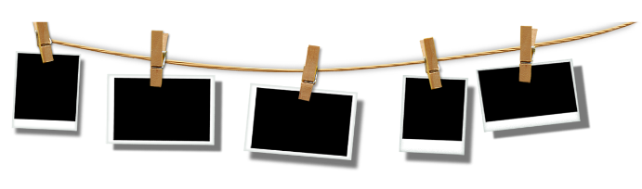

My achievements…

I’m most #proud of…

Where I see myself in 20 years…



My favourite school trip…



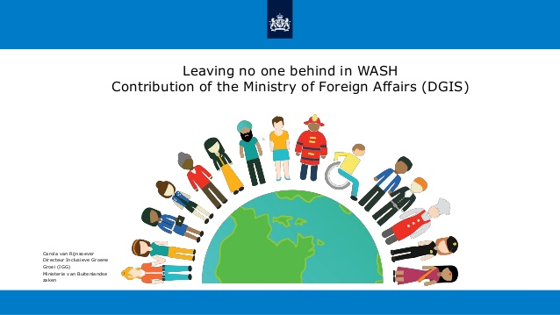



What I will miss most about Kirkhill…

A message to my Primary 7 family…



