Sports Committee Meeting
Agenda
30/01/2019
Present: Innes, Nico, Sophie, Jessica, Ryan, Ben, Ross, Emilia, Tom, Heather, Courtney, Sophia, Aminah, Finlay, Archie, Jodie, Melissa

Apologies: N/A

Minute Taker - Finlay

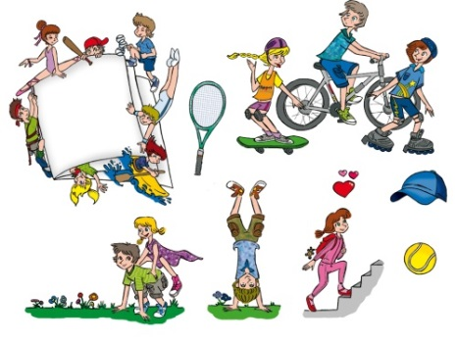
- Fun Run Organisations
Sports Leaders split into groups and began organising the fun run.
- Organising where the fun run route.
- Organising the Fun Run Stops.
- Organising the prizes.

- Future Organisation

- Posters
- Sponsorship form

