Sports Committee Meeting
Minutes
13/02/2019
Present: Jessica, Sophia, Emelia, Jodie, Ryan, Ross, Finlay, Aminah, Sophie, Innes, Ben, Tom, Heather, Melissa

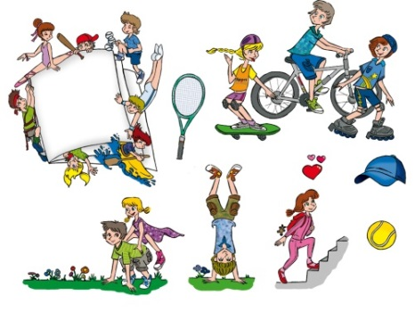
Apologies: Archie, Courtney and Nico

Minute Taker - Jessica

- Create Posters for Sponsored Run

Boys and girls completed posters with information regarding the fun run. When finished the posters will be placed around the school.

- Finalise Fun Run Route
Fun run route suggestions were looked at by Miss Jones and a final plan was made.

- Finalise Fun Run Prizes

Prizes for the fun run will be:

- Fastest House
- Fastest Runner from each class
- Class with the most points

