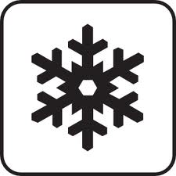
Winter Weather Activities
Primary 7
Ice cube experiment  How quickly does an ice-cube melt? Can you insulate it with different materials to slow the process? Investigate. | Create winter artwork using a variety of media | Write a poem describing the winter scene visible from a window in your house. | Make snowflakes using paper, scissors and sellotape.
Build a snow-animal and photograph it. | Measure the height and circumference of your snow animal. | Do 10 calculations relating to the work you are doing in class. E.g. division, fractions or multiplication. | Make / narrate a nature film about the season of winter
Design a sledge. Add as many interesting features as you can. | Pick an article from a newspaper. Identify the key points and write a detailed summary of the article. | Log onto https://www.topmarks.co.uk/maths-games/7-11-years/ordering-and-sequencing-numbers and complete 5 games. | Update your E-portfolio ensuring that your all about me page is completed.

