Sports Committee Meeting
Agenda
16/01/2018
Present: Me, Brandon, Ross, Emelia, Melissa, Courtney, Heather, Innes, Tom, Ben, Ryan, Sophie, Nico, Finlay, Sophia, Amina and Miss Jones

Apologies: N/A

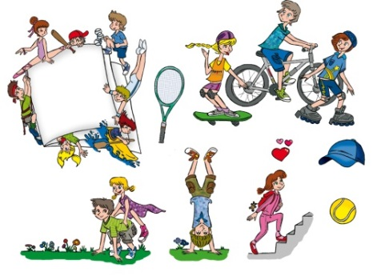
- Discuss Sports Leader Training

Sports Leaders discussed training.
Future training will take place. Hopefully in the next few
months.

- Thank you letter to Parent Council

P7 Sports Leaders worked together to make thank you letter for
Parent Council.

- Fun Run Ideas

- Fun run with questions that you have to answer before moving on (falling into water).
- Small slide into paddling pool of water/whipped cream.
- Healthy eating fun run.
- NASA Training Camp Fun Run ( Cargo nets, hand eye co., think fast)
- Gymnastics

