Sports Committee Meeting
Agenda
16/01/2018
Present:

Apologies:

Minute Taker -

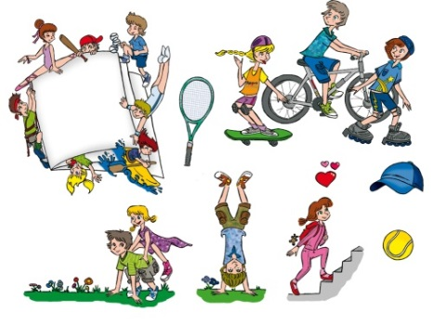
- Discuss Sports Leader Training

- Thank you letter to Parent Council

- Fun Run Ideas

