Sports Committee Meeting
Minutes
12/9/2017
Present:
Jessica, Sophie, Amelia, Melissa, Courtney, Ben, Tom, Heather and Miss Jones
Apologies: N/A

Minute Taker - Jessica
- Introductions –
Miss Jones introduced herself and all Sports Leaders shared their name and their favourite sport.

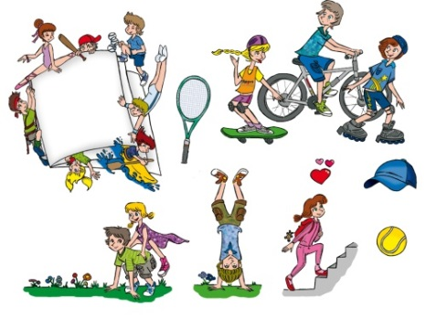
- Information about Sports Leaders –
Primary 7 Sports Leaders explained what they did last year and highlighted to the new Sports Leaders what to expect from the year ahead.
Children suggested areas that they would like to focus on from the year ahead (family fun event, helping younger ones, sports jobs, and master classes)

- Give out badges –
Badges were handed out to all new Sports Leaders.

- Action Plan –
We started looking at the School Action Plan and agreed to look at it in more detail next week.

