Sports Committee Meeting
Agenda
26/9/2018
Present: Jessica, Jodie, Nico, Finlay, Innes, Tom, Amina, Sophie, Archie, Ross, Ryan, Emelia, Sophia, Heather, Ben, Courtney, Melissa, Miss Jones.

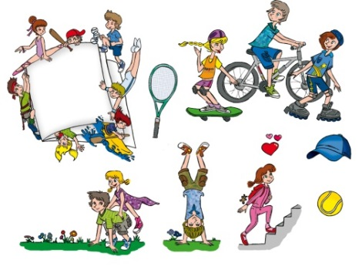
Apologies: N/A

Minute Taker - Miss Jones

- Wall Display
Sports Leaders all discussed what is currently on the wall display and what they would like the wall display to look like this year.
Suggestions Include:
- Large Sports Leader Badge – Sports information around the badge.
- Facts about famous athletes.
- Gold paper around badge on wall.
- Masterclass/ Family Masterclass suggestion box (Including Sports Leaders speciality).
- Show different sports jobs ( Physio, Coach, Sports and Exercise Scientist, Top players, Sport Doctor, Referee, Linesmen)
Sports Leaders researched and created posters that explained the different jobs involved in sports.

- Community Member
Miss Jones has invited the Active School Coordinator to come along to our meetings and we are awaiting his reply. We would also like to invite some of the Sports Leader’s parents in to participate in some of the meetings.

- Action Plan

Sports Leaders agreed on the final points for the action plan. Miss Jones is going to type up our suggestions and send it to Mrs Donaldson.

