

Kirkhill Primary School






Take the Mystery Out of Choosing Good Books

Access to good books is the first step to discovering the joy of reading. The more trips you make to the library together, the more likely your child will want to choose a book from the shelves. The more books you have in your home, the more likely your child will pick one up and read it. But how do you know which books are the right ones to bring into your home or to borrow from the library? This guide offers tips and strategies to help you and your child learn how to choose good books together.
By Primary 6/7, some pupils may have favourite authors or titles.

WHAT IS A GOOD BOOK?

A book doesn’t have to win an award to be considered “good.” It doesn’t have to be a bestseller or on a recommended booklist, either. A good book is simply one a child enjoys reading.

HOW CAN YOU FIND GOOD BOOKS?
Libraries, bookstores, charity shops and jumble sales are filled with books. But how do you know which ones are good? Trust your instincts. Keep your child’s interests and reading level in mind and use the tips listed in this guide to help you in your search.

WHAT DO CHILDREN KNOW?
A lot. So ask them. Children can tell you what they like and don’t like, what they want to learn, who they would like to meet, and what they want to do when they grow up. All of these are the subjects of great books. Your children’s input will help you guide them to good books.

Quick Tips!

- Knowing how to choose good books is a skill your children will keep for the rest of their lives. Take time to show them how. Encourage them to select books on their own as soon as they show preferences.
- You can even let them pick two kinds of books - one to read with you and one to read on their own.
- Get to know the children’s section of your local library and ask the staff for recommendations.
- Check lists of recommended books, such as those in this guide.
- It’s okay to look through a book and then decide not to read the whole thing. If you don’t like a book after reading a chapter or a few pages, pick another one. Reading is supposed to be fun, not a chore.

Kirkhill Pupils and our Librarian Pupil Group helped to compile this guide

Recommended Booklist for 9 to 11 year olds

There are many hundreds of books published for children aged 9 to 11. If you are feeling stuck for choice here are a few that the National Literacy Trust and Scottish Book Trust recommend.

Many of the books can be borrowed from an East Renfrewshire Library. You can check the status of books online at http://www.eastrenfrewshire.gov.uk/index.aspx?articleid=2113. Most books can also be bought in local bookstores or online (see links below) where a Kindle download or audio book may be available too.

These books are designed to appeal to the interests of children aged 9 to 11, however, if you feel that your child would like a different level of book other lists are available from the school.

Author | Title | ISBN
Nel Yomtov | Jason and the Golden Fleece | 9781434213853
Michael Morpurgo | Wartman | 9781842997918
Liz Pichon | Tom Gates Brilliant World | 9781407120690
Gill Lewis | Skye Hawk | 9780192756237
Bali Rai | Dream On | 9781842990454
Cornelia Funke, | Thief Lord | 9781905294213
Jonathon Meres | The World of Norm (Series) | 9781408313039
Michael Morpurgo | Kensuke's Kingdom | 9781405221740
Herge | Tintin and the Lake of Sharks | 9781405206341
Jamila Gavin | Grandpa Chatterji | 9780749717162
John Fardell | Seven Professors of the Far North | 9780571221554
Sam Angus | Soldier Dog | 9781250044174
Annie Dalton | Winging it: Angels Unlimited | 9780007153817
Michael Morpurgo | Toro! Toro! | 9780007107186
Beverley Naidoo | Journey to Jo'Burg | 9780007263509
Sam Hutton | Special Agents (series) | 9781421513751
Norton Juster | Phantom Tollbooth | 9780007263486
Francesca Simon | The Lost Gods | 9781846685668
Darren Shan | Cirque Du Freak (series) | 9780006754169
Jean Ure | Secret Meeting | 9780007428038
Lucy Daniels | Kittens in the Kitchen Animal Ark9 (series) | 9780340944363
Jacqueline Wilson | Tracey Beaker | 9780440867579
Ivan Southall | Hill’s End | 9781922147004
Jo Cottterill | Deep Water | 9781849412193
Bob Dewar | King o the Midden | 9781902927701
Dan Gutman | The Homework Machine | 9781435289307
Stephanie Milton | Minecraft Tricks | 9781495204258
Judy Blume | Superfudge | 9781447262893
Eva Ibbotson | Journey to the River Sea | 9780330538817
Paul Cookson | Don't Get Your Knickers in a Twist! | 9780330397698
Sophia Bennett | The Look | 9781906427917
Paul Geraghty | The Hunter | 9780099666318
Caroline Lawrence | Thieves of Ostia (series) | 9781842550205
Cliff McNish | The Doomspell (trilogy) | 9781858818504
Geraldine McCaughrean | Heroes: Hercules | 9780812627374
Roald Dahl | The Twits | 9780141346397

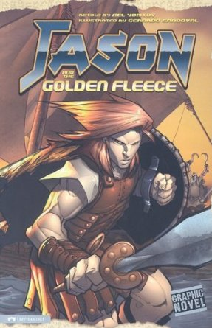



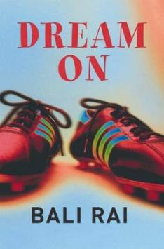

Author | Title | ISBN
Gillian Lobel | Midnight Tiger | 9780192725615
Cathy Cassidy | Indigo Blue | 9780141338897
Eoin Colfer | Artemis Fowl (series) | 9780141339092
Ally Carter | Gallagher Girls (series) | 9781408309513
Eoin Colfer | The Wish List | 9780141315928
Zizou Corder | Lion Boy | 9780141317571
Roald Dahl | George's Marvellous Medicine | 9780141346403
Morris Gleitzman | Bumface | 9780141303550
Michelle Magorian | Goodnight Mister Tom | 9780140315417
Jeremy Strong | Karate Princess and the Last Griffin | 9780140381566
Anne Fine | Return of the Killer Cat (series) | 9780141317199
Neil Arksey | As Good as Dead in Downtown | 9780141310527
Phillip Ridley | Krindlekrax | 9780141311531
Benjamin Zephaniah | Wicked World | 9780141306834
Steve Backshall | Deadly Factbook (series) | 9781444008319
Vassili Papastavrou | Whale | 9780789458704
Ursula Le Guin | Wizard of Earthsea | 9780140304770
Narinder Dhami | Bindi Babes (Series) | 9780440866336
Adam Blade | Beast Quest Series | 9781846164835
Tony Ross | I Want to Win | 9781849394741
Anne Fine | Up On Cloud Nine | 9780552554657
Robert Swindells | Ruby Tanya | 9780440863984
Stewart & Riddell | Last of the Sky Pirates | 9780552554268
Paul Stroud | Amulet of Samarkand | 9780552562799
Jack Gantos | What Would Joey Do? | 9780440865216
Malorie Blackman | Operation Gadgetman | 9780440863076
Jacqueline Wilson | Sleepovers | 9780552557832
Philip Pullman | Clockwork | 9780440866381
Robert Swindells | Room 13 | 9780440864653
Patrick Moore | The Night Sky | 9781849072977
Jacqueline Wilson | The Cat Mummy | 9780440868576
Brian Jacques | Lord Brocktree (series) | 9781862301450
Lauren Brooke | Heartland (series) | 9780439997959
Karen McCombie | The Past, the Present and the Loud, Loud Girl (series) | 9781407117614
Tamora Pierce | Wild Magic (series) | 9780756955083
Antony Horowitz | The Falcon’s Malteser | 9781406341423
Sammer Feal | Diary of a Weird Yeti Rescue | 9781782061892
Peter Joyce | Once Upon a Time Map Book | 9780763664756
Jackson & Livingstone | Fighting Fantasy (series) | 9781848310759
Sutherland & Chalk | Football Fantasy (series) | 9781840465976

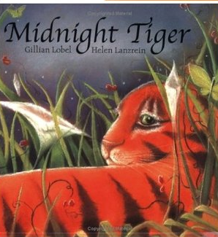

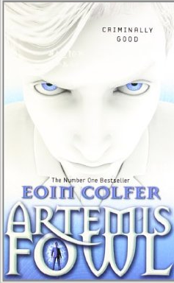

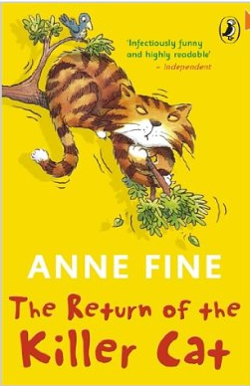

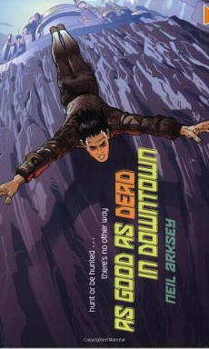

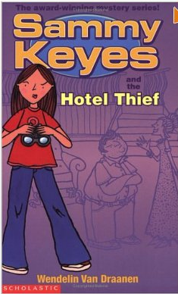
Author | Title | ISBN
John Lennon | The Case of the London Dragonfish | 9781846470981
W V Draanen | Sammy Keyes and the Hotel Thief | 9780439981231
A McCall Smith | The Bubblegum Tree | 9780747580539
Michael Rosen | Michael Rosen’s A to Z (Poems) | 9780141324500
Ted Hughes | The Rattle Bag (Poems) | 9780571225835
P Cookson & D Harmer | It’s Behind You (Poems) | 9781447242109
J M Barrie | Peter Pan | 9781933652078
Ross Mackenzie | Zac and the Dream Pirates | 9781906427160
Gillian Cross | The Demon Headmaster | 9780192755827
Frank Richards | Billy Bunter of Greyfriars School | 9781904605614
T H White | The Sword in the Stone | 9780007263493
Robin Jarvis | The Whitby Witches | 9780750005814
Roald Dahl | The Witches | 9780141346410
A Allan | The Robe of Skulls | 9780744583618
Lauren Child | Utterly Me, Clarice Bean | 9781843623045
Neil Gainman | Coraline | 9781408841754
Davis Walliams | Gansta Granny | 9780007371464
Alex Nye | Chill | 9780863155468
Gill Arbuthnott | Winterbringers | 9781782500988
Matt Haig | Shaddow Forest | 9780552555630
F C Boyce | Framed | 9780330452922
J Meres | The Word of Norm | 9781408329498
J Mackay | Accidental Time Traveller | 9780863159541
Libby Gleeson | I am Thomas (Picture Book) | 9781742373331
V French | The Three-Legged Mummy | 9781842993897
Andy Stanton | You’re a Bad Man, Mr Gum | 9781405223102
Andy Mulligan | Ribblestrop | 9781847382306
Louis Sachar | Holes | 9783125781702
A C McLean | The Hill of the Red Fox | 9780863155567
N Streatfield | The Circus is Coming | 9780140300963
E Garnett | The Family from One End Street | 9780141329673
Annemarie Kelly | Hox | 9780863156212
F G Ewart | There’s a Hamster in my Pocket | 9781847801180

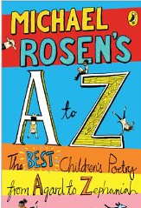



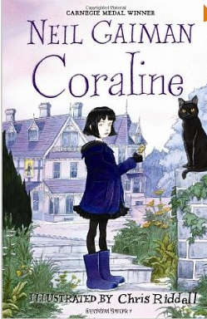

Recommended Online Sites 
http://www.scottishbooktrust.com/reading/book-lists/kids
http://www.lovereading4kids.co.uk/
http://www.amazon.co.uk/
http://www.wordsforlife.org.uk/
http://www.literacytrust.org.uk/

- PARENTAL GUIDANCE MAY BE REQUIRED WHEN CHOOSING A SUITABLE BOOK.

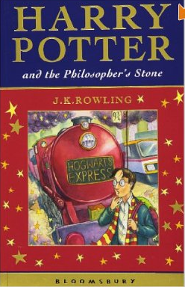

PUPIL RECOMMENDATIONS
Author | Title | ISBN
J K Rowling | Harry Potter (Series) | 9780747558194
Michael Grant | Gone | 9781405242356
Rachel Campbell Johnston | The Child’s Elephant | 9780552571142
David Walliams | The Boy in the Dress | 9780007279043
Rachel Russell | Dork Diaries | 9781471117671
Max Silver | Alien Invaders (series) | 9781849412353
Anthony Horowitz | Alex Rider (series) | 9781844280926
Rebecca Steel | Liar and Spy | 9781849395427
Suzanne Collins | The Hunger Games | 9781407109084
Arthur Ransom | Swallows and Amazons | 9780099572794
Susan Cooper | Ghost Hawk | 9780552568180
Enid Blyton | Famous Five (Series) | 9781444910582
Kim Lewis | Emma’s Lamb | 9780744520316
John Boyne | The Boy in the Striped Pyjamas | 9781862305274
Shirley Hughes | Hero on a Bicycle | 9781406336115
Jacqueline Wilson | Sleepovers | 9780552557832
Emma Carroll | Frost Hollow Hall | 9780571295449
Michael Morpurgo | Kensuke’s Kingdom | 9781405221740
Christopher McDougall | Born to Run | 9781861978776
Anthony Read | Baker Street Boy (Series) | 9781406336382
Michael Morpurgo | War Horse | 9781405226660
John Barrowman | Hollow Earth | 9781907151644
Daisy Meadows | Rainbow Magic | 9781408319789
Rose Impey | Six Feet Deep | 9781846162855
Enid Blyton | The Naughtiest Girl | 9781444910605
Rick Rordain | The Percy Jackson (Series) | 9781423141891
Katherine Rundell | Rooftoppers | 9781442490598
Malcolm Saville | The Lone Pine Adventures | 9780006911609
Betty Birney | Friendship According to Humphrey | 9780571233243
D K Smith | The Invisible Dog | 9780141332376

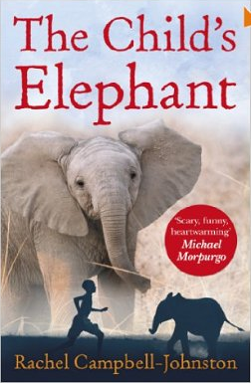

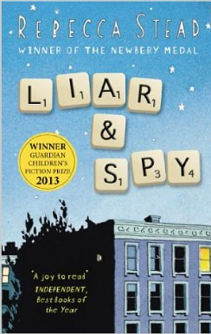

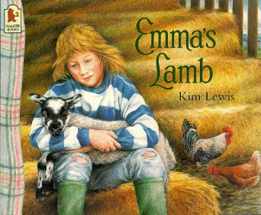

- PARENTAL GUIDANCE MAY BE REQUIRED WHEN CHOOSING A SUITABLE BOOK.

