Tuck Price List 2016/2017

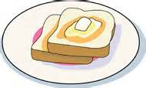 Tuck Limit £1.20 per day 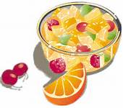

Biscuit – 30p Toast – 20p Fruit Tuck – 35p

Pancake (Toasted, Butter, Jam or Plain) – 40p

Plain Milk – 20p Flavoured Milk – 25p
Plain Water – 45p Flavoured Water – 50p

Aqua Juice (Apple, Orange & Apple & Blackcurrant) - 45p

Calypso Orange and Apple Juice – 45p

****Wednesday Only****

Cookie – 60p Muffin – 55p Crisps – 55p

