Child's name: _______________________

Class: ________________________

Date: ________________________

Signature of Parent/Carer:

__________________________________

Thank you for completing this form. Your views are important to us.






Meeting Pupil Needs in East Renfrewshire
Kirkhill Primary School

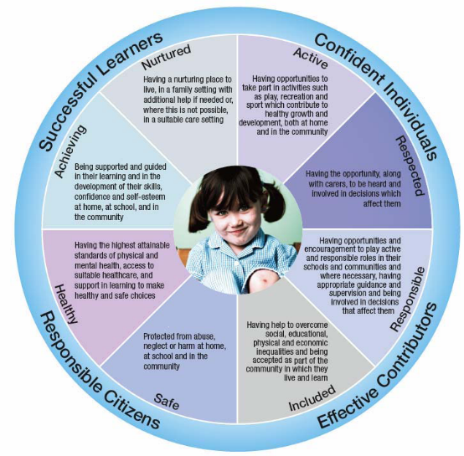

STAGED INTERVENTION - STINT

STAGED INTERVENTION (STINT) FRAMEWORK

- STINT is the framework by which all East Renfrewshire Schools, including Kirkhill Primary, and partners (particularly social work and health services), assess additional support needs and systematically review and refine those plans to ensure the best outcomes for pupils.
- STINT is a 5 level structure which reflects the level of intervention and coordination required to meet identified pupil needs at any given time. Needs range from classroom based strategies at Stage 1 to more complex multi-agency strategies at Stage 5.

- Stages can be summarised broadly as:
- Stage 1 Classroom based, teacher led strategy
- Stage 2 Classroom based with additional educational supports
- Stage 3 Joint Support Team, Multi-agency involvement
- Stage 4 Complex Multi-agency involvements. Case management approach
- Stage 5 Legislative requirements

ROLES AND RESPONSIBILITIES

The STINT framework has been designed to allow school staff, partner agencies, pupils and parents to be active participants in the plan. Your child's teacher will discuss the strategies agreed to help support your child, and will welcome your views and any suggestions you might have. The very important review process, when the success of the agreed strategies is discussed is also an area where your views will be sought.
The school's ASN Co-ordinator, Mrs Menzies is responsible for assuring the whole school approach and bringing together the various facets of pupil support including pastoral, behaviour and learning.
Class teachers are responsible for the delivery of education and are therefore central to the effective implementation of STINT at all levels.
Class teachers may be supported by pupil support staff (PSAs, ASN teacher) to deliver, monitor and review the strategies and actions as detailed in the STINT plan.
Other agencies working with the school may include, Family Learning, Outreach, Social Work, Speech and Language Therapist, School Nurse. When involved, their roles and responsibilities will be stated within the plan.
If you would like to discuss any aspect of your child's STINT plan further, please call and arrange a meeting with Mrs Menzies, Additional Support Needs Co-ordinator.

PARENT/CARER VIEWS
We would like to know your views regarding your child's STINT plan.
Please fill in the tear off section and return it to your child's teacher.
1. What do you consider to be your child's strengths? (he/she is good at...)
_________________________________________
_________________________________________
_________________________________________
2. What does your child like? (subjects, environment, preference for working - individually, partner, group...)
_________________________________________
_________________________________________
_________________________________________
3. What does your child dislike? (subjects, environment, preference for working...)
_________________________________________
_________________________________________
_________________________________________
4. What would you suggest for your child's personal target? (he/she could be better at...)
_________________________________________
_________________________________________
_________________________________________

