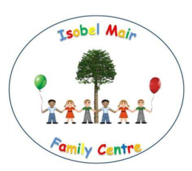
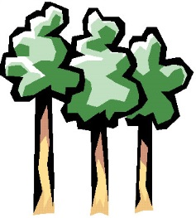
Isobel Mair Family Centre
Woodland Adventures Parental Audit
11.05.17

Dear Parents and Carers,

In February, we started a three month ‘test of change’ piloting our ‘Woodland Adventure’ project – offering all parents and children the opportunity to join staff in the woods for outdoor learning and play experiences.

We are approaching the end of the test of change period and would very much like to hear your views. Listening to your views will help us to make changes which should lead to improvement for all children and their families attending the Family Centre now, and in the future.

If you could take a few minutes to complete and return, we would be most grateful.

Did you participate in one or more Woodland Adventures? ________________________
____________________________________________________________________________________________________________________________________________________________________

If you did not participate in Woodland Adventures, can you let us know what stopped you from going? ______________________________________________________________________________________________________________________________________________________________________________________________________________________________________________________

Do you feel you would like to continue to have the opportunity to join Woodland Adventures? ______________________________________________________________________________________________________________________________________________________________________________________________________________________________________________________

Do you feel your child benefits from participating in Woodland Adventures? Why? ______________________________________________________________________________________________________________________________________________________________________________________________________________________________________________________

Did you personally benefit from participating in Woodland Adventures? Why? ______________________________________________________________________________________________________________________________________________________________________________________________________________________________________________________

Do you feel your child would be more likely to participate in Woodland Adventures if you were asked to drop them off at Eastwood Park and collect, but you would not have to stay? ________________________________________________________________________________________________________________________________________________________________________________________________________________________________________________________________________________________________________________________________________
Would you be happy for your child to go on a Woodland Adventure without you? (Staff would be responsible for your child for the session in the woods, with the woodland adventure ‘replacing’ the full nursery session) ________________________________________________________________________________________________________________________________________________________________________________________________________________________________________________________________________________________________________________________________________

Are you happy with our procedures, policies and risk assessments for accessing the woods and parklands? ________________________________________________________________________________________________________________________________________________________________________________________________________________________________________________________________________________________________________________________________________

Do you feel your child is kept safe during Woodland Adventures? ________________________________________________________________________________________________________________________________________________________________________________________________________________________________________________________________________________________________________________________________________

Is there anything you would like to ask or discuss about this (or any other aspect)?

Child’s Name:____________________________________________________________________

Parent/Carer Name: _____________________________________________________________

Signature: _______________________________________________________________________

Many thanks for completing, your views are important and we want to ensure we listen and make improvements.

