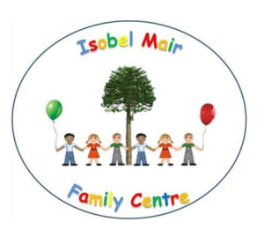

Dear Parents,

**Final Term!**

We hope everybody who was off on holiday had a wonderful break. It seems quite unbelievable that on Tuesday we will be welcoming you back to what will be the final term of the academic year. Preparations for school transitions will be getting well underway for those who have not already started and for those who have started the transitions, this will continue throughout this term.

This term is always very busy with children jointly planning with staff for our school leavers graduation celebration and end of term parties. If you have any ideas on how we could make our end of term celebrations even better then please let us know!



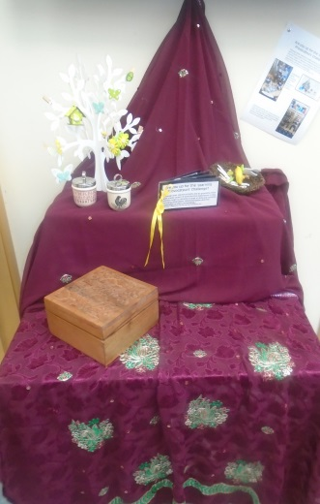**Were you up for the Provocation Challenge?**

A Learning Provocation Challenge was set prior to the Easter holidays. A table of learning provocations has been set up in the foyer for you to display your challenge endeavours! We are all really excited to see what curiosity provoking items you have managed to collect, find or gather during your time away from IMFC. Bring your ‘curiosity collection’ in any day from returning on Tuesday and claim your home challenge prize!

If you haven’t completed the challenge yet, don’t worry – there is still time! See our website for more details: <https://blogs.glowscotland.org.uk/er/IsobelMairFamilyCentre/2017/03/29/learning-provocateurs-challenge/>

**Woodland Adventures**

Our Woodland Adventures will continue this term with dates set as below weeks:

* Friday 28th April with Donna
* Wednesday 3rd May with Isla

Uptake on our Woodland Adventures has been a little quiet recently, so we are hoping for more parents to come along and join in. A letter will be coming out to you in due course asking for your views about this aspect of our service. We hope you will respond and let us know your thoughts.

**Balta TACPAC/Coffee and Chat**

**Parent and child session on Monday 24th April**

Isla invites all parents along on Monday 24th for parent and child TACPAC followed by coffee and chat. Both morning and afternoon sessions welcome. If you have not participated in TACPAC before, Isla will guide you along!

**Pop in and Play Sessions**

All playrooms are hosting Pop in and Play with coffee and chats. Please check the dates below and come along!

* Blue Group – Tuesday 18th April
* Yellow Group – Wednesday 19th April
* Red Group – Thursday 20th April
* Texa Playroom – Friday 21st April
* Balta Playroom – Monday 24th April

These opportunities are great times to come along and join in with your child in whatever they might be doing that particular day. Great playful learning opportunity with your child ☺

**Photomagic**

Brian and Morag from Photomagic will be visiting IMFC on Tuesday 25th April. All children present on the day will have photographs taken and a proof will be sent home. Parents can make purchases as they wish.

**Parent Committee Group**

Mairi-Jean Watkins, Emma’s mum recently hosted a parent committee meeting in the FC. Mairi-Jean has since been very active, beavering away putting together an online parent forum which came about after parents had spoken about the difficulties involved in meeting regularly within the centre.

One of the items that came up for discussion was a suggested input for a foreign language to be introduced to the children. This is something that we used to do but over time has been put on ‘the back burner’.

In response to the chat from the parents group – this has now been put right back on the agenda and Johanne March has agreed to take on this as an additional responsibility within her role. Johanne has liaised with the council’s Modern Languages Development Officer and will be attending the first French Forum on Tuesday 25th April.

Great job Mairi-Jean and the parent committee

**Texa Learning**

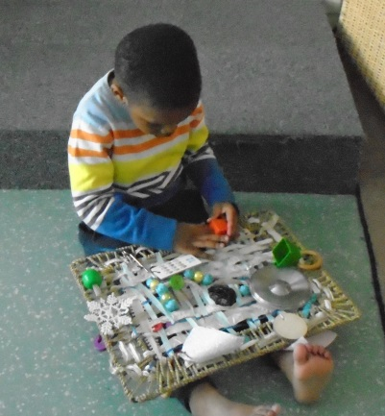Children in our Texa playroom have loved exploring a variety of messy play experiences over the last couple of weeks and will continue to investigate and explore using a multi-sensory playful learning approach as we return on Tuesday.

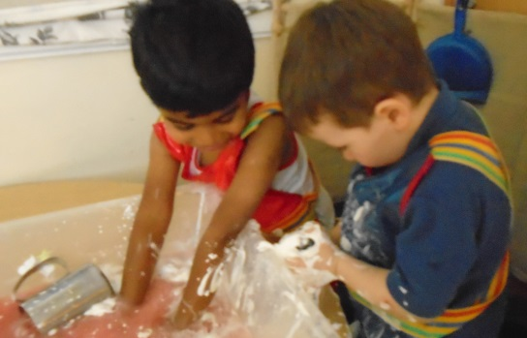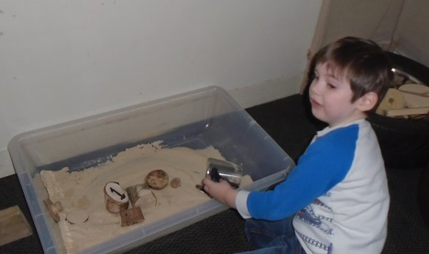

Lorraine also joined in the curiosity **learning provocation challenge,** with a little help from her Texa friends, made a beautiful ‘curiosity board’ with ribbon, weaving and threading interesting items on to the wicker mat. Great job Texa!

**Bookbug is Back**

IN the run up to Bookbug Week (15th – 21st May) Johanne will be offering parent and child Bookbug Sessions every Monday morning and afternoon at 9am and 1pm. Our spaces are limited to a maximum of 8 parents with children, so please be quick to add your name to the sheet outside the door of the parents room. Johanne’s first Bookbug Session will be held on Monday 24th April.

Below is a link of Bookbug events ongoing across East Renfrewshire:

<http://www.whatsoneastrenfrewshire.co.uk/event/014755-east-renfrewshire-bookbug-sessions/>

**Library Books**

We invite you to come and pick a book with your child from our lending library! Books will be set out in the Café every Thursday at 9am for our morning children and 1pm for our afternoon children. Reading with your child is so important; please click on the link to find out more from the Scottish Book Trust:

<http://www.scottishbooktrust.com/bookbug>

**RSPB**

The work towards our RSPB Bronze Award continues throughout this term. The children have been working really hard and we need some help for you! Here is the link to the booklet we are using to support ongoing learning.

<https://www.rspb.org.uk/Images/Full_booklet_tcm9-409169.pdf>

Pages 28 and 29 are all about bird feeding for those who may want to ‘have a go’ at home and a bird watching checklist is also attached for you to complete with your child at home and return to the FC. Please hand in to your child’s key worker.

**Dates for Your Diary**

Monday 17th April – Easter Monday Holiday – IMFC remains closed

Tuesday 18th April – IMFC Reopens for all children – welcome back ☺

Tuesday 18th April – Blue Group Pop in and Play/Coffee and Chat

Tuesday 18th April – IMS&FC Parent Council Meeting 7pm

Wednesday 19th April – Yellow Group Pop in and Play/Coffee and Chat

Thursday 20th April – Red Group Pop in and Play/Coffee and Chat

Friday 21st April – Texa Pop in and Play/Coffee and Chat

Monday 24th April – TACPAC and Chat

Tuesday 25th April – Photomagic

Tuesday 25th April – Johanne March attending French Forum

Friday 28th April – Woodland Adventures with Donna



Monday 1st May – IMFC Closed to all for May Day Holiday

Wednesday 3rd May – Woodland Adventures with Isla

Many thanks for reading our very lengthy bulletin!!

Have a wonderful long weekend and Happy Easter!

From all at IMFC

Quote of the Week

