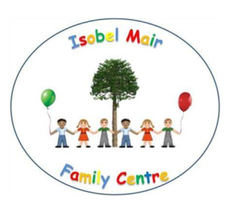
Isobel Mair Family Centre
Parent Consultation: Toy and Fruit Fund
May 2015

In April 2015 we were informed that due to council efficiency savings, children would no longer be in receipt of free fruit. We carried out a consultation with parents to gain their views and thoughts on the following:

- Would you be agreeable to a weekly increase?
- If yes, how much do you feel is appropriate per week?
- 50p increase?
- £1.00 increase?

All parents were issued with a voting slip to ensure their views were counted. The results are as follows:

Do you agree to an increase in Toy Fund? |  | A 50p per week increase | A £1.00 per week increase
Yes | 37 | 11 | 26
No | 1
Form returned unanswered | 4
Form not returned | 29

As the majority of parents were happy to increase the Toy Fund to £30.00 per week to include payment for children’s snack as of August 2015 this change will be made.

For parents who choose not to pay into the voluntary Toy Fund, a monthly bill will be issued to cover the cost of fruit/snack only. This will ensure that Toy Fund paying parents are not funding the snack of non Toy Fund paying parents.

