Dear Parent/Carer

East Renfrewshire Schools’ Funstrings Orchestra – Class 223 Orchestras B

Please find below details for the Glasgow Music Festival competition, which the Funstrings Orchestra will be taking part in this term.

Date: Sunday 10th March 2019

Venue: Glasgow Royal Concert Hall – Main Auditorium.

Time: Pupils should arrive at the Royal Concert Hall, which is best
accessed from the entrance in Killermont Street ( across
from Buchanan Street Bus Station) at 1.00pm. Music Festival
stewards will be on hand to direct you to our assembly
area which will be in the Island Bar area of the Concert Hall.

The class will begin at 2.00pm and should finish at 2.45pm approx.

Dress: Pupils should wear school uniform; black shoes, school shirts,
skirts, trousers, ties etc.

Tickets: These are only available from The Glasgow Royal Concert Hall
box office. Queues at the GRCH box office on the day can be considerable resulting in delays, particularly for classes commencing at 10:00, 14:00 and 18:30 hours. To ensure audience access to halls in time for the beginning of classes it is strongly recommended that tickets be purchased in advance. This may be done in person, by telephone or online from the Concert Hall Box Office. www.glasgowconcerthalls.com/events/
N.B. Please ensure that you book tickets for the daytime events
(10am -) and not the Band Night (6.30pm - )

If you have any queries regarding the above please do not hesitate to contact me on 0141 577 2568.

Yours sincerely
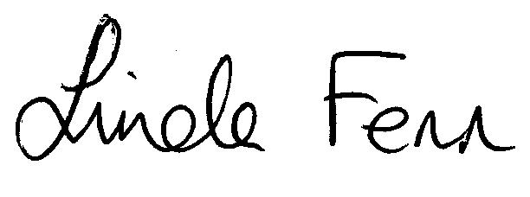
Linda Fenn
Co ordinator- Music Centre & Instrumental Music Service

