**NOVEMBER 2018**

 NEWSLETTER

Follow us **NOW** on [](http://scalar.usc.edu/works/lopes-ambition/twitter-logo) FriendsofERSM

Follow us **NOW** on  friends of east renfrewshire school music

Finally, here is a list of upcoming events for your diary.

**Who are Friends of ERSM?** We are a Scottish registered charity (SC032346) dedicated to raising funds to support the work and aims of the Schools Instrumental Music Service across East Renfrewshire. The committee comprises of parent volunteers whose children currently attend the Music Schools. We have provided funding for new specialised instruments, additional sheet music and hardship assistance for residential courses. We are always delighted to welcome new committee members and listen to any new innovative ideas. Meet us on Saturday mornings at Williamwood High School.

**It seems amazing that it is already November! Our young musicians are certainly working hard, and it is a real pleasure to listen to them on a Saturday morning.**

**Following a meeting with Linda Fenn and Donald Finlayson in September, we are delighted to announce that we have committed funding - £1,800 initially - for a concert to be held in March at the Glasgow Royal Concert Hall to celebrate the life and life-long commitment to music in East Renfrewshire by Ena Millar. The date will be confirmed in due course.**

**It will present a wonderful opportunity for our young musicians to perform in an outstanding venue in front of proud parents, relatives and friends, and to remember a well-loved and committed supporter of music across the authority.**

**We can confirm that the committee is also working hard to get ready for this years Christmas raffle on Saturday the 15th of December. With this in mind, I can confirm that raffle tickets will be on sale from Saturday the 3rd of November at the fERSM desk. We aim to sell 1000 tickets this year. This will enable us to raise more funds going forward as well as contributing to a great prize collection.**

**We will also welcome any donations for the Tombola from the 3rd of November and will have a box available at the desk.**

**We can also confirm that a re-useable tea/coffee cup will shortly be available for sale. It will enable us all to cut down on our single-use cups on a Saturday morning while raising additional funds. They’re also quite nice!**

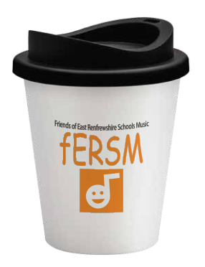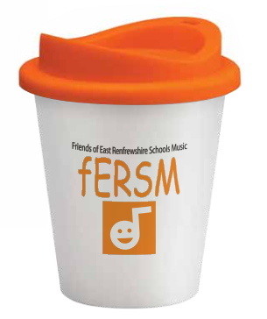

**We would also like to remind you all that we have been given permission to place a (small) donations jar at the café counter. Any small change will be counted by two committee members each week and put into the fERSM bank account.**

**Finally, if you would like to become an active member of the committee, particularly with the Christmas raffle coming up, please come over to the desk. We’d be delighted to meet you!**

**Regards**

**The committee**