Fun Christmas Games to help young children learn French
https://www.headstartlanguages.co.uk/resources/camembears-christmas-activities-bauble-challenge
https://www.headstartlanguages.co.uk/resources/camembears-christmas-activities-vive-le-vent

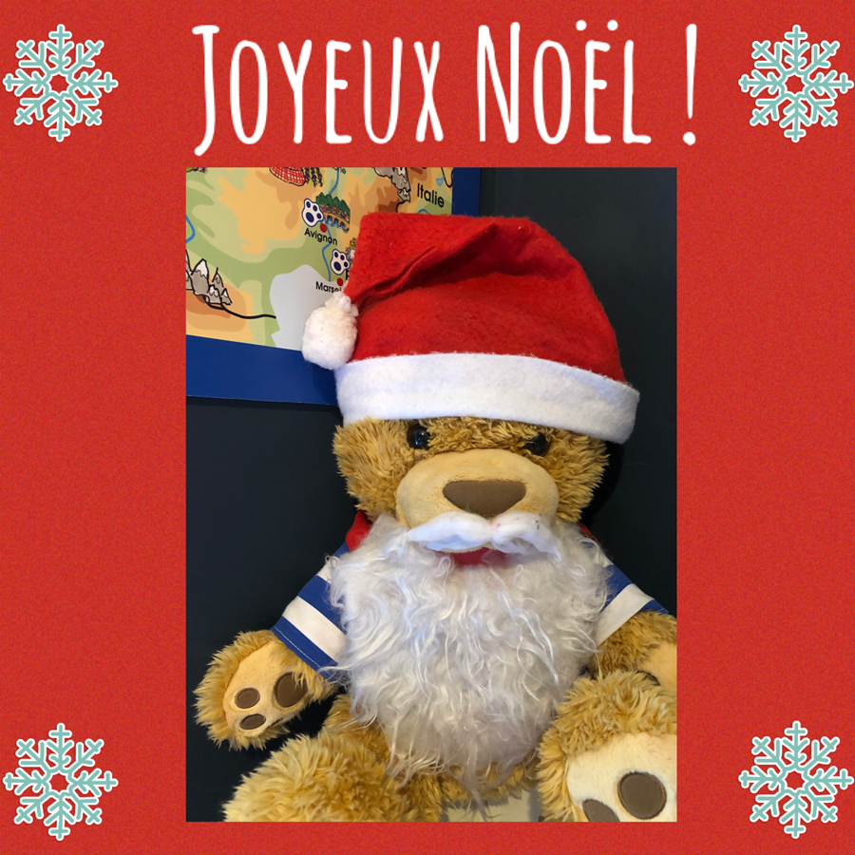

Click here for your free resources

