Family First- Work with families living in ERC and have children aged 0-11years
Family First
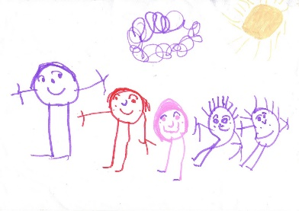
The Family First Team offer a free, confidential service to support with any worries you might have. They can help you find the right people when you don’t know who to ask for help. The highly skilled team will try to stop any issues you bring to them from getting worse and help you find the right support.

Contact the team at familyfirst@eastrenfrewshire.go.uk we look forward to hearing from you.

Twitter

Follow @FamilyFirst_ERC
For daily updates from a range of national and local organisations on themes of parenting, family wellbeing, ASN, money advice and rights, health and safety and education and learning

Website
https://www.eastrenfrewshire.gov.uk/family-services
Our website provides an overview of the Family First service and contact details for the team.

----------------------------------------------------------------------------

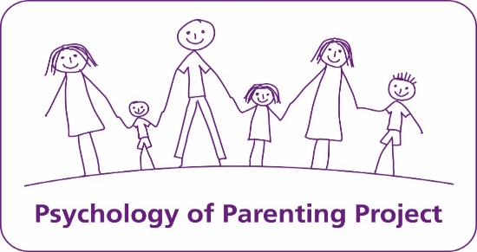

Psychology of Parenting Programme/ PoPP

If you are starting to worry about the behaviour of your child or a child you care for you may be interested in our new online parenting programme for children aged 2-8 years. The programme is aimed at increasing parents/carers confidence in dealing with unwanted behaviour and preventing it from getting worse.

Interested in finding out more? Contact the team on Popp@eastrenfrewshire.gov.uk we look forward to hearing from you.

