Ziggy’s Song (Wheels on the Bus tune)

When crossing the road, look right, left, right
Right, left, right
Right, left, right,
When crossing the road, look right, left, right
Sing Ziggy’s song.
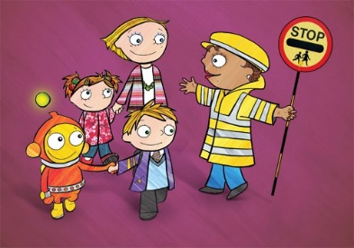
Wait on the kerb till it’s safe to cross
Safe to cross
Safe to cross.
Wait on the kerb till it’s safe to cross
Sing Ziggy’s song.

Watch out for traffic like cars and bikes
Cars and bikes
Cars and bikes
Watch out for traffic like cars and bikes
Sing Ziggy’s song.

Hold hands when you cross then squeeze them tight
Squeeze them tight
Squeeze them tight
Hold hands when you cross then squeeze them tight
Sing Ziggy’s song.

