Fun Facts about Dinosaurs!!!

Dinosaurs have lived on Earth for more than 180 million years. Dinosaurs were some of the most huge and powerful creatures ever to have lived!

10 fun facts

- Some dinosaurs are believed to have had feathers
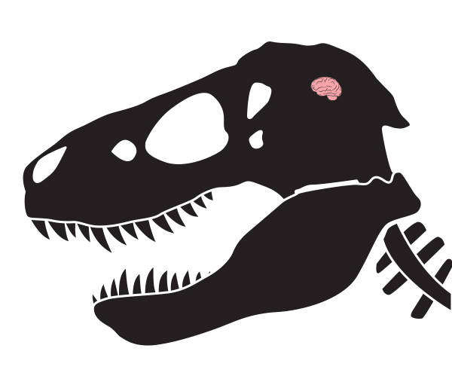
- Most dinosaurs had very small brains
- “Dinosaur” comes from the Greek language which means “terrible lizard”
- Dinosaurs were the biggest animal to ever have walked on earth
- Argentinosaurus was the heaviest and longest dinosaur ever discovered
- Megalosaurus was the first dinosaur to be named in 1824
- A Palaeontologist is someone who studies dinosaurs
- Most of the biggest dinosaurs only ate plants
- Spinosaurus is the largest meat-eating dinosaur which was around 50 feet long!
- No one is quite sure how long dinosaurs lived for

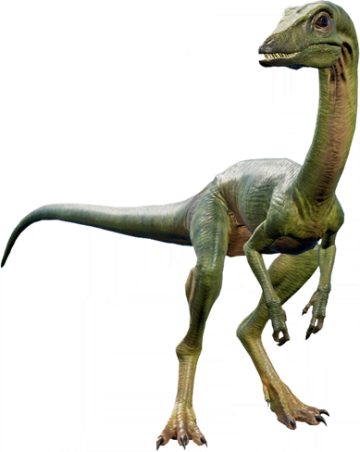
The smallest dinosaur discovered was smaller than a hummingbird. Its skull was found in a piece of amber, which was formed from tree gum millions of years ago. You can see pictures of it here: https://nhm.org/stories/tiny-dinosaur-and-big-discovery

The biggest dinosaur was called Argentinosaurus and weighed around 50 to 100 tonnes and was about 30 to 39.7 metres, which is about as long as 3 buses lined up behind each other and as heavy as 5 double decker buses!
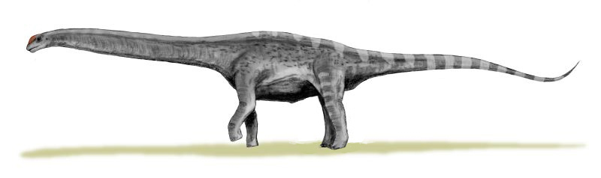

British fossil hunter William Buckland found some fossils in 1819.

Questions
- Do you know why most dinosaurs have long tails?
- Which dinosaurs had the smallest brain?
- How many horns did a Triceratops have?

Answers
- To help them to keep their balance when running.
- Stegosaurus
- Three

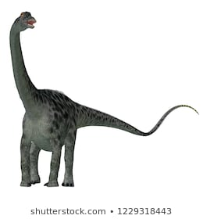
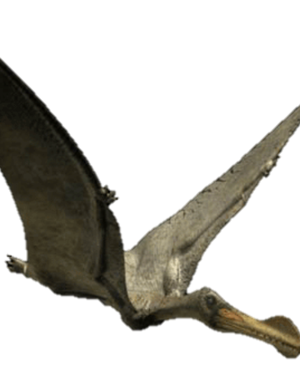
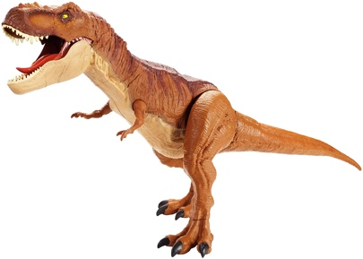
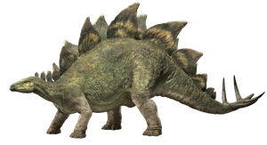

Ornithocheirus Stegosaurus Tyrannosaurus Rex Spinosaurus Diplodocus

Can you match the names up with the correct dinosaurs?
What one is missing?

Can you tell me any facts about dinosaurs?
What is your favourite dinosaur?

Here are some useful links to find more fun facts about dinosaurs….

https://paultonspark.co.uk/blog/article/13673/our-top-20-fun-dinosaur-facts
https://www.sciencekids.co.nz/sciencefacts/dinosaurs.html
https://www.kids-dinosaurs.com/dinosaur-facts.html
https://www.bbc.co.uk/cbeebies/search?q=dinosaurs

You can watch a video of Walking With Dinosaurs to see how they moved and lived here: The film was made using computers to draw the dinosaurs, but they look very realistic:

https://www.youtube.com/watch?v=L7Ee1wIspIw

